Name……………………………………………………………………….Index Number………………………………Class.………
443/2 AdmNo………………………Date………………………….
AGRICULTURE Candidates Signature…………………………
PAPER 2
2 Hours
MOKASA EXAMINATION
Instructions to candidates
Write your name and Index number in the spaces provided. Date and signature also be filled in the spaces provided.
The paper consist with three sections A , B and C. Answer all questions in sections A and B and any Two questions in Section C. All answers be written in the spaces provided after each question. The paper has 16 printed pages.
FOR Examiner’s Use Only
Section | Question | Maximum Score | Candidate’s Score
A | 1 - 17 | 30
B | 18 - 21 | 20
C |  | 20
 |  | 20
 | Total Score | 90

SECTION A (30 Marks)
Answer all the questions in this section in the spaces provided.
1 State four ways of controlling tsetse flies. (2mks)
a.spraying……………………………………………………………………………………………………………………………………… b.hand picking………………………………………………………………………………………………………………………………………………………washing……………………………………………………………………………………………………………………………………………………………………………………………………………………………………………………………………………………………………………………………………
2 Name four breeds of dairy goats. (2mks)
……………………………………………………………………………………………………………………………………………………………………………………………………………………………………………………………………………………………………………………………………………………………………………………………………………………………………………………………………………………………………………………………………………………………………………………………………………………………………………………
3 Give four characteristics of a good vaccine. (2mks)
……………………………………………………………………………………………………………………………………………………………………………………………………………………………………………………………………………………………………………………………………………………………………………………………………………………………………………………………………………………………………………………………………………………………………………………………………………………………………………………
4 State four advantages of outbreeding in livestock production. (2mks)
……………………………………………………………………………………………………………………………………………………………………………………………………………………………………………………………………………………………………………………………………………………………………………………………………………………………………………………………………………………………………………………………………………………………………………………………………………………………………………………
5 Give four factors that affect the quality of honey. (2mks)
……………………………………………………………………………………………………………………………………………………………………………………………………………………………………………………………………………………………………………………………………………………………………………………………………………………………………………………………………………………………………………………………………………………………………………………………………………………………………………………
6 Outline three functions of calcium in the body of a dairy cow. (1 ½ mks)
………………………………………………………………………………………………………………………………………………………………………………………………………………………………………………………………………………………………………………………………………………………………………………………………………………………………………………………………………………………
7 List four cattle diseases caused by virus. (2mks)
……………………………………………………………………………………………………………………………………………………………………………………………………………………………………………………………………………………………………………………………………………………………………………………………………………………………………………………………………………………………………………………………………………………………………………………………………………………………………………………
8 State the function of each of the following.
- Plumb bob ( ½ mk)
…………………………………………………………………………………………………………………………………………………………….
- Drenching gun ( ½ mk)
…………………………………………………………………………………………………………………………………………………………….
- Garden trowel ( ½ mk)
……………………………………………………………………………………………………………………………………………………………
- Pipe wrench ( ½ mk)
…………………………………………………………………………………………………………………………………………………………..
9 State two reasons for seasoning timber before use. (1mk)
…………………………………………………………………………………………………………………………………………………………………………………………………………………………………………………………………………………………………………………………
10 State four reasons for culling a breeding boar. (2mks)
……………………………………………………………………………………………………………………………………………………………………………………………………………………………………………………………………………………………………………………………………………………………………………………………………………………………………………………………………………………………………………………………………………………………………………………………………………………………………………………
11 State four uses of lubrication system in a tractor. (2mks)
……………………………………………………………………………………………………………………………………………………………………………………………………………………………………………………………………………………………………………………………………………………………………………………………………………………………………………………………………………………………………………………………………………………………………………………………………………………………………………………

12 Give four observations on the behavior of chicks which would indicate that the temperature in the brooder is too high. (2mks)
……………………………………………………………………………………………………………………………………………………………………………………………………………………………………………………………………………………………………………………………………………………………………………………………………………………………………………………………………………………………………………………………………………………………………………………………………………………………………………………
13 State four ways of stimulating milk let – down in a dairy cow. (2mks)
……………………………………………………………………………………………………………………………………………………………………………………………………………………………………………………………………………………………………………………………………………………………………………………………………………………………………………………………………………………………………………………………………………………………………………………………………………………………………………………
14 State four measures that should be taken to control brucellosis in cattle. (2mks)
……………………………………………………………………………………………………………………………………………………………………………………………………………………………………………………………………………………………………………………………………………………………………………………………………………………………………………………………………………………………………………………………………………………………………………………………………………………………………………………
15 Give four conditions that would encourage hens to eat eggs in poultry production. (2mks)
……………………………………………………………………………………………………………………………………………………………………………………………………………………………………………………………………………………………………………………………………………………………………………………………………………………………………………………………………………………………………………………………………………………………………………………………………………………………………………………
16 State four advantages of a hedge fence in a farm. (2mks)
……………………………………………………………………………………………………………………………………………………………………………………………………………………………………………………………………………………………………………………………………………………………………………………………………………………………………………………………………………………………………………………………………………………………………………………………………………………………………………………

SECTION B ( 20 Marks)
Answer all questions in the spaces provided
17 Study the diagram below and answer questions the questions that follow.
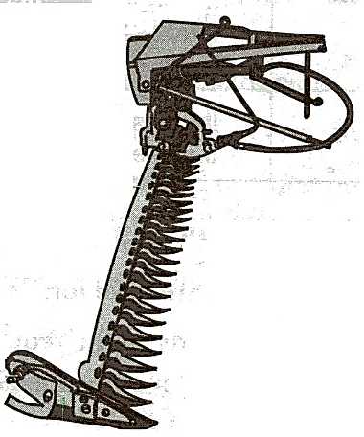
- Identify the implement illustrated in the diagram. (1mk)
…………………………………………………………………………………………………………………………………………………………….
- What is the method of power transmission for operating implements? (1mk)
…………………………………………………………………………………………………………………………………………………………….
- State the use of the implement. (1mk)
…………………………………………………………………………………………………………………………………………………………….
- Give two maintenance practices for implement A. (2mks)
………………………………………………………………………………………………………………………………………………………………………………………………………………………………………………………………………………………………………………………….
18 Below is a diagram of a rabbit hutch. Use the diagram to answer the questions that follow.
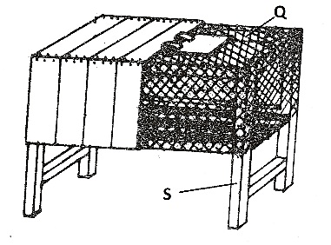
- How should the materials used for constructing parts Q and S be treated to last long?
(2mks)
…………………………………………………………………………………………………………………………………………………………………………………………………………………………………………………………………………………………………………………………
- Name the appropriate tools that should be used to cut the materials for constructing parts Q. (1mk)
…………………………………………………………………………………………………………………………………………………………….
- Give two reasons for raising the rabbit hutch above the ground level. (1mk)
…………………………………………………………………………………………………………………………………………………………………………………………………………………………………………………………………………………………………………………………
19 Below is an illustration of an internal parasite in livestock
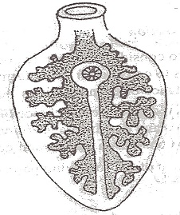
- Identify the parasite. (1mk)
…………………………………………………………………………………………………………………………………………………………….
- Name one final host for the parasite. (1mk)
…………………………………………………………………………………………………………………………………………………………….
- Name the intermediate host for the parasite. (1mk)
…………………………………………………………………………………………………………………………………………………………….
- State two control measures of the parasite. (2mks)
…………………………………………………………………………………………………………………………………………………………………………………………………………………………………………………………………………………………………………………………

20 The illustration below represents the digestive system of poultry. Study the illustration carefully and answer questions that follow.
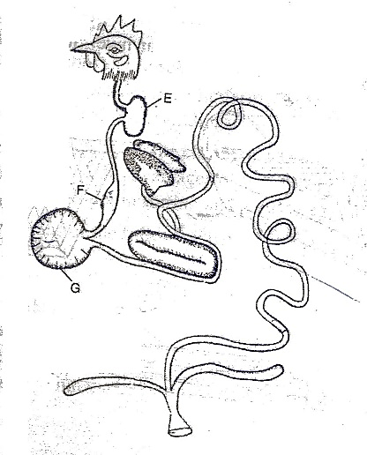
- Name the parts labeled E , F and G.
E……………………………………………………………………………………………………………………………......(1mk)
F………………………………………………………………………………………………………………………………….(1mk)
G………………………………………………………………………………………………………………………………...(1mk)
( b) State two ways in which the part labeled G is adapted to its function. (2mks)
…………………………………………………………………………………………………………………………………………………………………………………………………………………………………………………………………………………………………………………………
SECTION C (40 Marks)
Answer any two questions from this section in the spaces provided.
21 (a) Name the strokes in a four stroke cycle engine and describe how each operates. (12mks)
……………………………………………………………………………………………………………………………………………………………………………………………………………………………………………………………………………………………………………………………………………………………………………………………………………………………………………………………………………………………………………………………………………………………………………………………………………………………………………………………………………………………………………………………………………………………………………………………………………………………………………………………………………………………………………………………………………………………………………….……………………………………………………………………………………………………………………………………………………………………………………………………………………………………………………………………………………………………………………………………………………………………………………………………………………………………………………………………………………………………………………………………………………………………………………………………………………………………………………………………………………………………………………………………………………………………………………………………………………………………………………………………………………………………………………………………………………………………………….……………………………………………………………………………………………………………………………………………………………………………………………………………………………………………………………………………………………………………………………………………………………………………………………………………………………………………………………………………………………………………………………………………………………………………………………………………………………………………………………………………………………………………………………………………………………………………………………………………………………………………………………………………………………………………………………………………………………………………….
- Describe four physical characteristics that a poultry farmer would use to identify poor layers from a flock of hens. (8mks)
…………………………………………………………………………………………………………………………………………………………………………………………………………………………………………………………………………………………………………………………………………………………………………………………………………………………………………………………………………………………………………………………………………………………………………………………………………………………………………………………………………………………………………………………………………………………………………………………………………………………………………………………………………………………………………………………………………………………………………………………………………………………………………………………………………………………………………………………………………………………………………………………………………………………………………………………………………………………………………

22 (a) Describe the disease milk fever under the following sub headings:
- Animals affected (2mks)
…………………………………………………………………………………………………………………………………………………………………………………………………………………………………………………………………………………………………………………………
- Symptoms (5mks)
……………………………………………………………………………………………………………………………………………………………………………………………………………………………………………………………………………………………………………………………………………………………………………………………………………………………………………………………………………………………………………………………………………………………………………………………………………………………………………………………………………………………………………………………………………………………………………………………………………………………………………………………………………………………………………………………………………………………………………….
- Control measures (3mks)
………………………………………………………………………………………………………………………………………………………………………………………………………………………………………………………………………………………………………………………………………………………………………………………………………………………………………………………………………………………

b) Describe five calf management practices carried out immediately after parturition. (5mks)
……………………………………………………………………………………………………………………………………………………………………………………………………………………………………………………………………………………………………………………………………………………………………………………………………………………………………………………………………………………………………………………………………………………………………………………………………………………………………………………………………………………………………………………………………………………………………………………………………………………………………………………………………………………………………………………………………………………………………………………………………………………………………………………………………………………………………………………………………………………………………………………………………………………………………………………………………………………………………………………………………………………………………………………………………………………………………………………………………….
c) Outline five qualities of eggs for marketing. (5mks)
…………………………………………………………………………………………………………………………………………………………………………………………………………………………………………………………………………………………………………………………………………………………………………………………………………………………………………………………………………………………………………………………………………………………………………………………………………………………………………………………………………………………………………………………………………………………………………………………………………………
23 (a) State and explain five harmful effects of parasites in livestock. (10mks)
………………………………………………………………………………………………………………………………………………………………………………………………………………………………………………………………………………………………………………………………………………………………………………………………………………………………………………………………………………………………………………………………………………………………………………………………………………………………………………………………………………………………………………………………………………………………………………………………………………………………………………………………………………………………………………………………………………………………………………………………………………………………………………………………………………………………………………………………………………………………………………………………………………………………………………………………………………………………………….
b) Describe any five parts and functions of a Zero grazing unit. (10mks)
…………………………………………………………………………………………………………………………………………………………………………………………………………………………………………………………………………………………………………………………………………………………………………………………………………………………………………………………………………………………………………………………………………………………………………………………………………………………………………………………………………………………………………………………………………………………………………………………………………………………………………………………………………………………………………………………………………………………………………………………………………………………………………………………………………………………………………………………………………………………………………………………………………………………………………………………………………………………………………

