NAME ------------------------------------------------------------------ INDEX NO---------------------------------
DATE_________________________ CANDIATES SIGNATURE _____________

443/1
AGRICULTURE
FORM 4 pp 1
TIME: 2 HRS

TERM 1

Answer all the questions in this section in the spaces provided
1a)Distinguish between flood irrigation and basin irrigation (1mk)

b) Give two maintenance practices required in flood irrigation system. (1mk)

2) State the fate of water added to soil in crop field. (2mks)

3a)Name two crops which after harvesting are processed using a flail. (1mk)

b) What name is give to the practice in 3a above. (1/2mk)

4State two conditions under which opportunity cost can be zero. (2mks)

5. Shown below is part of a record found in Nyali farm
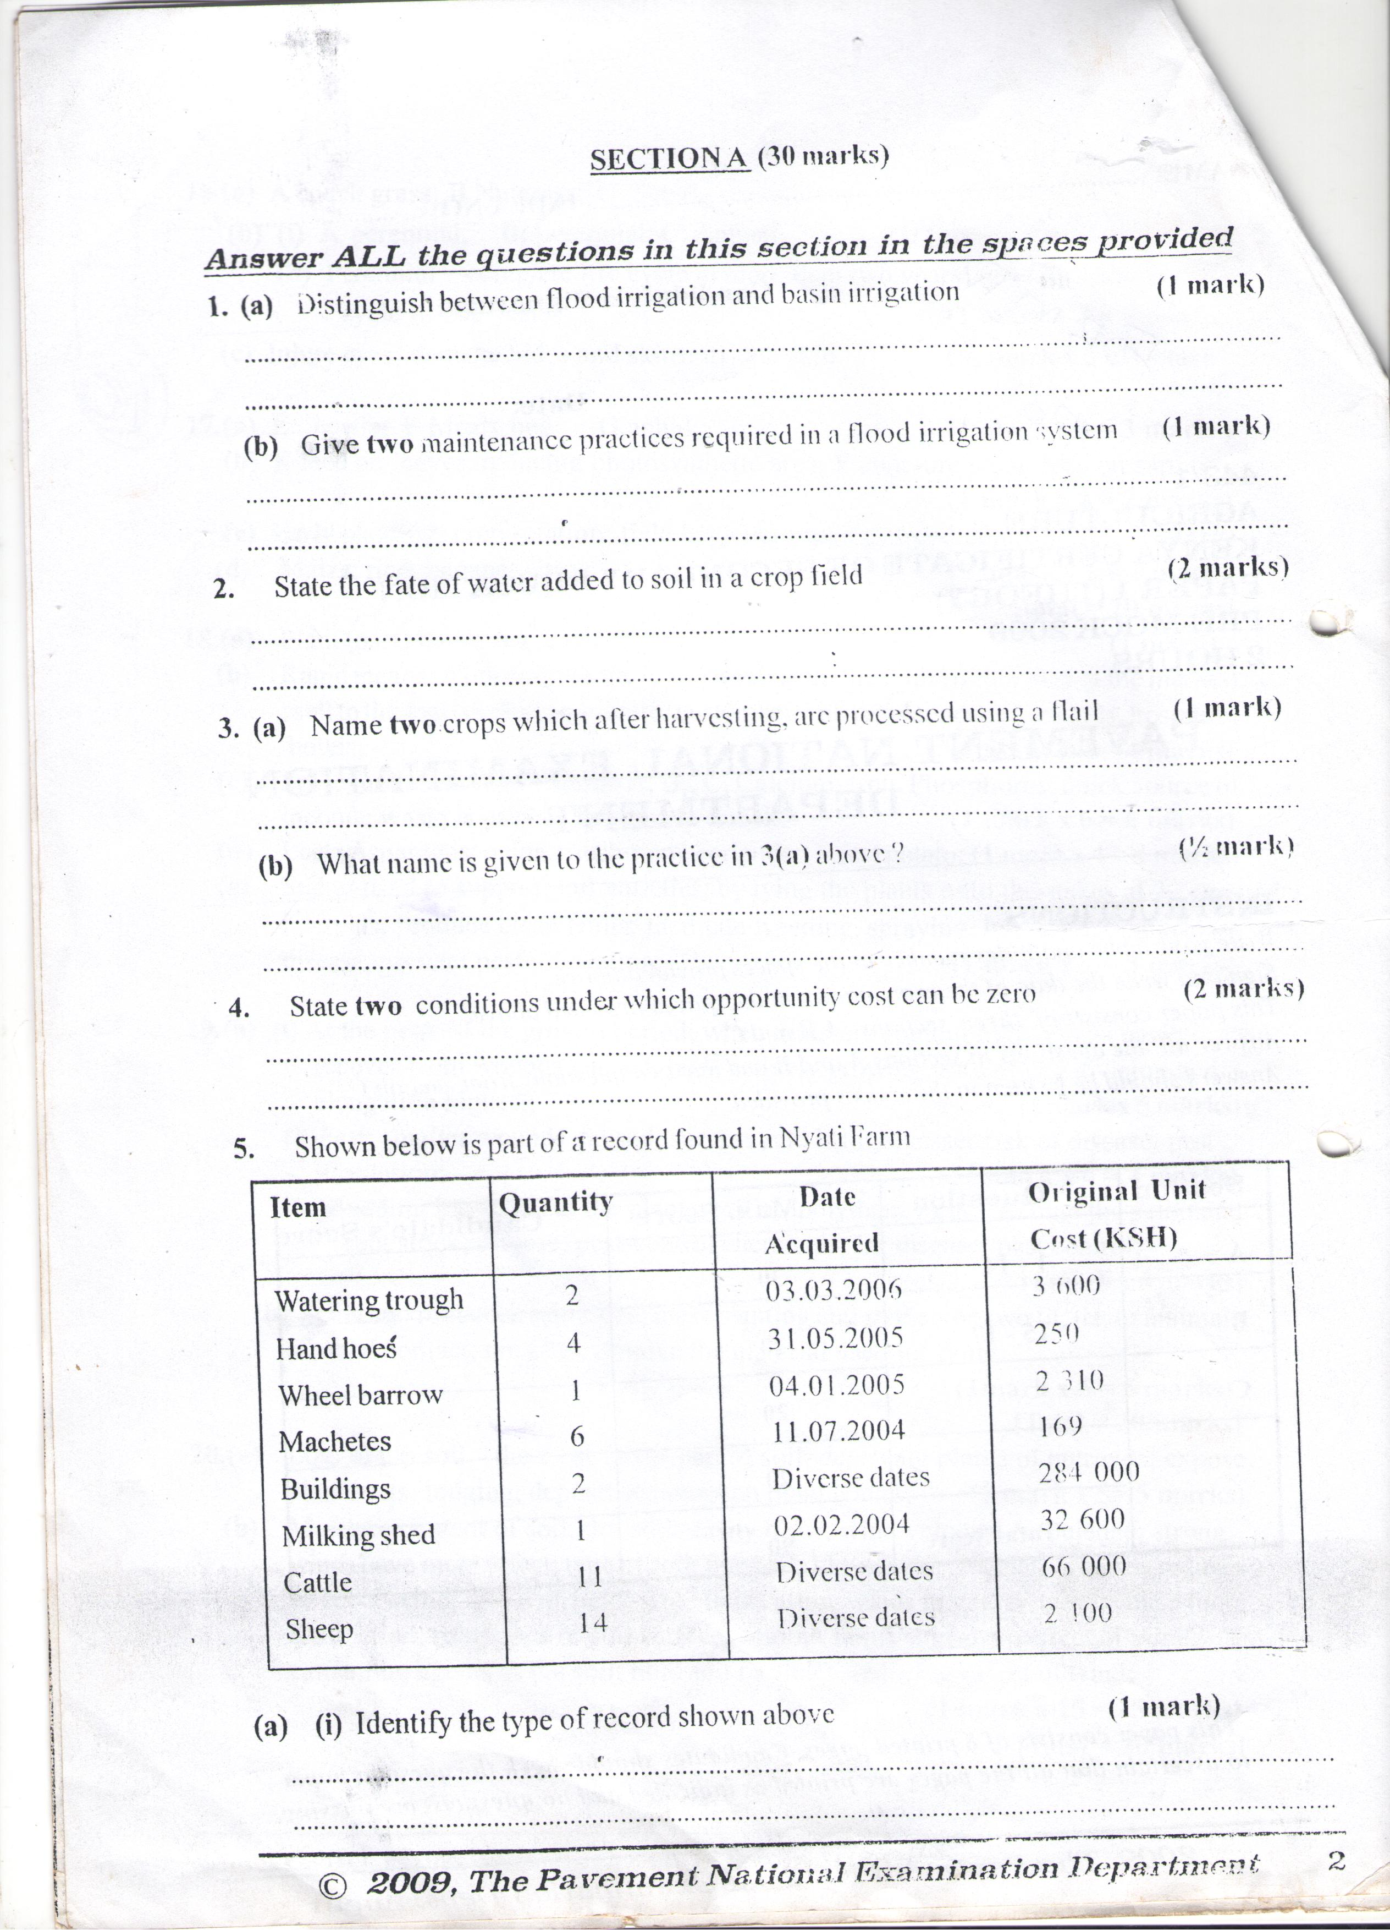
a)i Identify the type of record shown above. (1mk)

ii) Give reason for your answer to a (i) above. (1mk)

b)What other column should be added to this record, to make it complete. (1mk)

6Give two disadvantages associated with burning as a land clearing method. (1mk)

7(a)Name three components of rooting mixture used in polythene sleeves in raising tree seedlings. (3mks)

b) State two benefits of using polythene sleeves, in raising tree seedlings. (2mks)

8. a)Define tissue culture. (1mk)

bGive three advantages of tissue culture

9. Shown below is the average yield and total digestible nutrients (TDN) per hectare of hay cut in June July, August and September

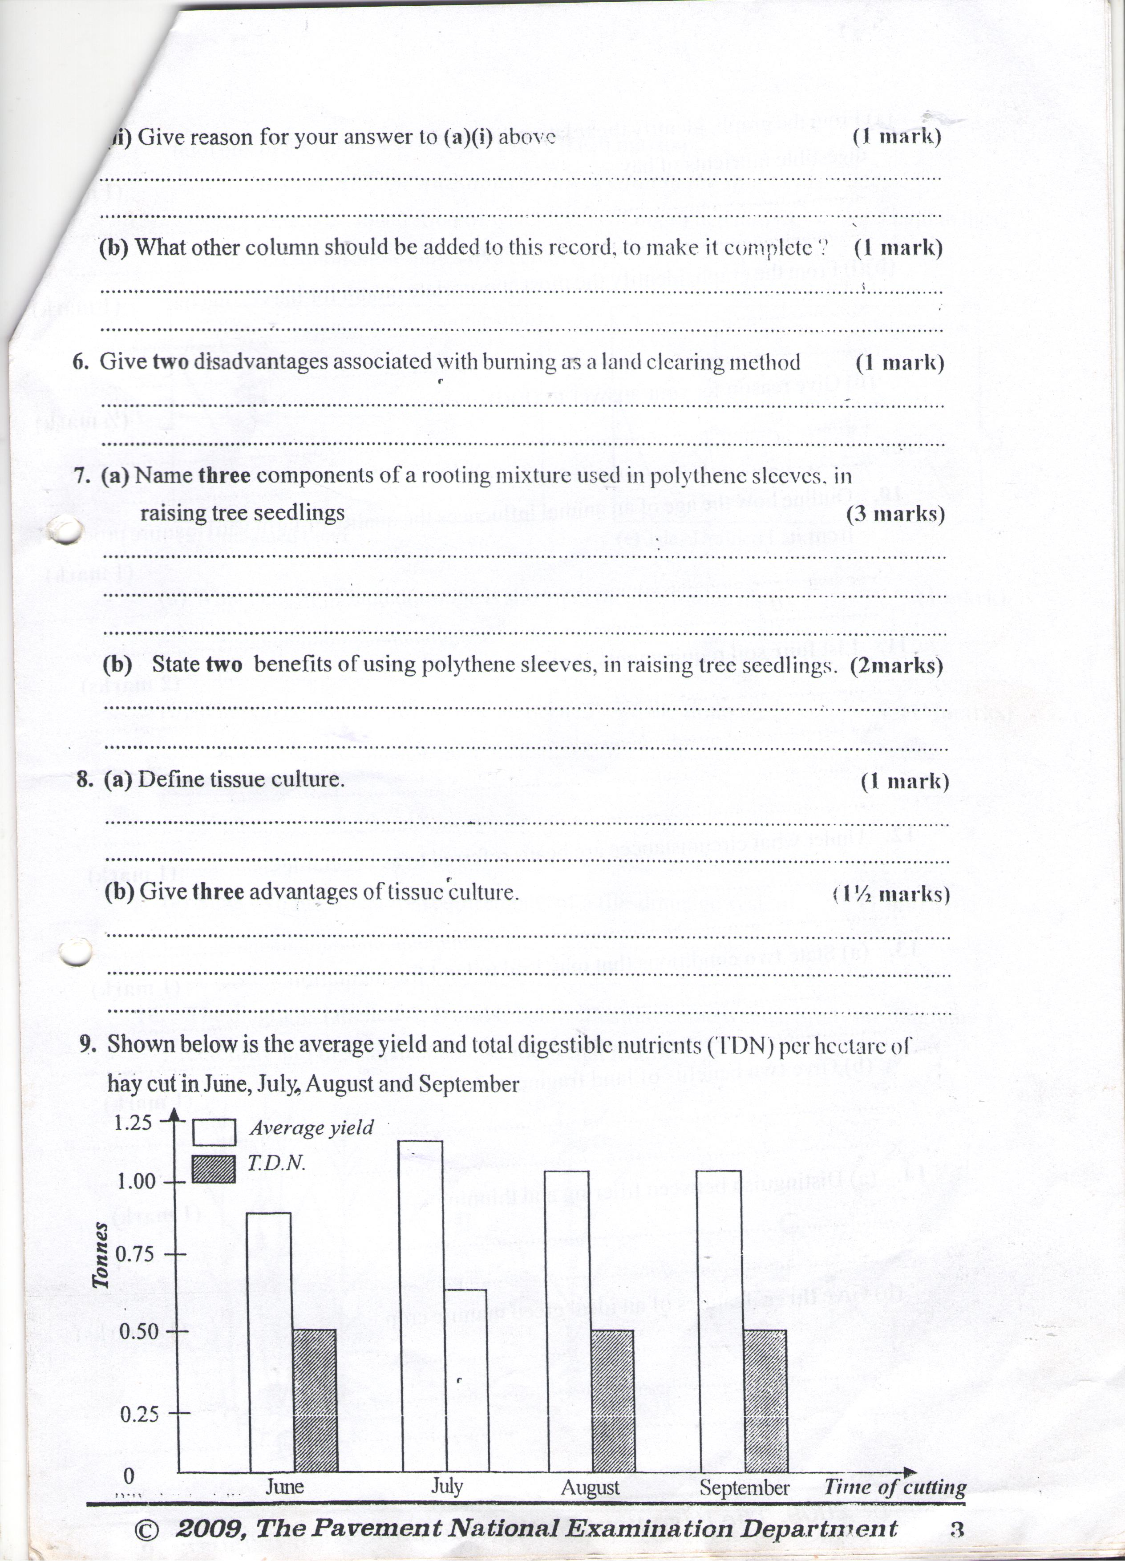

a)From the graph identify the relationship between average yield and total digestible nutrients of hay. (1mk)

- From the graph, identify the most appropriate month of harvesting hay. (1mk)

10. Outline how the age of an animal influences the quality of farm yard manure production form it. (1mk)

11. List four soil requirements for tomatoes. (2mks)

12. Under what circumstance are beans referred to as vegetables. (1mk)

13a) State two conditions that may lead to land fragmentation. (1mk)

b) Give two benefits of land fragmentation. (1mk)

14a) Distinguish between tillering and thinning. (1mk)

b) Give three features of an ideal green manure crop. (11/2 mks)

SECTION B (20MKS)
15 Given below is an illustration of water levels of undrained and tile – drainage land in the sowing and maturation stage of cereal crop
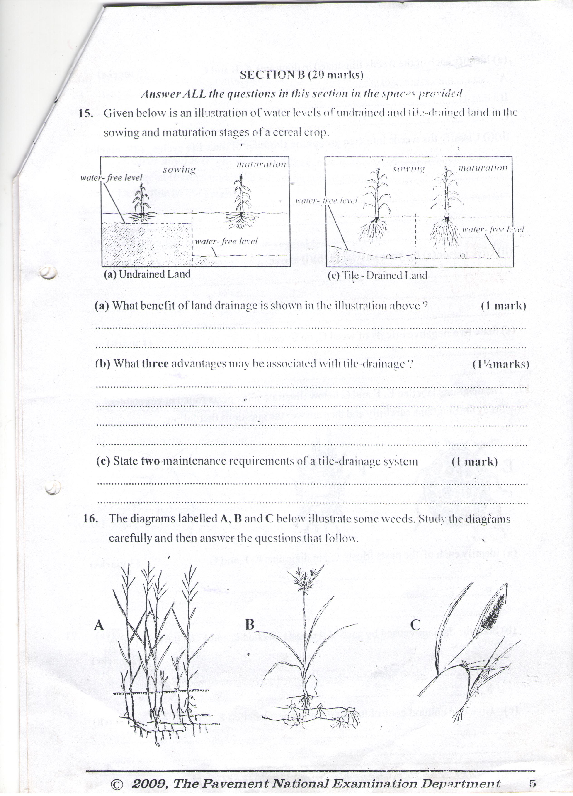
- What benefit of land drainage is shown in the illustration above? (1mk)

- What three advantages may be associated with tile-drainage? (11/2mks)

- State two maintenance requirements of tile-drainage system. (1mk)

16. The diagrams labeled A,B and C below illustrate some weeds. Study the diagrams carefully and then answer the questions that follow.
- Identify each of the weeds illustrated in diagram A,B and C. (3MKS)
A

B

C
B)i Classify the weeds into two groups, on the basis of their life cycles. (21/2marks)

ii) Give reasons for you answer in (bi) above. (3mks)

c)State two negative effects of weed C, on livestock. (1mk)

17. The diagram labeled E, F and G below illustrate some pest found in vegetables study the diagrams carefully and then answer the questions that follow
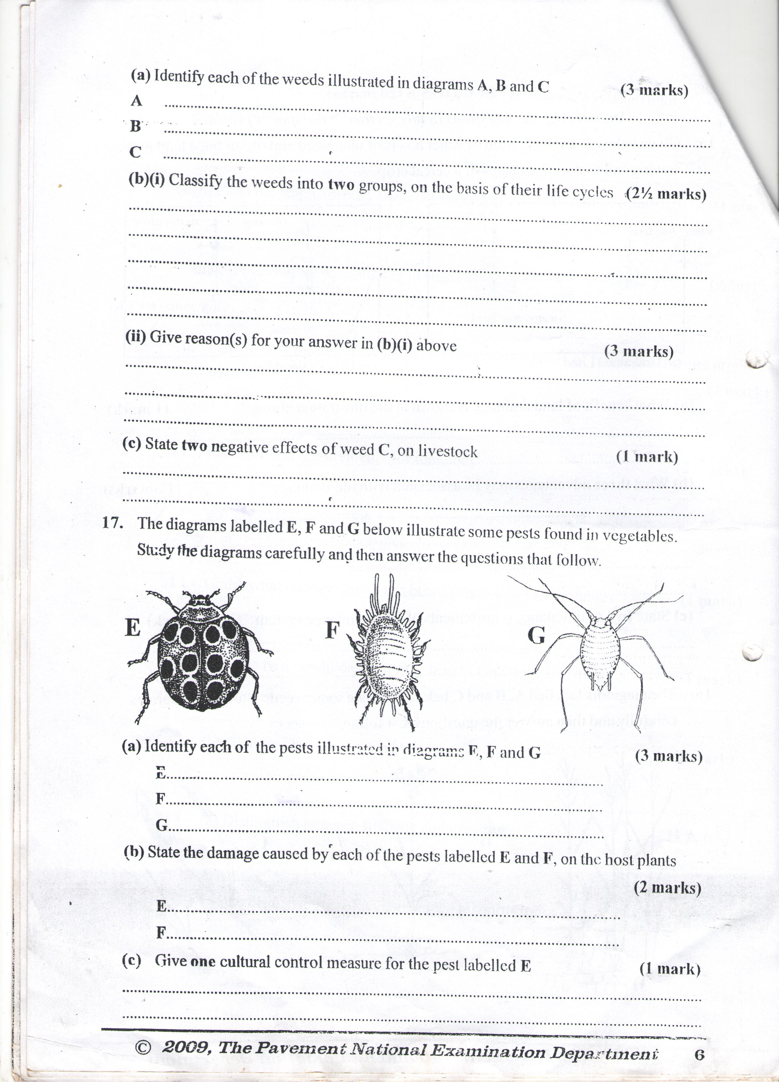
- Identify each of the pest illustrate in diagram E,F, and G. (3MKS)

B) State the damage caused by each of the pest labeled E and F, on the host plants. (mksa_

c)Give one cultural control measure for the pest labeled E (1mk)

- Other than vegetables name two crop plants that may be infested with the pest labeled G

SECTION C (40MKS)
Answer an two question in this section the space provided
18Discuss vegetable crops under the following sub- headings
a)Definition of vegetable. (1mk)

b)Management of perishability vegetables. (4mks)

c)Importance of vegetables. (6mks

d)Common stem vegetables. (4mks)

e)Staking in tomatoes. (5mks)

19a) Discuss budding a applied in crop production under the following sub-headings
- Timing (5mks)

- Advantages over grafting. (4mks)

- Materials used. (6mks)

- Briefly describe whip grafting. (5mks)

20 Discuss wind erosion under the following sub- headings
a)Destructive effects of wind erosion on crop plants. (5mks)

- Factors affecting susceptibility of soil to wind erosion. (15mks)

