AGRICULTURE PAPER 2
FORM 4

NAME ……………………………………………… ADM …………………………
CLASS …………………………..

- State four mechanical methods of controlling ticks. (4mks)

- Give two examples of feed addicted in cattle. (1mk)

- Name the mineral deficiently that causes each of the following condition in livestock.
Grass stagger (Tetany) (1/2mk)

Milk fever/parturient parensis (1/2mk)

- Name two hormones produced in a lactating cow. (2mks)

- What is referred to as a ‘ Notifiable disease’ (1mk)

b) Name four examples of notifable diseases in livestock. (2mks)

- Outline three pre-disposing factors of footrot disease in sheep.(1 ½ mks)

- List any four metal work tools and equipment used in the farm. (2mks)

- Outline four qualities of eggs for incubation. (2mks)

- State four prophylactic measures used by a farmer to control livestock diseases. (2mks)

- Give three methods of feeding colostrums to newly born calves. (1 ½ mks)

- A) Define the term “zoonote disease.” (1mk)

b) Give two examples of zoonote diseases. (1mk)

- List three advantages of hedges. (1 ½ mks)

- Why is it necessary to provide grit to birds? (1mk)

- State four good qualities of honey. (2mks)

- State two causes of soft shell in eggs. (1mk)

- Name three methods of livestock selection. (1 ½ mks)

- Name a tool used for tightening barbed wires during fencing. (1mk)

SECTION B. (Answer all the questions.)
- Study the diagram of an egg below and answer the question that follow.

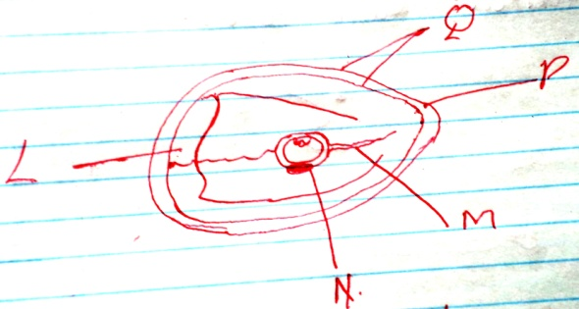

- Name the parts labeled N,Q and P. (1 ½ mks)
N
Q
P

- State the function of the parts labeled M and L. (1 ½mks)

- Why should the egg be turned during incubation. (1mk)

- State four reasons of treating timber. (4mks)

- Below are the diagrams of workshop tools H, J and Q. Study them and answer the question that follow.
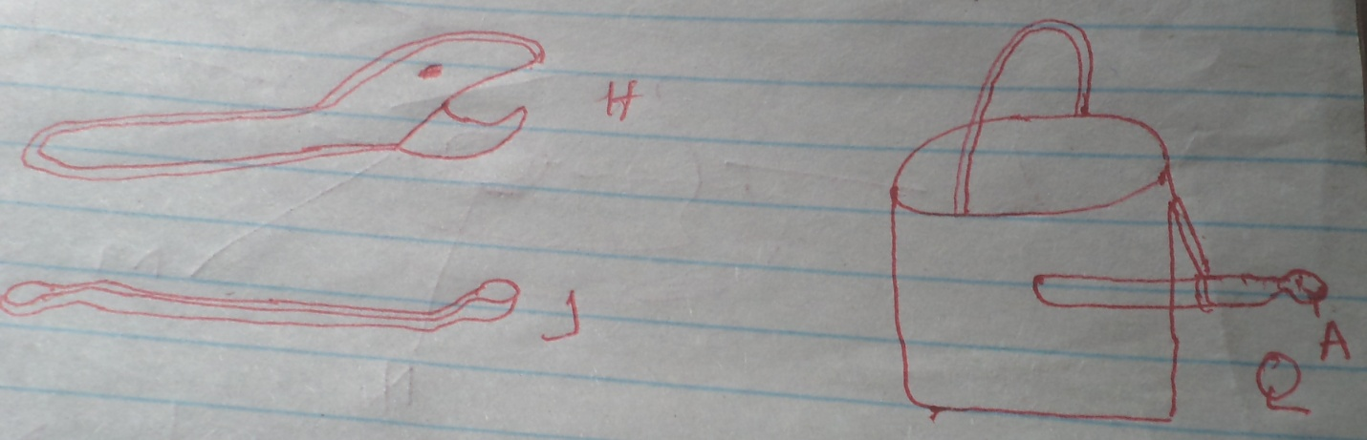

- Identify each tool. (1 ½ mks)
H

J

Q

- What functional advantages does H have over J. (1mk)

- Why is the part labeled H an important component of watering can. (1mk)

- Below is a diagram of a certain farm structure. Use it to answer the questions that follow.

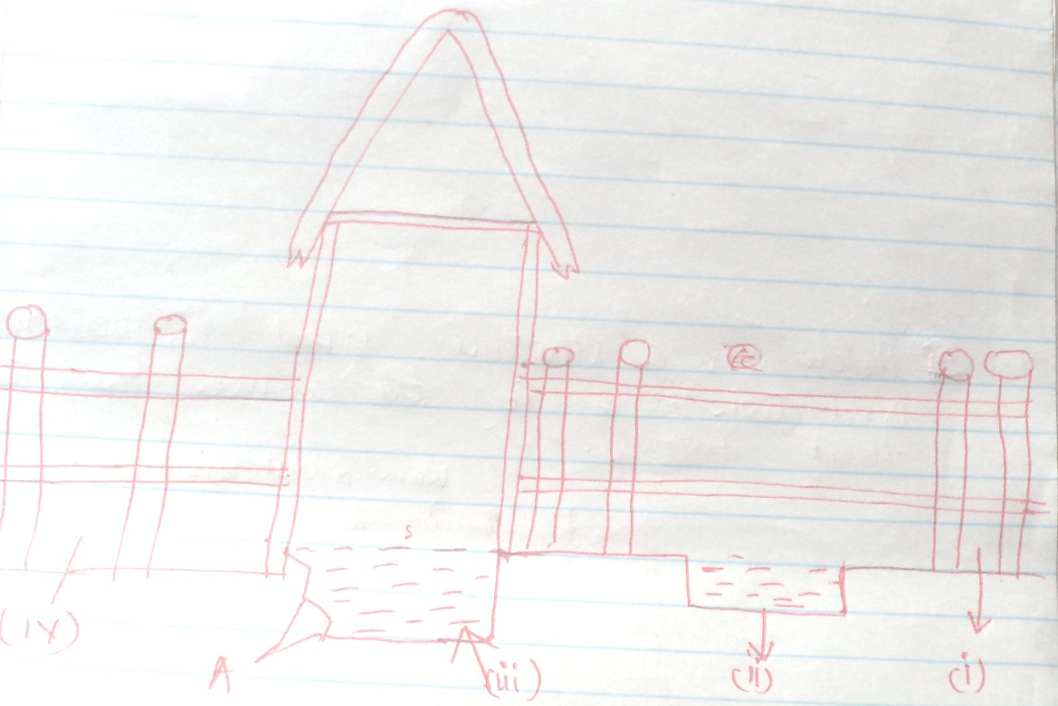

- Name the parts labelled.

ii.
iii.
iv.
- Identify the part labeled A.(1/2 mk)

- Give the function of the part labeled A.(1/2 mk)

- State two maintenance practice carried out in part (ii) above. (2mks)

- Below is a structure used in poultry production. Use it to answer the questions that follow.
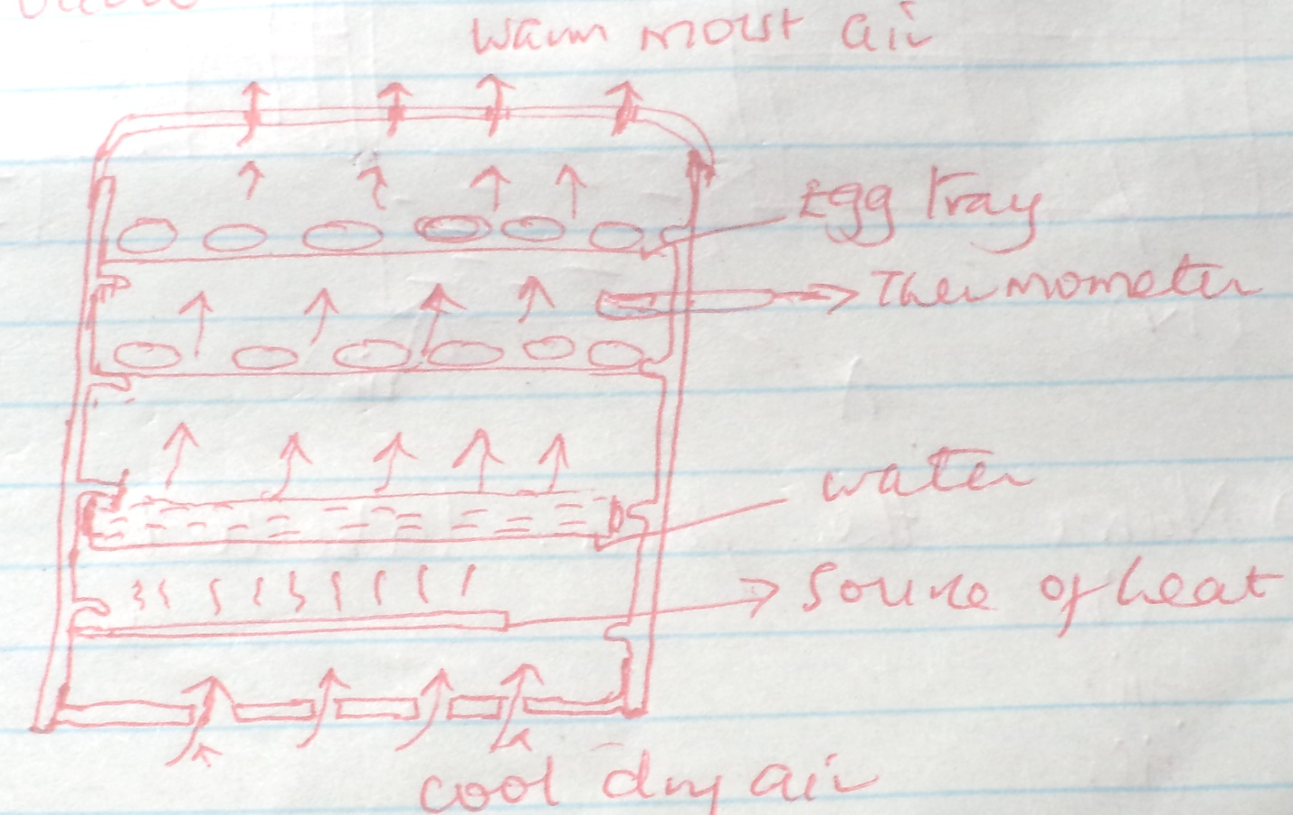

- Identify the structure. (1mk)

- State the main function of the structure. (1mk)

- Give the function of the following in the structure.
Water (1/2 mk)

Thermometer (1 /2 mk)

SECTION C
Answer any two questions in this section.

- A) Outline the use of fence in the farm. (10mks)

b) Discuss the tractor transmission system. (10mks)

- A) Discuss foot and mouth disease under the following sub-headings.
Animal affected. (2mks)

Methods of transmission. (2mks)

Symptoms of attack. (4mks)

Control measures. (2mks)

b. Outline general control measures of livestock parasites. (10mks)

- Outline the various methods of maintaining farm tools and equipment. (8mks)

b. Describe artificial rearing of layer chicks from day one to end of brooding. (12mks)

