Name: ……………………………………………................................ Adm No…………………...…………..................
School: …………………………………………………………………………. Candidate’s sign ……………………...............
Class………………………………………….…..………………………………
AGRICULTURE 443/2
AUGUST 2022
TIME: 2 HOURS
FORM THREE MOKASA II MOCK
Kenya Certificate of Secondary Education (K.C.S.E.)
Agriculture
Paper 2
INSTRUCTIONS TO CANDIDATES:
- Write your name and index number in the spaces provided above.
- Sign and write the date of examination in the spaces provided above.
- This paper consists of three sections A, B and C.
- Answer all the questions in section A and B.
- Answer any two questions in section C.
- All answers should be written in the spaces provided.
- This paper consists of 12 printed pages.
- Candidates should check the question paper to ascertain that all the pages are printed as indicated and that no questions are missing.
- Candidates should answer all the questions in English.
For Examiner’s Use Only:
SECTION | QUESTIONS | MAXIMUM SCORE | CANDIDATES SCORE
A | 1-17 | 30
B | 18-21 | 20
C |  | 20
 |  | 20
 | TOTAL SCORE | 90

SECTION A (30MKS)
Answer all the questions in the spaces provided below
- Name four breeds of rabbits. (2mks)
……………………………………………………………………………………………………………………………………………………………………………………………………………………………………………………………………………………………………………………………………………………………………………………………………………………………………………………………………………………………………………………………………………………………………………………………………………………………………………………………………………………………………………………
- Give four field conditions where animal drawn implements are useful than tractor drawn implements. (2mks)
……………………………………………………………………………………………………………………………………………………………………………………………………………………………………………………………………………………………………………………………………………………………………………………………………………………………………………………………………………………………………………………………………………………………………………………………………………………………………………………………………………………………………………………
- State two functions of carbohydrates in animal body. (2mks)
………………………………………………………………………………………………………………………………………………………………………………………………………………………………………………………………………………………………
- State four disadvantages of fold unit of rearing poultry. (2mks)
……………………………………………………………………………………………………………………………………………………………………………………………………………………………………………………………………………………………………………………………………………………………………………………………………………………………………………………………………………………………………………………………………………………………………………………………………………………………………………………………………………………………………………………
- Give two reasons why layers lay soft shelled eggs. (1mk)
………………………………………………………………………………………………………………………………………………………………………………………………

- State four management practices that should be carried out during the mating season in sheep. (2mks)
……………………………………………………………………………………………………………………………………………………………………………………………………………………………………………………………………………………………………………………………………………………………………………………………………………………………………………………………………………………………………………………………………………………………………………………………………………………………………………………………………………………………………………………
- Give two reasons of spreading a polyethene sheet (PVC) on the slab of farm buildings during construction. (1mk)
………………………………………………………………………………………………………………………………………………………………………………………………………………………………………………………………………………………………
- State four features of a good maize granary. (2mks)
……………………………………………………………………………………………………………………………………………………………………………………………………………………………………………………………………………………………………………………………………………………………………………………………………………………………………………………………………………………………………………………………………………………………………………………………………………………………………………………………………………………………………………………
- State four reasons why wind power is not commonly used on the farm.
(2mks)
……………………………………………………………………………………………………………………………………………………………………………………………………………………………………………………………………………………………………………………………………………………………………………………………………………………………………………………………………………………………………………………………………………………………………………………………………………………………………………………………………………………………………………………

- State the functional difference between a cold chisel and a wood chisel.
(1mk)
…………………………………………………………………………………………...………………………………………………………………………………………….…………………………………………………………………………………………..
- State four factors that affect the digestibility of feeds in livestock. (2mks)
……………………………………………………………………………………………………………………………………………………………………………………………………………………………………………………………………………………………………………………………………………………………………………………………………………………………………………………………………………………………………………………………………………………………………………………………………………………………………………………………………………………………………………………
- State two methods of preserving fish. (1mks)
……………………………………………………………………………………………………………………………………………………………………………………………………………………………………………………………………………………
- Outline four ways which farmers can use to prevent mastitis in a herd of dairy cattle. (2mks)
……………………………………………………………………………………………………………………………………………………………………………………………………………………………………………………………………………………………………………………………………………………………………………………………………………………………………………………………………………………………………………………………………………………………………………………………………………………………………………………………………………………………………………………
- State four functions of a worker bee in the hive. (2mks)
……………………………………………………………………………………………………………………………………………………………………………………………………………………………………………………………………………………………………………………………………………………………………………………………………………………………………………………………………………………………………………………………………………………………………………………………………………………………………………………………………………………………………………………

- State four properties of a concrete that makes it popular in construction of a farm structure than timber. (2mks)
……………………………………………………………………………………………………………………………………………………………………………………………………………………………………………………………………………………………………………………………………………………………………………………………………………………………………………………………………………………………………………………………………………………………………………………………………………………………………………………………………………………………………………………
- State four advantages of embryo transplant in livestock. (2mks)
……………………………………………………………………………………………………………………………………………………………………………………………………………………………………………………………………………………………………………………………………………………………………………………………………………………………………………………………………………………………………………………………………………………………………………………………………………………………………………………………………………………………………………………
- State four factors that would contribute to the depreciation pf a fam equipment. (2mks)
……………………………………………………………………………………………………………………………………………………………………………………………………………………………………………………………………………………………………………………………………………………………………………………………………………………………………………………………………………………………………………………………………………………………………………………………………………………………………………………………………………………………………………………

SECTION B (20 MARKS)
Answer all questions in this section in the spaces provided.

- The diagram below is a cross section of part of a cow`s udder

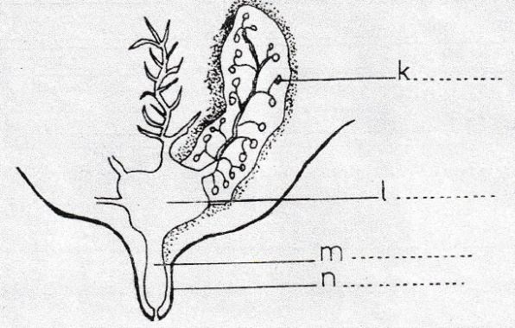

(a) Label, on the diagram, the parts marked K, L,M and N (2mks)
K……………………………………………………………………………………………L……………………………………………………………………………………………M……………………………………………………………………………………………N……………………………………………………………………………………………
(b) Define milk let-down. (1mk)
………………………………………………………………………………………………………………………………………………………………………………………………
(c)(i) Which hormone stimulate milk let-down (1mk)
………………………………………………………………………………………………………………………………………………………………………………………………
(ii) Which hormone stimulate milk synthesis (1mk)

………………………………………………………………………………………………………………………………………………………………………………………………

- The diagram below illustrates a foundation of a farm structure, study it and answer questions that follow.

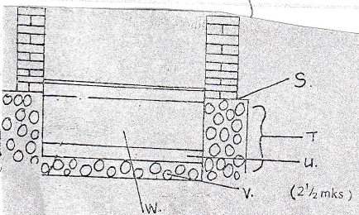

- Name the part (2mks)
S………………………………………………………………………………………...
T………………………………………………………………………………………...
U………………………………………………………………………………………...
W………………………………………………………………………………………..
- State three properties of concrete that make it popular in construction of farm structure than timber. (3mks)
………………………………………………………………………………………………………………………………………………………………………………………………………………………………………………………………………………………………………………………………………………………………………………………………………………………………
- Study the illustration of a tractor transmission system shown below and answer the questions that follow.

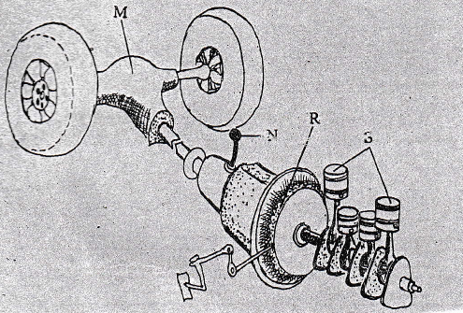

- Name the parts labelled M, N, R and S shown above. (2mks)
M……………………………………………………………………………………….
N………………………………………………………………………………………...
R………………………………………………………………………………………...
S………………………………………………………………………………………...
- State the functions of the part labelled. (3mks)

- R………………………………………………………………………………...
- M………………………………………………………………………………..

- (a)Study the illustration below and answer questions that follow.

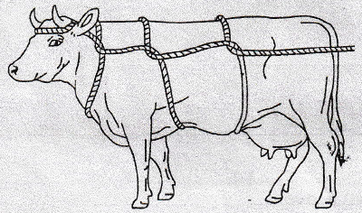

- Identify the practice demonstrated in the illustration above. (1mk)
…………………………………………………………………………………………….………………………………………………………………………………...
- Give one condition under which the method above cannot be used. (1mk)
………………………………………………………………………………………………………………………………………………………………………………
(b ) Study the illustration of workshop tools and answer questions that follow.
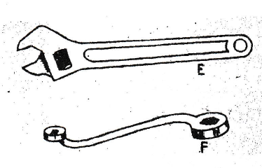

- (i) Identify the tools labelled E and F. (1mk)

E………………………………………………………………………………………...
F………………………………………………………………………………………
- Give the functional advantage that E over F (1mk)
………………………………………………………………………………………………………………………………………………………………………………………………………………………………………………………………………

SECTION C (40 Marks)
Answer any two questions in this section.
22.(a) Describe the procedure of dressing a broiler for sale. (8mks)
(b) Describe the uses of fences on the farm. (7mks)
(c) state five indicators that can be observed on a goat to confirm sickness. (5mks)
23.(a) Describe Foot and Mouth under the following sub-headings
- Causative agent. (1mk)
- Animals affected. (2mks)
- Symptoms (4mks)
- Control measures. (3mks)
(b). Describe the life cycle of a liver fluke. (6mks)
(c) Outline four general characteristics of beef cattle breeds. (4mks)
24.(a) Explain six differences between a two-stroke and four-stroke cycle engine. (6mks)
(b) Outline eight factors considered when selecting materials for construction of farm structures. (8mks)
(c) Describe six factors considered when selecting goat for breeding. (6mks)
………………………………………………………………………………………………..…………………………………………………………………………………………………..…………………………………………………………………………………………………..…………………………………………………………………………………………………..…………………………………………………………………………………………………..…………………………………………………………………………………………………..…………………………………………………………………………………………………..…………………………………………………………………………………………………..…………………………………………………………………………………………………..…………………………………………………………………………………………………..…………………………………………………………………………………………………..…………………………………………………………………………………………………..…………………………………………………………………………………………………..……………………………..……………………………………………………………………..………………………..…………………………………………………………………………..…………………..………………………………………………………………………………..……………..……………………………………………………………………………………..………...……………………………………………………………………………………………………………………………………………………………………………………………………………………………………………………
………………………………………………………………………………………………..……………………………………………………………………………………………...………..……………………………………………………………………………………...……………..……………………………………………………………………………….…………………..…………………………………………………………………………..………………………..……………………………………………………………………………………………………………………………………………………………………………………………………………………………………………………………………..…..……………………………..………………………………………………………….………………………………………..…………………………………………………….……………………………………………..……………………………………………….…………………………………………………..………………………………………….………………………………………………………..…………………………………….……………………………………………………………..……………………………….…………………………………………………………………..………………………….………………………………………………………………………..…………………….……………………………………………………………………………..……………….…………………………………………………………………………………..………….………………………………………………………………………………………..…….…………………………………………………………………………………………………………………………………………………………………………………………………..…………………………………………………………………………………………..………..……………………………………………………………………………………..………...……..……………………………………………………………………………...………….......................................................................................
………………………………………………………………………………………………..…………………………………………………………………………………………….……..……………………………………………………………………………………….…………..…………………………………………………………………………………………………..…………………………………………………………………………………………………..…………………………………………………………………………………………………..…………………………………………………………………………………………………..…………………………………………………………………………………………………..…………………………………………………………………………………………………..…………………………………………………………………………………………………..…………………………………………………………………………………………………..……………………………………….…………………………………………………………..………………………………….………………………………………………………………..…………………………….……………………………………………………………………..……………………….…………………………………………………………………………..………………….………………………………………………………………………………..…………….……………………………………………………………………………………..………...…………………………………………………………………………………………..….………………………………………………………………………………………………..……………………………………………………………………………………………..……..………………………………………………………………………………………..…………..…………………………………………………………………………………..………………..………………………………………………………………………
………………………………………………………………………………………………...…………………………………………………………………………………………….…….
………………………………………………………………………………………………..……………………………………………………………………………………………..……..………………………………………………………………………………………..…………..…………………………………………………………………………………..………………..……………………………………………………………………………..……………………..………………………………………………………………………..…………………………..…………………………………………………………………..………………………………..……………………………………………………………..……………………………………..………………………………………………………..…………………………………………..…………………………………………………..………………………………………………..…………………………………………………………………………………………………..…………………………………………………………………………………………………..………………………………….………………………………………………………………..…………………………….……………………………………………………………………..……………………….…………………………………………………………………………..………………….………………………………………………………………………………..…………….……………………………………………………………………………………..……….…………………………………………………………………………………………..….………………………………………………………………………………………………..…………………………………………………………………………………………….……..…………………………………………………………
………………………………………………………………………………………………..…………………………………………………………………………………………….……..
………………………………………………………………………………………………..……………………………………………………………………………………………..……..………………………………………………………………………………………..…………
………………………………………………………………………………………………..……………………………………………………………………………………………..………………………………………………………………………………………………………………………………………………………………………………………………………………………………………………………………………………………………………………………………………………………………………………………………………………………………………………………………………………………………………………………………………………………………………………………………………………………………………………………………………………………………………………………………………………………………………………………………………………………………………………………………………………………………………………………………

