NAME...............................................................................CLASS..........................
INDEX NO.........................................SIGN...................... DATE........................
231/1
BIOLOGY
PAPER 1 MARKING SCHEME
OCTOBER 2022
TIME: 2 HOURS
MOKASA II
JOINT EXAMINATION-2022
KENYA CERTIFICATE OF SECONDARY EDUCATION (K.C.S.E)
FORM FOUR.
Instructions
- Write your name, class and admission number in the space provided above.
- Write the date of the examination and sign in the space provided above.
- Answer all the questions in the spaces provided.
- You may be penalized for wrong spelling especially technical terms.

For Examiner’s Use Only
Question | Maximum Score | Candidate’s Score
1-30 | 80

This paper consists of 13 printed pages. Candidates should check the question paper to ascertain that all the pages are printed as indicated and no questions are missing

- (a) How would you proof that a species of wildbeest in Tanzania belongs to the same species as a similar looking wildbeest in Kenya (1 mark)
If they can interbreed to produce a viable/fertile offspring;
(b) State two principles of Binomial Nomenclature.(2 marks)i. The generic name is first written followed by the specific name;
ii. The first letter in the generic name must be a capital letter and the rest are small letters;
iii. The two parts of the name are underlined separately when typed or hand written. In printed manuscripts should be in italics; Mark first 2
2. Explain how altitude may affect the rate of breathing (2marks)
Rate of breathing increase with increase in altitude; oxygen concentration in the air decrease with increase in altitude;
- The diagrams below show disorders arising frommutation
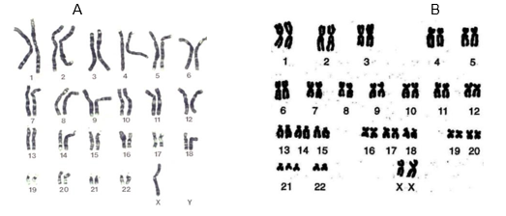
- Identify the genetic disordersshown above (2marks)
ATurners syndrome
B Downs syndrome
- Name the type of mutation responsible forthesedisorders (1mark)
Chromosomal mutation
- a) Define the term genetic engineering (1mark)

Is the artificial manipulation of genetic material by transferring gene(s) from one organism to another to achieve desired characteristics
b) State two disadvantages of genetically modified maize (2marks)
- Cross pollination may occur with weeds/other species
- People may become over reliant on genetically modified seed companies
- High cost of development
- Reduce biodiversity
- Not all countries can afford genetically modified seed
- The diagram below illustrates the relationship between variation in atmospheric temperature in the course of day and the body temperature of two animals A and B.
Study it and answer the questions that follows;
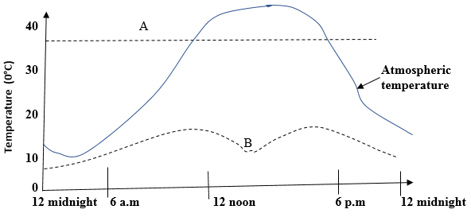
- What is the biological term used to describe animal type:,
A Endothermic (1mark)
BEctothermic(1mark)
- List three possible mechanisms that animals A may be regulating body temperature between 12.00 midnight and 9.00 a.m (3marks)
Vasoconstriction
Erector pili muscle contract and hair stand uptrighr
Increased metabolism
Shivering
- Suggest one way in which animal B uses to regulate its body temperature between 12:00 noon and 6:00 p.m (1mark)
Under shade/ rock
Barrowing
- State two adaptations of a guard cell to its function (2 marks)
Thick inner wall curve inwards while thin outer wall curve outwards causing opining of stomata
It contains chlorophyll that traps light that is use for photosynthesis
- Name two forces that maintains transpiration stream (2 marks)
Transpiration pull
Capillarity
Cohesive and adhesive forces
Root pressure

- a)Give two features of osmosis that justify this statement ‘‘Osmosis is a special type of diffusion”
(2 marks)Involves movement of water molecules only;
A semi permeable membrane must be present;

b) What is the importance of a cell membrane in active transport(2mrks)
Contain protein carrier molecules ;that transport ions across a semi-permeable membrane
9. (a) State a characteristic of an efficient respiratory surface which is absent in amoeba (1mark)Possession of a dense network of blood capillaries;
(b) Name the gaseous exchange structure in breathing roots (1mark)Lenticels/pores;
(c) Which muscles contract to cause air to pass out of the lungs through bronchioles? (1mark)Internal intercostal muscles;
- Phylum Arthropoda is divided into five main classes. State threecharacteristics used for their classification (3mks)
iNumber of limbs
- Presence and number of antennae
- Number of body parts
- Types of eyes
11. State the function of spiral bands of chitin in the trachea of terrestrial insects (1mark)Keeps the trachea open
12. Although air has more oxygen than water, fish cannot live outside water.
Explain. (2marks)When out of water, gill filaments stick together; thus reducing the surface area over which gaseous exchange takes place;
13. Nutrition is an important physiological process in living things. State the significance of the following in plant nutrition.(2mks)
- Root hairs
Absorption of water for photolysis during photosynthesis
- Stomata
Enables diffusion of carbon IV oxide gas for photosynthesis

14. The figure below shows a biological reaction between an enzyme molecule and a substrate molecule.
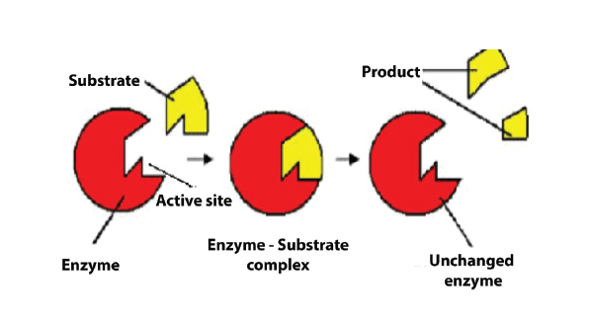
State two properties of the enzyme shown in the biological reaction above (2marks)Substrate specific
They are not used up during chemical reaction/destroyed/altered
15. The graph below represents the effect of temperature on the rate of photosynthesis
a) Label the axes on the diagram (1mk)
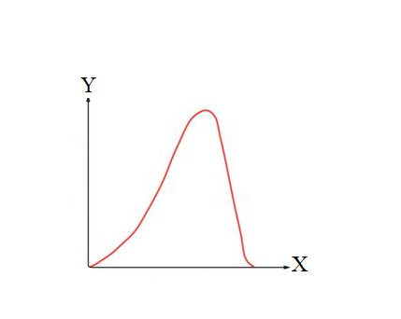

b) Comment on the general trend of the graph (3marks)
The rate of photosynthesis increases with increase in temperature upto optimim due to enzymes being active;after which the rate reduces as enzymes are denatured by temperatures above optimum.
16. A rhinocerous in a national park was found to be infected with ticks. Name the trophic level occupied by the;
a) Ticks (1mark)
Secondary consumer
b) Rhinocerous(1mark)
Primary consumer
17. State three structural differences between biceps muscles and muscles of the fallopian tube in a human being(3marks)
Biceps | Oviduct
Multinucleated and nuclei located at the periphery | Uninucleated and nucleus usually at the centre
Fibres are cylindrical | Cells are spindle shaped
Have long fibres /elongated | Have short fibres
Striated | Smooth

18. State two processes that take place during interphase (2marks)
Replication of DNA/genetic material
Formation of new cell organelles
Build up of enough energy stores
19. Name the hormone in plants which stimulates fruit development (1marks)
Gibberellins
20. The diagram below shows some processes that take place in the ovary and oviduct around the time of fertilization.
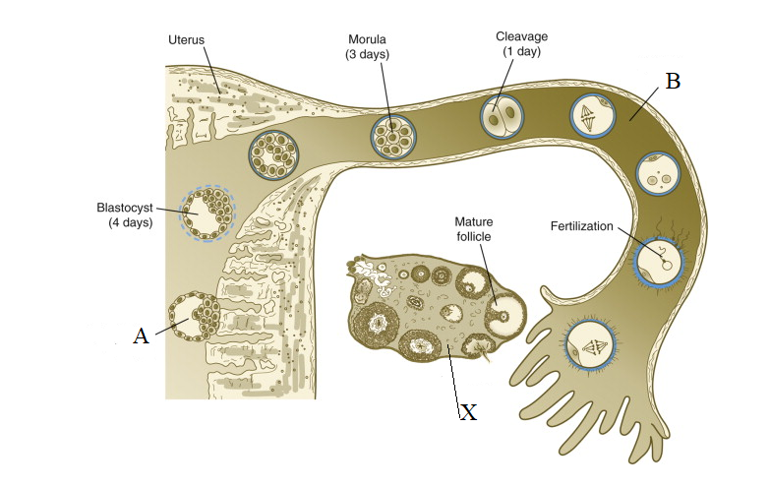
Name
- The process labeled A (1mark)
Implantation
- Structure X and B(2marks)
XOvary
BOviduct / fallopian tube
- The hormone produced by structure labeled X (1mark)
Oestrogen
21. The paddles of whales and fins of fish adapt these two organisms to aquatic habitats.
- Name the evolutionary process that may have given rise to such similar structures (1mk)
Convergent
- What name is given to such structures (1mk)
Analogous
22. The malarial parasite in the recent past has developed resistance to most antimalarial drugs.
Explain. (3marks)
Continuous/prolonged use of antimalarial drugs lead to mutation of some malarial parasits;they then become resistant; to the drug,grow to sexual maturity and reproduce/ pass the mutant gene to the offsprings;
23. What is natural selection? (2mks)The process whereby organisms better adapted to their environment/with advantageous traits tend to survive and produce more offspring
24. Explain the meaning of each of the following as used in evolution (3marks)
Comparative embryology
Comparison of embryos of different species, during early stages of development to show how all animals are related.
Vestigial structures
Structures which in the course of time ceased to be functional and have reduced in size
Adaptive radiation
Refers to the adaptation of an organism that enables them to spread successfully or radiate into other environments.
25. The diagram below represents a neurone.Use it to answer questions that follow.
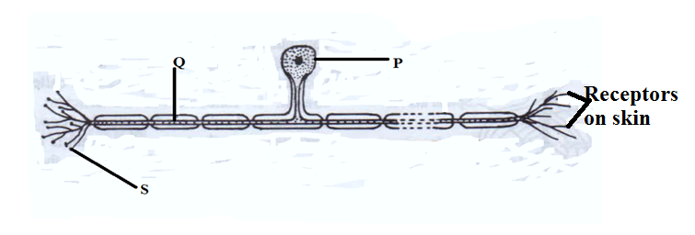
(a)Identify the neurone. (1 mark)
Sensory neurone
(b) Using an arrow,show the direction of impulse. (1 mark)
Arrow should be away from receptors on skin
(c)Name the parts labelled P (1 mark)
Cell body
(d) Name the neurotransmitter substance released at part S. (1 mark)
Acetylcholine
26. Define the following terms.(2marks)
- Ecdysis
Shedding of the hard exoskeleton (cuticle) is in order to allow growth to occur;
- Metamorphosis
Sudden change in body form during the life cycle of an organism;
27.During an experiment it was found out that germinating bean seeds released 9.0 cm³ of carbon IV oxide while 8.8 cm³ of oxygen was consumed.
- Calculate the respiratory quotient (1marks)
Respiratory Quotient (RQ) =Volume of Carbon (IV) oxide produced
Volume of oxygen consumed
9.0 cm3
8.8 cm3
=1.02
- State the type of respiratory substrate(1mark)
Carbohydrate
28. (a) Differentiate between respiration and gaseous exchange (1 mark)Reparation is the process by which food substances are chemically broken down in living cells to release energy, carbon (IV) oxide and water while Gaseous exchange is the process by which respiratory gases are passed across a respiratory surface;
(b) State two conditions necessary for maintaining respiration (2marks)I i.Cells must be provided with food/glucose
ii. Oxygen must be taken in to react with the glucose
iii. Presence of respiratory enzymes to catalyze the reaction
iv.Optimum/Favorable temperature must be maintained for efficient enzyme functioning
v. End products of the reaction i.e Carbon (IV) oxide, water and energy must be constantly removed from the mitochondrion

29. Differentiate between members of class Chilopoda and class Diplopoda (3 marks)
Diplopoda | Chilopoda
Have a cylindrical body | Body is dorso-ventrally flattened
Have three body parts | Body divided into two parts: the drunk and head
Segments between 9 and 100 | Body consist of up to 15 segments
Each segment has a pair of walking legs | Each segment has a pair of walking legs

- State two ways which enable the fertilized ovum to move from the place where fertilization occurs up to the uterus. (2marks)
wafting of cilia
contraction of smooth muscles of oviduct

