NAME ……………………………………… ADM.NO……….…………… CLASS ….……...

Candidate’s Sign ………………………. Date ……………………………………
231/2
Biology Paper 2(Theory)
SEPTEMBER 2022
Time: 2 Hours

MOKASA II JOINT EVALUATION EXAMINATION
Kenya Certificate of Secondary Education

- Write your name, Index Number in the spaces provided above
- Write the date of examination in the space provided above
- Answer ALL the questions in section A in the spaces provided below each question in the question paper
- In section B, answer question 6(Compulsory) and either question 7 or 8
FOR EXAMINER’S USE ONLY

Section | Question | Maximum Score | Candidate’s Score
A | 1 | 08
 | 2 | 08
 | 3 | 08
 | 4 | 08
 | 5 | 08
B | 6 | 20
 | 7 or 8 | 20
 | TOTAL | 80

1.a) Name one examples of non-disjunction (1 marks)
Down’s syndrome; Klinefelter’s syndrome; Turner’s syndrome; polypliody
b)i)Sickle cell trait is an hereditary disease controlled by a recessive gene. Red blood cells of people with the trait are sickle shaped. Using symbols Hb-^{A} to represent normal haemoglobin and Hb-^{S} to represent abnormal haemoglobin. Work out the possible phenotypes of the offsprings resulting from a marriage between a man who is homozygous and a woman who is heterozygous for the trait. (4 marks)
Parental phenotypes: man with sickle cell anaemia Sickle cell trait woman
Parental genotype: Hb^{S}Hb^{S}xHb^{A}Hb^{S;}
Gametes Hb^{S}Hb^{S}Hb^{A}Hb^{S;}
Fusion;
 | Hb^{A} | Hb^{S}
Hb^{S} | Hb^{A}Hb^{S} | Hb^{S}Hb^{S}
Hb^{S} | Hb^{A}Hb^{S} | Hb^{S}Hb^{S}
;

ii) From the cross obtained in (i) above, what proportion of the offspring would have sickle cell anaemia? (1 mark)
½ or50%;
iii).Explain why a higher population of individuals with sickle cell trait are found in the tropics (2marks) (1 mark)
In the tropics there is a higher prevalence of malaria; individuals with sickle cell trait have some red blood cells with abnormal haemoglobin S with low oxygen loading hence plasmodium parasite cannot survive in it;

2. List two homeostatic functions of the kidney (3mrks)
Osmoregulation;
Ionic balance;
Regulation of Ph;

b) The diagram below shows the structure of a mammalian skin.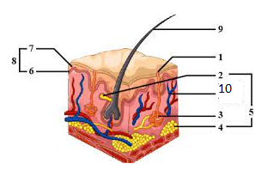

a) i) What substance is produced in the part labelled 2 (1mrk)
Sebum;
ii) State two functions of the substance named in ai above (2mrks)
Keeps the hair and epidermis flexible and waterproof;
Contain antiseptic substance for protection against bacteria;
iii) Name the protective functions of the above organ (3mrks)
Protect underlying tissues from; Entry of micro-organisms;
Physical damage;
Ultra violet rays from the sun;
3. Study the photograph below and answer the questions that follow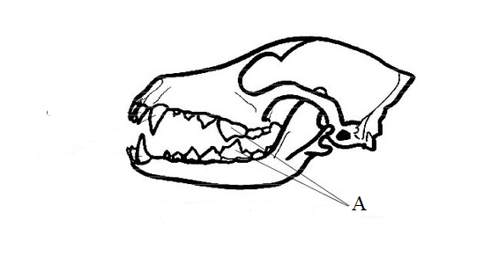
a) With a reason, state the class of the animal from which the photograph was obtained (2mks)
Mammalia
Heterodont dentition
b)Name the parts labeled A and state its function (2mks)
Name ;carnassial teeth
Function .crushing bones; Slicing flesh;
c(i) state the mode of feeding of the organism whose photograph is shown above (1mk)
Carnivorous;
ii) State the adaptations of the organism to the named mode of feeding (2mks)
Has long/curved/pointed/large canines for gripping, piercing, kill prey and tearing flesh;
Has carnassial teeth which have smooth sides and sharp edges /slicing flesh/skin/tendons and crushing bones;
Sharp, closely fitting incisors for gripping/biting/striping;
Molars/Premolars have wide surface and sharp pointed cusps for crushing bones;
d) Explain how articulation of the jaws adapt the organism to its mode of feeding.(1mks)
Allows wide opening of the mouth to catch prey;
Allows up and down movement (not sideways)creating a great force for canines to grip and pierce prey and for carnassial teeth to crush bones.;

4. The diagram below illustrates the process of sperm formation in a mammalian testes.

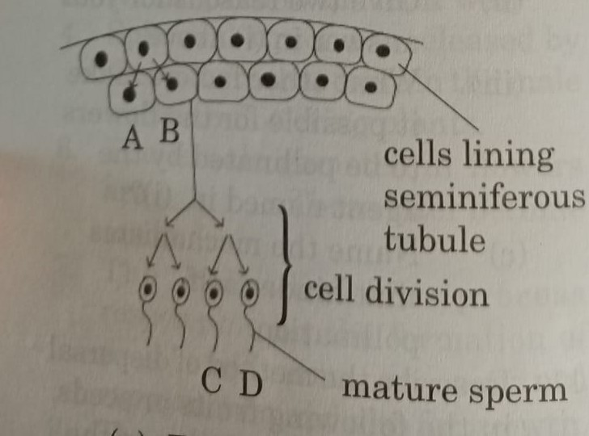

- Explain why the cells A and B are genetically identical (1mk)
Formed from similar cells by mitotic division;
- Describe two ways in which cell division leads to cells C and D being genetically different (4mks)
During crossing over at prophase 1; genetic exchange occurs during chiasma formation leading to variation/genetically different gametes;
During independent assortment; homologous chromosomes segregate independently of each other producing wide variety of different gametes;
c) In what way do cells A, B differ from cells C, D in terms of genetic constitution? (1mk)
A,B are diploid
C,D are haploid
d) State any two adaptations of cells C,D to its function.(2mks)
Has acrosome with lytic enzymes to dissolve egg membranes to enable it penetrate the egg forfusionof their nuclei
Has a long tail to propel it through lashing action towards the ovum
Has numerous mitochondria to provide energy for propulsion towards the ovum
Has a large nucleus with haploid genetic materia
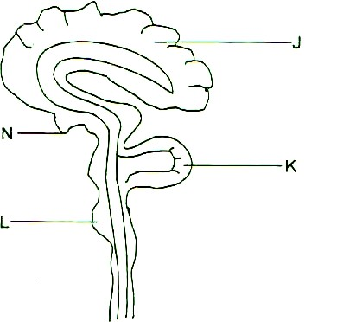
5. The diagram below shows a vertical section through human brain
- Name the parts labelled K and L (2mks)
KCerebellum;
LMedulla Oblongata;
- Identify the part labelled J and explain why it is large and highly folded (2mks)
Cerebrum;
To increase the surface area for packaging of neurones to increase brain capacity/coordination of most of the body functions;
- Identify the damaged parts of the brain that would exhibit the following symptoms.
(i) Loss of memory. (1 mk)
Cerebrum
(ii) Inability to maintain proper body balance and posture.( 1mk)
Cerebellum
- Poor breathing, swallowing and blood circulation (1mk)
Medulla Oblongata
- State one hormone secreted by the pituitary gland (1mk)
FSH, ADH, TSH

6. Ten batches each containing 50 maize seedswere placed separately in trays containing moist soil. The trays were kept at different temperatures in a greenhouse. After ten days, the percentage germination in each batch was found to be as follows:

Temperature (ºC) | Percentage germination (%)
0 | 0
5 | 0
10 | 4
15 | 9
20 | 16
25 | 32
30 | 60
35 | 88
40 | 5
45 | 0

- Using a suitable scale, plot a graph of percentage germination against temperature.
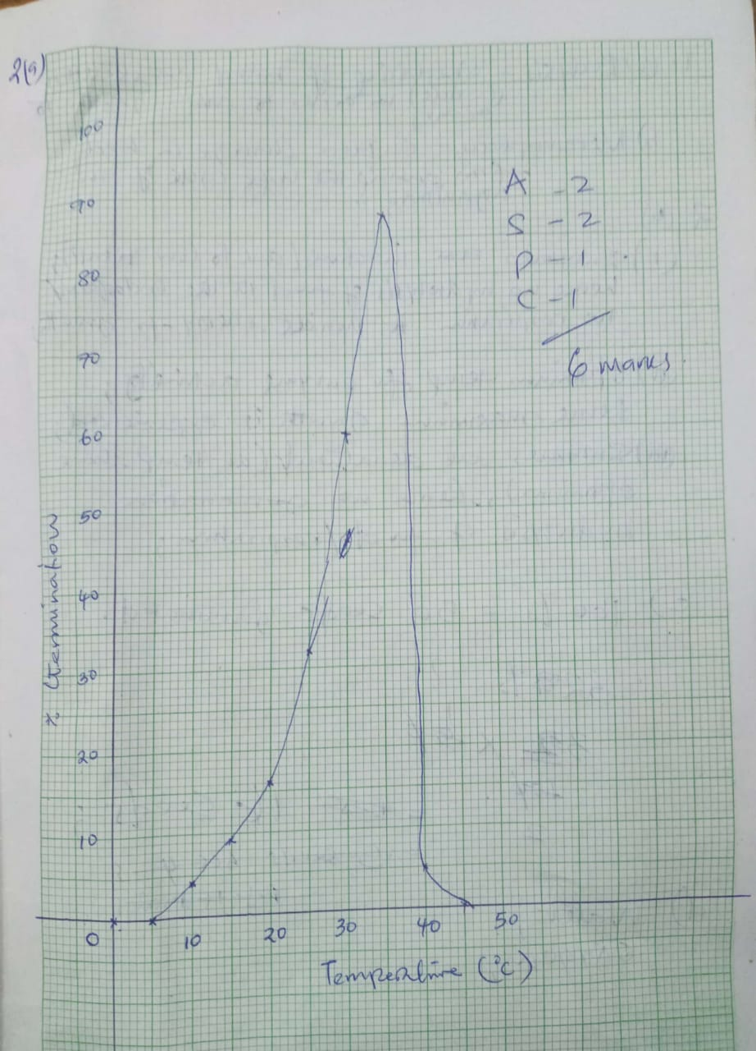 (6mk)
- Account for germination percentage at:
- 0ºC (2mk)
Enzymes are inactive due to low temperature; hence no hydrolysis of food in the endosperm/no respiration to provide energy for growth;
- 35ºC (2 marks)
This is the optimum temperature for enzyme activity; hence maximum growth is experienced;
- 45ºC (2marks)
High temperature beyond the optimum hence enzymes get denatured; hence no hydrolysis of food takes place and no energy is produced for growth;
- Calculate the number of seeds that germinated at 15ºC. (1mark)
100% = 50 seeds germinated
32% =?
32/100x 50
16 seeds
- Other than temperature, state two other abiotic factors that affect germination. (2marks)
Water; oxygen; Light; any two
- State the importance of each of the factors named in (d) above. (2mk)
Water
- Activates enzymes;
- Medium for enzyme activity;
- Hydrolyses stored food;
- Medium of transport of soluble food substances;
- Softens the seed coat Award only for the first correct
Oxygen
Oxidizes food to generate energy for germination /growth;
- Explain the biological importance of dormancy in seeds. (3mk)
- Provides seeds with adequate time for dispersal so that they germinate away from the parent plant;
- Enables seeds to survive adverse environmental conditions without depleting the stored food;
- Provides enough time for the embryo to mature fully before it can germinate;
7a) Briefly describe formation of tissue fluid

Blood entering the capillaries from arterioles is under high pressure; This is due to the pumping action of the heart and the high resistance offered by the narrow lumen of the capillaries; The high pressure forces fluid and low molecular weight components of blood to filter out; through the spaces between the capillary endothelial cells to form tissue fluid also known as intercellular fluid;[4marks]

- Describe the mechanism of blood clotting process

When blood vessels are damaged, the platelets exposed to air rapture to release enzyme thromboplastin/thrombokinase; which serves two major functions: one to neutralize anticlotting factor in blood,heparin; and two is to catalyse the conversion of pro-thrombin to thrombin; in the presence of calcium ions and vitamin k as cofactor and co-enzyme respectively; The thrombin enzyme catalyse the conversion of soluble plasma protein fibrinogen to insoluble fibrin; that form a meshwork of fibres on the fresh cut wound hence bring to a stop the oozing of blood;[6marks]

- Describe how the white blood cells are adapted to performing its function
Leucocyte/ white blood cell
Irregular in shape/amoeboid to enable the cell to squeeze through the capillaries; phagocytes are amoeboid shaped to change shape and engulf pathogens in a process called phagocytosis;
Lymphocytes produce various antibodies to fight infection such as
- Antibodies called antitoxins; neutralize the toxins( antigens)produced by pathogenic micro-organisms;
- Agglutinins; cause clumping together of micro-organisms. This stops the microorganisms from multiplying and eventually they die after being ingested by phagocytes ;
- Lysins; destroy micro-organisms by digesting their cell membranes or walls ;
- Opsonins; adhere to the outer surface of microorganisms thus making it easier for the phagocytes to ingest them; [10marks]

Essay
8.The following organisms were recorded in a grassland ecosystem by form four students during their field trip.
Organisms | Number
Crickets | 1000
Grass | 120000
Snakes | 250
Hawk | 100
Grasshopper | 1000
Frogs | 500
Chicken | 500
Locust | 1000

Draw a possible food web to illustrate the feeding relationships amongst the above organisms (5mks)

Discuss how the following abiotic factors will influence the population of the organisms in the food web suggested above.(15mks)

Temperature.
Temperature affects enzyme activity and thus rate of chemical reactions in organisms; Optimum temperature therefore increases the rate of photosynthesis in grass/plants ;High Rate of photosynthesis in plants leads to high rate of growth and development ; thus higher population of grass as they are able to make food for themselves.higher population of grass subsequently leads to an increase in the population of organisms feeding on grass/on the lower trophic levels; favourable temperature increases the rate of seed germination increasing the population of grass in this ecosystem;
Low temperatures limit growth of plants due to low rate of dark stage of photosynthesis. Low rate of photosynthesis leads to slow plant growth rate and reduced plant population. Low temp also causes low rate of seed germination due to low activity of germination enzymes.

Atmospheric pressure
Low atmospheric pressure leads to low oxygen and carbon IV oxide concentration. low oxygen concentration lowers the rate of respiration in grasss/plants and animals hence less energy supply and thus low rate of cell division and low rate of growth and development reducing total population in the ecosystem.
low carbon IV oxide concentration lowers the rate carbon iv oxide fixation during photosynthesis ,less amount of food is produced ,thus low rate of plant growth reducing the total population of grass and animals feeding on grass.
Light intensity

Higher light intensity leads to maximum rate of photosynthesis by increasing photolysis and causing opening stomata to allow diffusion of carbon iv oxide, causing rapid growth and development of the plants thus higher number of plants in an ecosystem.the more the plants ,the higher the number of organisms that depend on plants directly or indirectly .i.e more herbivores leads to increase in number of carnivores due to available food.
Low light intensity, lowers rate of photosynthesis, thus fewer plant growth in such ecosystem leading to fewer number of herbivores and carnivores.

Light intensity influences Transpiration.
High light intensity increases rate of photosynthesis in guard cells chloplasts ,forming glucose which is osmoticallyactive.guard cells in turn gain water by osmosis from epidermal cells ,become turgid,stoma opens ,increasing water loss.theexcsssive water loss eventually leads to death of plants ,and reduced number of organisms depending on plants due to lack of food. Open stoma increases rate of transpiration leading to permanent wilting in plants hence death reducing plant growth as well as the organisms depending on the plants in the ecosystem .

Light also affects migration in birds.
Migration of birds causes reducedpopulation in the ecosystem.
Birds Migrate at Night due to Cooler temperatures which prevent them from overheating. Darkness keeps them safe from hawks, falcons and other daytime predators. Night air is less turbulent so it takes less effort to navigate.
Wind.
Influences the rate of transpiration by blowing away moist air surrounding the leaves increasing saturation deficit and thus high rate of transpiration,eventually permanent wilting /death ,reducing the population of organisms.
They are agents of pollination and seed and fruit dispersal influencing their distribution
Wind speed and direction influences migration of insects and birds.it helps them move to far areas.
Moist wind brings rainfall to terrestrial habitats encouraging growth of plants. Increased plant growth causes an increase in number of organisms that depend on the plants.
Strong winds cause stunted and distorted growth.
Altitude.
High altitude leads to low concentration of gases/oxygen and carbon iv oxide;low oxygen concentration reduces the rate of respiration in the organisms ,less energy produced for cell division thus reduced rate of growth and development; low carbon iv oxude concentration leads to low rate of photosynthesis hence less amount of food is formed in grass leading to low rate of growth and development.all these lead to reduced plant population and animals depending on plants directly or indirectly.
Low altitude leads to high concentration f gases/ CO₂ and O2 increasing the rate of photosynthesis and respiration respectively;thus higher rate of growth and development in organisms ;increasing the total population.

