NAME.......................................................................ADM NO...............................

DATE............................. SIGN.....................................
231/3
Biology paper 3
(Practical)
1 ¾ HRS
September 2022.

MOKASA MOCK
Kenya Certificate of Secondary Education 2022
231/3
Biology paper 3
(Practical)
TIME: 1 ¾ HRS
September 2022.

INSTRUCTIONS TO CANDIDATES
- Write your name and index number in the spaces provided at the top of this page.
- Answer all the questions in the spaces provided.
For examiner’s use only

QUESTION | MAXIMUM SCORE | CANDIDATE’S SCORE
1. | 14
2. | 12
3. | 14
TOTAL | 40

- Study the specimen R provided.

(a) Identify the type of fruit. (1 mark)
……………………………………………………………………...……………………………………………………………………………………………………………………………………………...…
(b) i) What is the method of dispersal for the specimen R. (1 mark)
……………………………………………………………………...………………………………………………………………………………………………………………………...………………………
ii) Give reason(s) for your answer in (i) above (2 marks)
……………………………………………………………………………………………………………………………….……………………………………………………………………………………..
……………………………………………………………………….………………………………….
(c) Peel the sliced specimen R to show the inner juicy part. Extract a small portion of the juicy part, place in a mortar and mash it using a pestle.
Filter the extract from the specimen R into a boiling tube.
Divide the extract from specimen R into two portions and use them as follows;

Portion one
Use the reagents provided to test for the food substances present in portion 1. Use the table below as a guide. (6 marks)
Food substance | Procedure | Observation | Conclusion

Portion two

(d) (i) To 1cm³ of DCPIP in a test tube, add 0.1% solution of Ascorbic acid drop by drop until the colour of DCPIP disappears. Shake the test tube after addition of each drop. Record the number of drops used. (1 mark)
………………………………………………………………………………………………………………………………………………………………...……………………………………………………
ii) To another 1cm³ of DCPIP in a test tube add the portion two of extract drop by drop, shaking the test tube after addition of each drop until the colour of DCPIP disappears. Record the number of drops used (1 mark)
………………………………………………………………………………………………………………………………………………………...……………………………………………………………
iii) From the results obtained in (d) (i) and (ii) above, calculate the percentage of Ascorbic acid in the juice obtained from specimen R. Show your working (2 marks)
…………………………………………………………………………………………………………………………………………………………………………………….…………………………………………………………………………………………………………………………………………………………..………………………………………………………………………………,…………
2. You are provided with photographs A, M and D representing certain plants and specimens P and Q .Use them to answer the questions that follow.

Photograph A
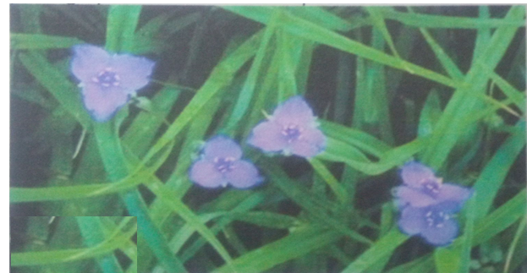
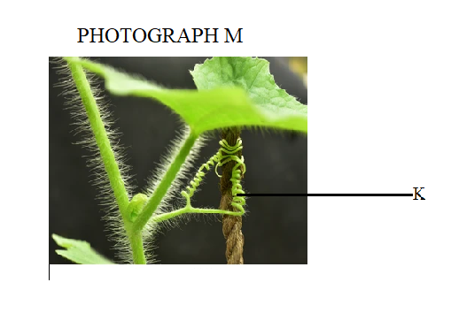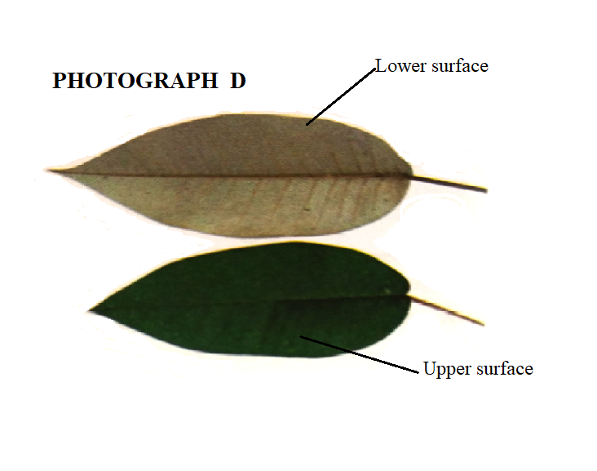
(a). i Name the sub division to which the plant in photograph A and specimen Q belong. (1 mark)
………………………………………………………………………………………………………………………………………………………………………………………………………………….…

ii. Give a reason for your answer in a (i) above. (1 mark)
……………………………………………………………………………………………......................................................................................................................................................................……………
(b). State the differences between the leaves of specimen P and Q (3 marks)

Specimen P | Specimen Q

c) Name the unique features observed on stems of specimen Q and stem of photograph M and state their function. (2mks)
Specimen Q
…………………………………………………………………………………………………………...
Photograph M
…………………………………………………………………………………………………………...
d) Account for the differences observed on the upper and lower surfaces of leaves on photograph D (2mks)
……………………………………………………………………………………………………………………………………………………………………………………………………………………………………………………………………………………………………………………………………………………………………………………………………………………………………………………………………………………………………………………………………………………...
e) The stem of specimen Q and that of photograph M are green in colour. What does the colour imply? (1mk)
…………………………………………………………………………………………………………
f) (i) Name the part labelled K on photograph labelled M (1mk)
…………………………………………………………………………………………………………...
(ii) Explain how the coiling of the structure occurred (2mks)
……………………………………………………………………………………………………………………………………………………………………………………………………………………………………………………………………………………………………………………………………………………………………………………………………….…………………………………..

3 a) Use the photograph provided to answer the questions that follow.

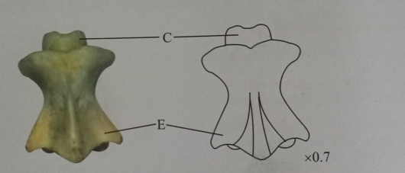

(i)identify the bone (1mk)
………………………………………………………………………………………………………………………………………………………………………………………………………………….......
ii)Give reason for your answer in (i) above (1mk) ………………………………………………………………………………………………………………………………………………………………………………………………………………….......
iii) Name the region of the body from which the above bone was obtained (1mk) ………………………………………………………………………………………………………………………………………………………………………………………………………………….......
(iv) Name the bone which articulates with the above bone at its anterior end (1mk) ………………………………………………………………………………………………………………………………………………………………………………………………………………….......
(v) Identify the type of joint formed in (iv) above (1mk) ………………………………………………………………………………………………………………………………………………………………………………………………………………….......
(vi) Name the structure that joins the two bones in c(i) together at the joint formed above (1mk) ………………………………………………………………………………………………………………………………………………………………………………………………………………….......

vii) Identify the view of the above bone in the photograph (1mk) …………………………………………...……………………………………………………………………………………………………………………………………………………………………….......
viii) State two differences between the above bone and the bone it articulates with at the anterior end. (2mks)
…………………………………………………………………………………………………………………………………………………………………………………………………………………………………………………………………………………………………………………………………………………………………………………………………………………………………….......

b)(i) Identify the bone in the photograph below (1mk)
………………………………………………………………………………………………………………………………………………………………………………………………………………….......
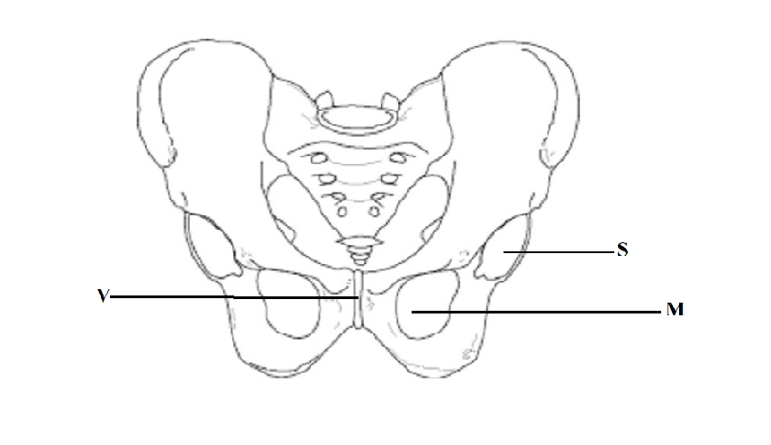

(ii) Name the structure labeled S and state the structure that it articulates with. (2mks) …………………………………………………………………………………………………………………………………...………………………………………………………………………………………………………………………………………………………………………………………….......
(iii) Name the structure labelled V and state its function (2mks) ……………………………………………………………………………………………………………………………..……………………………………………………………………………………………………………………………………………………………………………………………….......
(iv) Name the part labelled M on the diagram (1mk)
………………………………………………………………………………………………………………………………………………………………………………………………………………........

