NAME.......................................................................ADM NO...............................

DATE............................. SIGN.....................................
231/3
Biology paper 3
(Practical)
1 ¾ HRS
September 2022.

MOKASA MOCK
Kenya Certificate of Secondary Education 2022
231/3
Biology paper 3
(Practical)
TIME: 1 ¾ HRS
September 2022.

INSTRUCTIONS TO CANDIDATES
- Write your name and index number in the spaces provided at the top of this page.
- Answer all the questions in the spaces provided.
For examiner’s use only

QUESTION | MAXIMUM SCORE | CANDIDATE’S SCORE
1. | 14
2. | 12
3. | 14
TOTAL | 40

1 (a) (1mk)
Pome
(b) i) (1mk)
Animal
ii) (2mks)
- Brightly coloured
- Pleasant scent
- Succulent /juicy
(c) (6mks)
Food substance | Procedure | Observation | Conclusion
Reducing sugars | - Put 2ml of portion 1 into a test tube  - Add 2ml of Benedict’s solution  - Heat to boil | Color changes from blue ,green ,yellow ,orange | Reducing sugars present
Proteins  Vitamin C/Ascobic acid | - Put 2ml of portion 1 into a test tube  - Add 2ml of Sodium hydroxide solution  - Add 3 drops of Copper Sulphateand shake after each drop  - To 2ML of DCPIP add food sample drop wise | Blue colour is retained  DCPIP decolourised | Proteins absent  Vitamin C present

d) (i) 4 drops
ii) Should be more than 4 drops
iii) 0.1 x 4 drops
drops in d (ii)

2. You are provided with photographs A, M and D representing certain plants and specimens P and Q .Use them to answer the questions that follow.
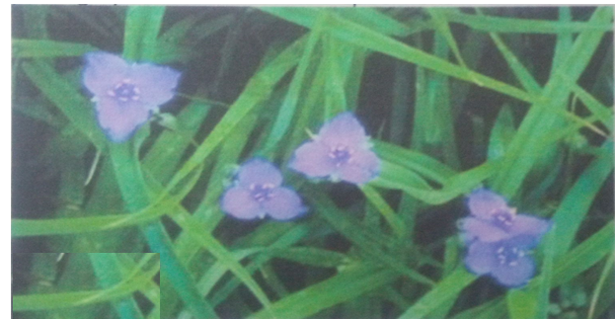

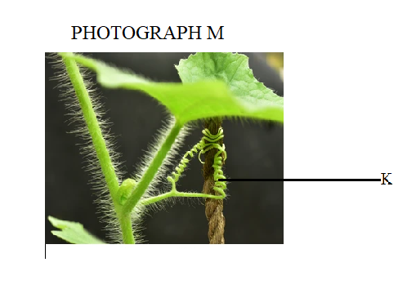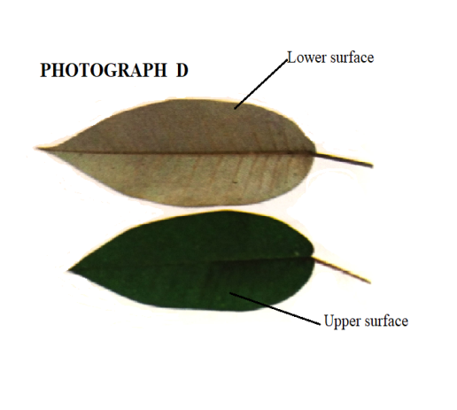
(a). i Name the sub division to which the photograph A and specimen Q belong. (1 mark)
Angiospermaphyta;/acc.Angiospermae Reject if does not begin with capital letter

ii. Give a reason for your answer in a (i) above. (1 mark)
They are flower bearing

(b). State the differences between the leaves of specimen P and Q (3 marks)
Specimen Q | Specimen P
Network venation | Parallel venation
Rounded apex | Pointed apex
Margins are Serrated | Margins entire
Broader | Slender

c) Name the unique features observed on stems of specimen Q and stem of photograph M and state their function. (2mks)

Specimen Q
Presence of spines
Prevents herbivores from feeding on it.

Photograph M
Hairy stem
Traps a layer of moisture preventing excessive loss of water vapour
Tendrils
Support

d) Account for the differences observed on the upper and lower surfaces of leaves on photograph D (2mks)
Upper surface is (dark) green while lower surface is white/light grey; chloroplasts are concentrated on the upper surface to trap maximum light for maximum photosynthesis. The light grey lower surface is due to numerous epidermal hairs to reduce transpiration.

e) The stem of specimen Q and that of photograph M are green in colour. What does the colour imply? (1mk)
Have chloroplasts for photosynthesis

f) (i) Name the part labelled K on photograph labelled M (1mk)
Tendril
(ii) Explain how the coiling of the structure occurred (2mks)
Contact on solid object causes lateral diffusion/migration of auxins away from point of contact, higher concentration of auxins at the point away from contact causes faster/rapid cell division and elongation and thus coiling.

3 a) use the photograph provided to answer the questions that follow.

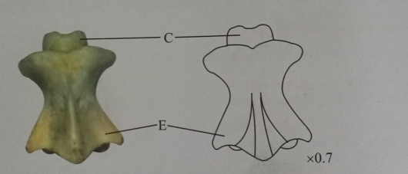
(i)identify the bone (1mk)
Axis
ii)Give reason for your answer in (i) above (1mk)
it has odontoid process

iii)Name the region of the body from which the above bone was obtained (1mk)Neck region
iv) Name the bone which articulates with the above bone at its anterior end(1mk)Atlas
(v) Identify the type of joint formed in (ci) above (1mk)
Pivot
(vi) Name the structure that joins the two bones in c(i) together at the joint formed above (1mk)ligaments
vi) Identify the view of the above bone in the photograph (1mk)
Dorsal
vii) State two differences between the above bone and the bone it articulates with at the anterior end.(2mks)
Atlas | Axis
Has the articulating facet that articulates with occipital condyles | Lacks the articulating facets
Lacks odontoid process | Has odontoid process

b) Identify the bone in the photograph below (1mk)
Pelvic girdle
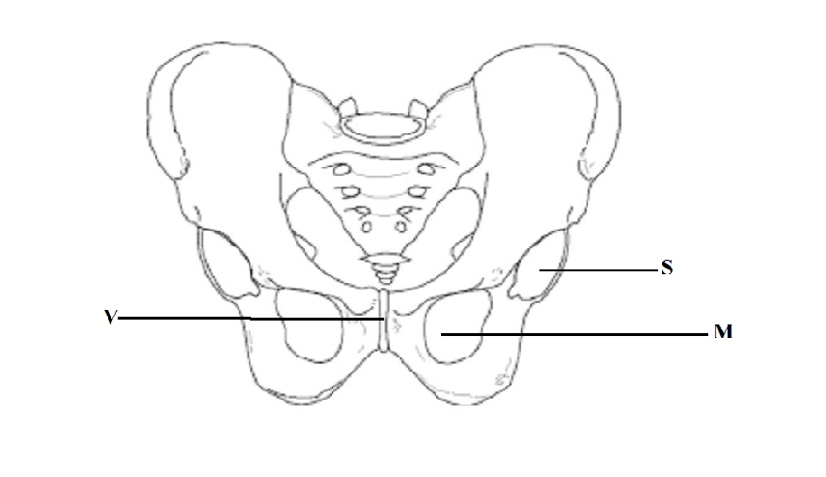

ii) Name the structure labelled S and state the structure that it articulates with. (2mks)acetabulum
Head of femur
iii) Name the structure labelled V and state its function (2mks)
Pubis symphysis
iv) Name the part labelled M on the diagram (1mk)
Widens to allow parturition

