MARKING SCHEME
451/1
COMPUTER STUDIES
PAPER 1
(THEORY)
SEPT, 2022
TIME: 2 ½ HRS

MOKASA 11 JOINT EXAMINATIONS
Kenya certificate of secondary education
(K.C.S.E)

451/1
COMPUTER STUDIES
PAPER 1
(THEORY)
SEPT, 2022
TIME: 2 ½ HRS
Instructions to candidates
- This paper consists of TWO sections; A and B
- answer all questions in sections A.
- Answer question 16 and any other THREE questions from section B.

for examiners use only

section | Question
A | 1 – 15
B | 16
 | 17
 | 18
 | 19
 | 20
Total marks

This paper consists of 16 printed pages.
Candidates should check to ensure that all pages are printed as indicated and that no question is missing.
SECTION A (40MKS)
Answer all the questions in this section
- A computer must go through the process of booting before use. State what happens during power on self-test (POST) (1mk)
Checks the existing drives , basic input/output devices such as keyboard, monitor and mouse
- State two differences between traditional mouse and trackball (2mks)
Trackball has a ball on top while traditional mouse has a ball underneath
Trackball does not need a flat surface to operate while a standard mouse needs a flat surface to operate.
- State any two circumstances where sound output devices would not be appropriate (2mks)
When in a noisy environment
When the output cannot be presented in audio form eg graphics
Or any other correct response
Circumstance @ 1 Mark
Total = 2 * 1 Mark
= 2 Marks
4. Software can be categorized according to end user licence. Differentiate between proprietary and open source software (2mks)
Open source: the source code is freely made available to the users
Proprietary : Source code is hidden from the users
- State the function of each of the following features when creating a word processing document
- Word wrap (1mk)
Feature which automatically moves a text which does not fit in a line to the beginning of the next line
- Watermark (1mk)
Text or picture that appears behind a document Clipboard (1mk)
- Clipboard
Temporary location for storing data awaiting paste.

- Different types of cables are suitable for different applications
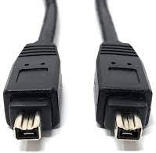
- Identify the cables in the diagram above (1mk)
Firewire
Cable @ 1 Mark

- State one advantage of using the above cable (1mk)

- To transfer power to the device through the same data transfer cable.
Or any other correct response
Advantage @ 1 Mark
Total = 1 * 1 Mark
= 1 Mark

- State any two factors to consider when selecting a computer for an organization (2mks)
Purchase price
Processor speed
Size and make
Warranty
- Identify the following symbols as used in spreadsheet (3mks)
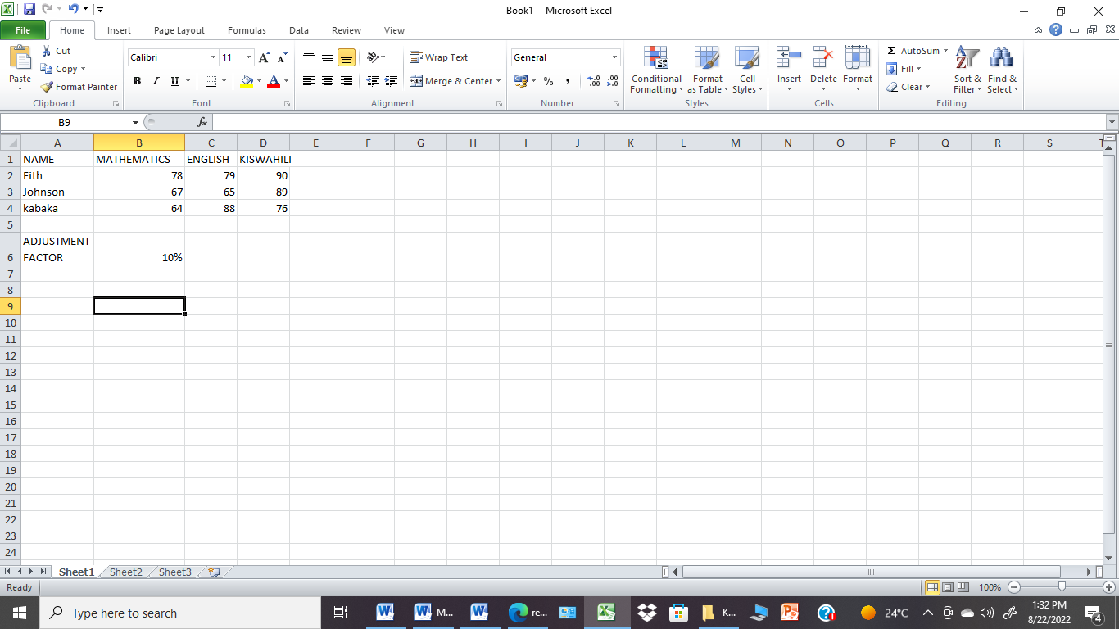
C
B
A
- A
Borders
- B
Find
- C
Filter
- The formula D10*E12 was initially stored in in cell F10 of a spreadsheet. Write the formula as it would appear when copied to cell M20 of the same spreadsheet (1mk)
- Write a formula in cell E2 that can be copied to the other cells to display the positive adjusted marks for mathematics using the value in cell B6 (2 mks)

- The operating system is known to be very critical in the operation of a computer.

The Operating system identifies errors that come about in the use of the computer system by the user, and in the execution of instructions. Once it identifies an error, it alerts the user of the errors by stating the error and possible causes, as well as a suggestion of a possible course of action to rectify the error.
- Error handling @ 2 Marks

- State the importance of the feedback mechanism in a system (1 mk)
Many unnecessary disturbances and noise signals from outside the system can be rejected.
The change in the performance of the system due to parameter variations is reduced.
The steady-state error of the system can be relatively small.
The transient behavior of the process can be easily manipulated.
The feedback is compared with the desired state in order to take corrective measures.
Or any other correct response
Importance @ 1 Mark
Total = 1 * 1 Mark
= 1 Mark
- State one disadvantage of the feedback mechanism (1 mk)
The system is complicated by the increased number of components, such as sensors and error detectors.
The overall gain of the system is reduced and must be compensated for in the design.
The system may not be stable (it may oscillate or depart greatly from the desired output), even though the comparable open-loop system is stable.
The error detector is necessary in order to compare two states.
If there is a change in an Output, it will affect the system input.
Or any other correct response
Disadvantage @ 1 Mark
Total = 1 * 1 Mark
= 1 Mark
- Differentiate between universal resource locator and hyperlink as used when connecting to the internet. (2 mks)
url is a web address used to access a website while an Hyperlink is a text or picture on an electronic document which when clicked cause another webpage to open.
- A database is the best application to manage and manipulate organization data;
- Distinguish between a candidate key and a primary key in a database (2 mks)
A primary key is a unique field within a record that uniquely identifies it and is used for searching while A Candidate key is a column in a table that has all the characteristics of a primary key but it is not used as a primary key.
- Difference @ 2 Marks
- State any two functions of a query (2 mks)
A query can give you an answer to a simple question,
A query can be used to perform calculations in a database,
A query can be used to combine data from different tables,
A query can be used to add records in a table,
A query can be used to change records in a table
A query can be used to delete data from a table in database.
Or any other correct response
Function @ 1 Mark
Total = 2 * 1 Mark
= 2 Marks
- Give the function of cache memory (1mk)
Used to improve processing speed of the processor by holding data and instructions that are frequently required by the processor
- With aid of a flowchart, show a selection control structure. (2 marks)
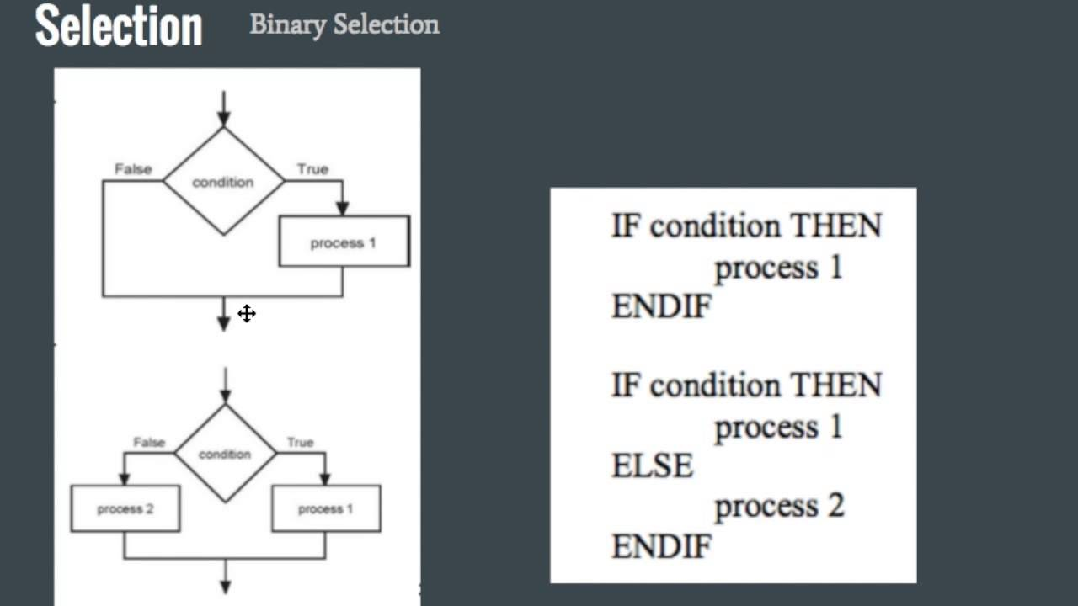
14. An employee in a business company is charged with the responsibility of putting the company advertisement on the internet. State the profession title of the employee to carry out the above task (1mk)
Web administrator
(b) State two roles of a system analyst (2mk)
Review the current system and making recommendations on how to replace it with a more efficient one
Work with programmers to construct and test the system
Coordinate the training of users of the new system
15(a) Describe Memory management in relation to Operating system (2mks)
RAM is a scarce resource, Operating system determines which task remains in the main memory awaiting for execution and which one will be kicked out back to the secondary memeory.
It organizes the main memory into blocks of sizes called page frames .The processes are equaly divides into pieces that fit into page frames.
(b)Elaborate the application of Artificial intelligence in Artificial neural network (2mks)
Use of electronic device and software to emulate neurological structure of the human brain.

SECTION B (60mks)
Answer question 16 and any other three questions
16. (a)Study the flowchart below and use it to answer questions that follow.
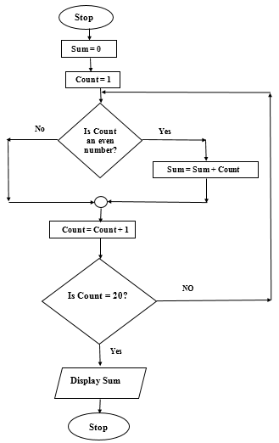

- Write a pseudocode from the flowchart. (7 marks)
Start
Initialise sum=0
Count=1
Repeat
If count=even, then
Sum=Sum + count
Else
Count=Count+1
End if
Until count=20
Print sum
Stop
- Explain the purpose of this flowchart. (2 mks)
Used to find sum of even number in the first 20 natural numbers.
- Determine the output from the flowchart if count is:
- 4 (2 mks)
- 12 (2 mks)
Count | SUM
1 | 0
2 | 1
3 | -
4 | 5
5 | -
6 | 11
7 | -
8 | 18
9 | -
10 | 29
11 | -
12 | 41
13

- Differentiate between object orientated programming and web scripting language. (2mks)
Object-oriented languages are primarily based on the object. The objects constitute two parts: data and code. The data part contains attributes of objects, and the code part contains the functions or procedures.
Scripting languages are made up of scripts. These scripts are used for the automation of functions or actions. The scripts are designed for a specific runtime environment. Scripting languages include JavaScript, PHP, Python, Ruby, etc.
17. Find the value of X in the question below (2mks)
(a) 16₈+1010₂=X₂
_{Step 1:} _{Step 2:}
Add the two binary numbers to get X
1010
+ 1110
X₂= 11000₂
Convert 16₈ to Binary
Octal Binary
- 001
- 110
16₈ =1110₂

(b) Perform the following binary operation (2mks)
1010.11+111.10-101.11
1010.11 + 111.10 – 101.11
1010.11₂
+111.10₂
10010.01₂
- 101.11₂
1110.10₂

(c)In a certain coding scheme, each character occupies 7 bits. Letters of the alphabet are assigned consecutive codes. If letter N is represented by 1010010.Whatis the representation of letter a in this coding scheme? (2mks)
1010010₂ =82₁₀
Letter N is 14th in the alphabet
82-14=68+1=69 since 0 is also a digit.
69=1000101₂

(d)Using 8 bit notation find the 2’s complement of the following operation (4mks)
4+(-7)
One’s complement of the negative number -7₁₀ =1111100₂
Add one to one’s complement to get two’s complement
11111000₂
+ 1
11111001
11111001
00000100
11111101₂
=11111101₂
Step 1: Convert the numbers into 8 bit binary. Step 2:
2 7 REM
2  2 | 3  1  0 | 1  1  1
7₁₀ =00000111₂
2 4 REM
2  2 | 2  1  0 | 0  0  1
4₁₀ =00000100₂

(e) Differentiate between pure binary and BCD code as used in data representation (2mks)
In pure binary the whole number is converted into binary while BCD code each individual digit is converted to binary represented using 4 bits
f)Brian a supermarket owner complains that management of daily sales is becoming overwhelming
(i) Advice Brian on a retail system that he needs to acquire (1mk)
Point of sale system (POS)/Stock control system/EPOS
(ii) State two input devices that are used in the above stated retail system (2mks)
Keyboard
Barcode scanner
Credit card reader
Mouse
Printer
18. (a) State and explain data transmission impairments (4mks) Attenuation-Loss of signal /weakening of the signal
Crosstalk/Noise
(b)State the roles of the following devices/equipment used in networking (3mks)
(i) Brouter
A device that determines the best path for data to flow and filter broadcast traffic to the local segment

(ii) Network interface card
Provides connectivity between the PC and the networks physical medium.
(iii)Concentrator
18. The diagram below shows a layout of a computer network as used in an industrial firm. A work station and a printer are located in every consultation room
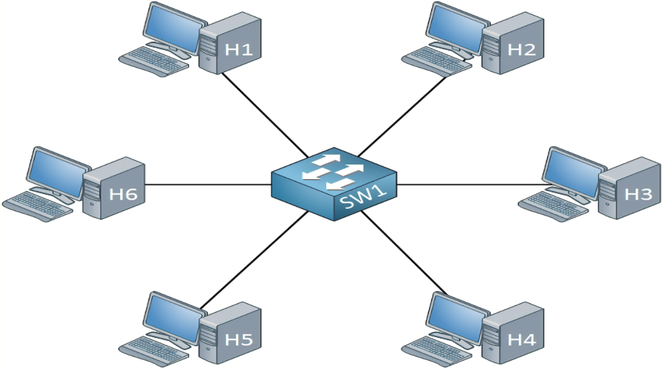
- Identify the type of network topology depicted above (1mk)
Star topology
(b)List three disadvantages associated with the network topology identified in (a) above (3mk)
Costly because it requires one complete cable per computer
If the central hub fails the entire network will be down
Installation is time consuming because each node forms a segment of its own
- An employee sneaked into the accounts office, gained access to the payroll and adjusted his salary for his personal gain.
- Identify two types of crimes the employee committed (2mks)
Theft
Fraud
Sabotage
Alteration
Hacking

- Give two advice to the company to prevent such future occurrences (2mks)
Burglar proof the room
Use passwords
Biometric security
19. (a) The management of Mawingu county government opt to employ a Database administrator. State two roles of this employee. (2 mks)
- Developing database application.
- Enforce database security measures to control access to data and information.
- Updating the database
(b)(i)Explain four circumstances that may necessitate an organization to develop a new information system. (8 marks)
- New opportunities- a chance to improve quality of internal process and service delivery in the organisation.
- Problems- undesirable circumstance that prevent the organisation from meeting its goals.
- Directives- new requirements imposed by the government, due to internal and external influence.
- System failure – due to catastrophic breakdown of system.
(ii)A school opted to use a changeover strategy where the new system and old system are run concurrently as the performances of the two systems are compared.
- Name the type of changeover approach above. (1 mark)
Parallel changeover
- Explain two benefits that the school may get as a result of this approach. (4 marks)
Old system is backup- incase the new system fails, the old one is available.
Adequate staff training – staff are given time to familiarize themselves with the new system.
Benchmark for performance- old system provided a benchmark for assessing the performance of the new system.
20. A school evaluation system relies heavily data processing to rank students
- Identify and describe the file organization applied by the evaluation system (2 Mks)
Sequential file organisation
Sequential file organisation means that records are stored sequentially, one after the other. Records stored using sequential file organization normally are stored in ascending order or descending order, based on the value in the key field.
File Organization @ 1 Mark
Description @ 1 Mark
Total = 1 Mark + 1 Mark
= 2 Marks
- State the data processing method applied by the evaluation system (1 Mark)
Batch processing
- State any two reasons for your data processing method choice in (x. b) above (2 mks)
- Batch processing is one where data is accumulated over a period of time
- Data is processed as a group (batch) all at once.
- There is minimal user interaction during processing
Or any other correct response
Reason @ 1 Mark
Total = 2 * 1 Mark
= 2 Marks

- During data collection stage of data processing, data is verified and coded. Define the terms
- Verification (1 mk)
This is the process of determining whether the collected data is correct as required for processing. If errors occurred in data collection, it is corrected at this stage.
Definition @ 1 Mark

- Coding (1 mk)
This is the process of converting the verified data into machine-readable form so that it can be processed by the computer.
Definition @ 1 Mark

- Jane is a copy typist at Majengo Holdings, she frequently confuses characters in hand written documents thus replacing them with different characters.
- State the type of data processing error Jane makes (1mk)
Misreading error
Error @ 1 Mark

- State how she can overcome the error (1mk)
Misreading errors can be avoided by using modern data capture devices such as bar code reader, digital cameras etc which enter data with minimum user intervention.
Solution @ 1 Mark
- Peter the technician connected and installed a scanner to the office computer but when testing he realized it was not responding to the scanning commands, state any two possible causes of the failure (2mk)
- The scanner may not be powered on
- The scanner may not be compatible with the computer
- Computer may not be properly configured
Or any other correct response
Cause @ 1 Mark
Total = 2 * 1 Mark
= 2 Marks
- Distinguish between disk compression and file compression (2 mks)
Disk compression is the process creating more space on the disk by making files occupy less space on the disk while file compression is the process of using a file compression utility software to reduce the size of a file
Difference @ 2 Marks
- The operating organizes data in a hierarchy. Give any two reasons for the hierarchical organization of data in a computer (2mks)
- For easier and faster management and location of files in the computer
- It is convenient for breaking information to it’s simplest form
Or any other correct response
Reason @ 1 Mark
Total = 2 * 1 Mark
= 2 Marks

