ULUTYA MIXED SECONDARY SCHOLL
KCSE TRIALS EXAMINATION
GEOGRAPHY PAPER 2 (312/2)
100 MARKS, TIME: 2 ¾ HOURS

NAME______________________________ INDEX NO.___________________ DATE____
SECTION A (25 MARKS)
Answer all the question
- a) Name two counties in Kenya where horticulture is practiced. (2mks)

b) Give three reasons why flowers are grown in green houses. (3mks)

- a) State three human factors that influence the location of Mwea Tebere irrigation scheme. (3mks)

b) Name the two projects started by the Netherlands to reclaim land. (2mks)

- a) Name two types of fishing. (2mks)

b) State three reasons why the Kenyan government is encouraging fish farming in many parts of the country. (3mks)

- a) Name three problems facing diamond mining in South African. (3mks)

b) Name two types of settlements. (2mks)

5. a) Draw a sketch map of Africa, and on it mark the location of the following H. E. P projects: Aswan, Akosombo, Kariba. (3mks)
b) Name two areas in Kenya where softwood forests are planted. (2mks)

SECTIO B (75 MAKS)
Answer question 6 (compulsory) and any other two questions
- Study the photograph below and use it to answer the questions that follow.
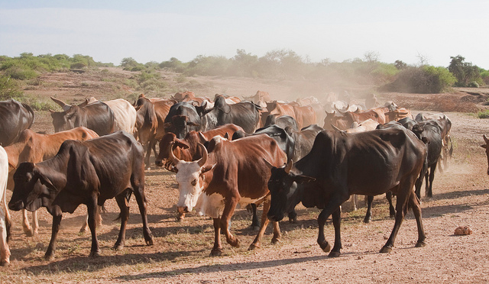
a) i) Name the type of photograph shown above. (1mk)
ii) Give two reasons for your answer in a(i) above. (2mks)
iii) What time of the day was the photograph taken if the camera was held facing south? (1mk)
iv) Draw a rectangle measuring 16cm by 9cm to represent the area of the photograph. On it sketch and label the main features shown on the photograph. (5mks)
v) Name the main economic activity shown on the photograph. (1mks)
vi. Name two counties in Kenya where this photograph would have been taken (2 marks)
b) Explain four problems facing people who practice the above agricultural activity (8mks)
c) You intend to carry out a field study to a community practicing the above agricultural activity.
i) State two objectives of your study. (2mks)
ii) Give three reasons why you should pre-visit the area. (3mks)
7. a) Distinguish between a forest and forestry. (2mks)
b) Below is a world map showing distribution of natural forests
i) Identify the forests labeled A, B and C. (3mks)
ii) List five characteristics of the forest labeled A. (5mks)
iii) Name two examples of hardwoods found in Kenya. (2mks)
c) Explain four factors influencing distribution of forests. (8mks)
d) Give five importance of forests and forest products in Kenya. (5mks)
8. a) What is mining? (2mks)
b) Name most common methods of mining. (3mks)
c) Explain four factors influencing exploitation of minerals. (8mks)
d) Name four major oil procedures in the Middle East. (4mks)
e) Explain four effects of mining on the environment. (8mks)
9. a) i) Name three non-renewable sources of energy. (3mks)
ii) Give three disadvantages of using wood as a source of energy. (3mks)
b) The diagram below shows the Kenya hydroelectric power stations along the River Tana.
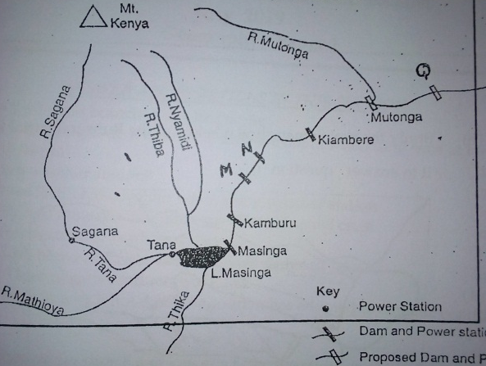

i) Name the H. E. P stations marked M and N. (2mks)
ii) Name the water fall marked Q (1mk)
iii) A part from natural waterfalls, state three other physical factors that led to the establishment of seven forks hydro electric power project along river Tana. (3mks)
c) Identify two areas in Kenya where wind energy is harnessed. (2mks)
d) i) Define energy crisis. (2mks)
ii) Explain the effects of energy crisis under the following sub-headings
Agriculture (2mks)
Tourism (2mks)
Industries (2mks)
e) If you were to carry out a field study on sources of energy by sampling hotels in Ulutya markets
i) State three sampling techniques you may use. (3mks)
10. a) What is settlement? (2mks)
b) Explain four physical factors influencing location and patterns of settlement. (8mks)
c) The map below shows the location of some urban in East Africa.
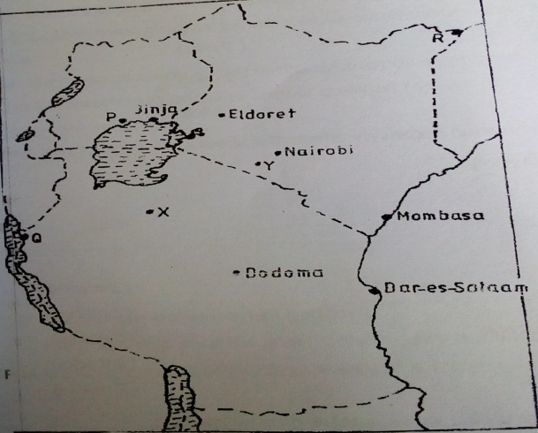

i) Name the towns marked P, Q and R. (3mks)
ii) Name the mineral that influence the growth of towns marked X and Y. (2mks)
iii) Name two categories of urban centres (2mks)
iv) Explain four factors that have led to the growth of Thika as a major industrial centre in Kenya. (8mks)

