312/1
GEOGRAPHY
PAPER 1
TIME: 2hours 45 minutes
Form 3
Kenya Certificate of Secondary Education
312/1
Paper 1
GEOGRAPHY

INSTRUCTIONS TO STUDENTS
This paper has two sections, A and B
Answer ALL the questions in Section A. In section B, answer question 6 and any other TWO questions
Section A: 25 MARKS
Answer all questions in this section.
1 (a) What is the solar system? (2 marks)
(b) State three effects of the earth’s revolution. (3 marks)
2 (a) Name two layers of the atmosphere. (2 marks)
(b) Given that time at Rabat, Morocco 5⁰ W is 8.00am. Calculate the longitude of Mogadishu where time is 11am. (3 marks)
3 (a) Identify the countries in which the following fold mountains are found(3 marks)
- Himalayas
- Atlas
- Rockies
(b) Draw a diagram showing a simple fold (3 marks)
4 (a) Distinguish between Vulcanicity and Volcanicity. (2 marks)
(b) Apart from vulcanicity, give three processes that lead to formation of lakes. (3 marks)
5 (a) State four ways in which humus improves the quality of soil. (4 marks)

SECTION B
6.Study the map of YIMBO 1:50,000(sheet 115/1) provided answer the following questions.
a.) i.) Convert the representative fraction scale given on the map to a statement scale (2 marks)
ii.)Identify three Districts that are covered by the Yimbo map (3 marks)
b.) i.) Give the exact height of Usengi hill (1 mark)
ii.) with evidence from the map, give any two social services that are offered in the area covered by the map (2 marks)
c.) i.) Using a scale of 1 cm represents 20 m, draw a cross section from grid reference 320790 to grid reference 390790 (4 marks)
ii.) On the cross section, mark and name the following:-
- A lake (1 mark)
- Main track (motorable) (1 mark)
- A river (1 mark)
d.) i.) Describe the relief of the area covered by the map (4 marks)
ii.)Explain three factors that have influenced settlement in the area covered by the map(6 marks)
7.a)i) Distinguish between faulting and earth movements. (2marks)
ii)The diagram below represents an area affected by faulting. Name the parts marked E, F and G. (3marks)
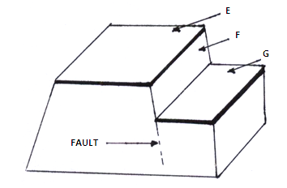
b) Describe the formation of the Rift valley by anticlinal arching. (7marks)
c) Describe the origin of the continents according to plate tectonics theory (4marks)
(d)(i)List three features formed as a result of faulting apart from Rift Valley(3marks)
(ii)Explain three ways in which faulting may influence drainage of an area(6 Marks)

8 (a) (i) What is vegetation? (2 marks)
(ii) Distinguish between natural and derived vegetation. (2 marks)
(b) The map below shows the world vegetation regions. Study and use it to answer the questions that follow.
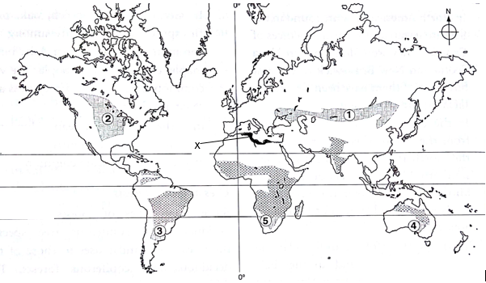
(i) Identify grassland regions marked 1, 3 and 5. (3 marks)
(ii) Describe the characteristics of vegetation marked X (5 marks)
(c) Explain how the following factors influence growth and distribution of vegetation
- Altitude (2 marks)
- Soils (2 marks)
- Human activities (2 marks)
(d) Your class is to undertake a field study on vegetation in the Mau forest.
(i) State two objectives of the study. (2 marks)
(ii) Prepare a working schedule for the study. (5 marks)

9.a.) i) State two reasons why wind erosion is effective in hot deserts (2 marks)
ii.) Explain three processes of wind erosion in deserts (6 marks)
b.) i) Name three features that result from wind erosion apart from rock pedestals (3 marks)
ii) Describe the formation of rock pedestals (5 marks)
c. i) what is a Karst Scenery? (1 mark)
ii)State three conditions that are necessary for the formation of a karst Scenery (3 marks)
d.i) Name three surface features in the Karst region. (3 marks)
ii) State two significances of the Karst scenery. (2 marks)

10 (a) (i) Define the term glacier. (2 marks)
(ii) List three types of glaciers (3 marks)
(b) describe how the following features found in glaciated landscapes are formed.
- U-shaped valley(5 marks)
- Roche mountonee(5 marks)
(c) Explain three significances of upland glaciated features to human activities (6 marks)
(d) Suppose you were to carry out a field study of glaciated lowlands.
(i) Sate two advantages of using oral interviews to collect information during the study(2 marks)
(ii) Name two features of deposition found in glaciated lowlands that you are likely to study. (2 marks)

