Jina:……………………………………………………………………………… Nambari ya usajili:………………
Sahihi ya Mtahiniwa: ……………………………………………. Darasa: ………………………………
MTIHANI WA PAMOJA WA MOKASA
102/2
KISWAHILI
Karatasi ya 2
LUGHA
Muda: Saa 2½
Maagizo
- Andika jina lako na namba yako ya usajili shuleni katika nafasi ulizoachiwa hapo juu.
- Tia sahihi yako kisha uandike tarehe ya mtihani katika nafasi ulizoachiwa hapo juu.
- Jibu maswali yote.
- Majibu yote yaandikwe kwenye nafasi ulizoachiwa katika kijitabu hiki cha maswali.
- Majibu yote ni lazima yaandikwe kwa lugha ya Kiswahili.
- Usitoe ukurasa wowote kutoka kwenye kijitabu hiki.
- Karatasi hii ina kurasa 13 zilizopigwa chapa.
- Watahiniwa ni lazima wahakikishe kwamba kurasa zote za karatasi hii zimepigwa chapa sawasawa na kuwa maswali yote yamo.

Kwa matumizi ya mtahini pekee

SWALI | UPEO | ALAMA
- UFAHAMU | 15
- MUHTASARI | 15
- SARUFI | 40
- ISIMUJAMII | 10
JUMLA | 80

UFAHAMU (Alama15)
Soma habari ifuatayo kisha ujibu maswali yanayofuata.
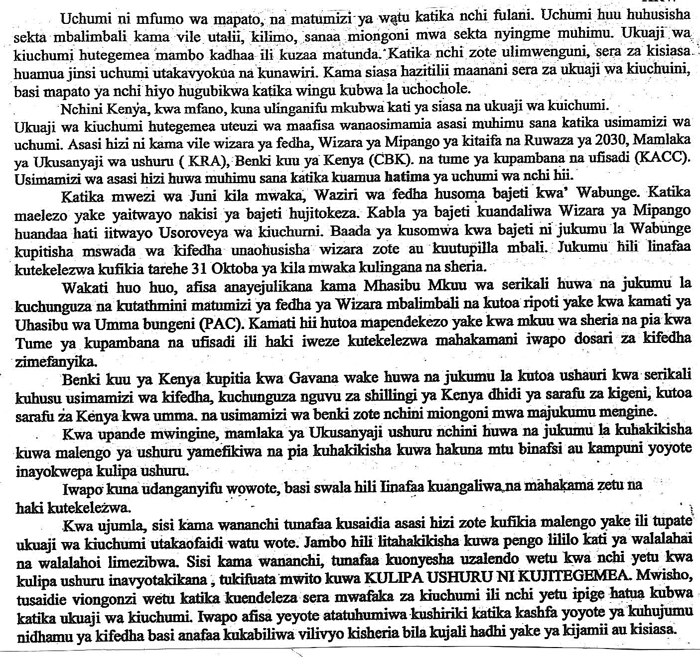

Maswali
- Ipe habari hii kichwa mwafaka. (alama 1)
…………………………………………………………………………………………………

- Ukuaji wa kiuchumi nchini Kenya hutegemea nini? (alama 2)
………………………………………………………………………………………………….
………………………………………………………………………………………………….
………………………………………………………………………………………………….
- Benki kuu ya Kenya ina majukumu yepi? (alama 4)
………………………………………………………………………………………………….
………………………………………………………………………………………………….
………………………………………………………………………………………………….
………………………………………………………………………………………………….
………………………………………………………………………………………………….
………………………………………………………………………………………………….
………………………………………………………………………………………………….
- Mhasibu mkuu ana dhima ipi serikalini? (alama 2)
………………………………………………………………………………………………….
………………………………………………………………………………………………….
………………………………………………………………………………………………….
………………………………………………………………………………………………….
- Pendekeza hatua tatu za kufufua uchumi kulingana na taarifa (alama 3)
………………………………………………………………………………………………….
………………………………………………………………………………………………….
………………………………………………………………………………………………….
………………………………………………………………………………………………….
………………………………………………………………………………………………….
………………………………………………………………………………………………….
- Ni vipi Wakenya wanaweza kuonyesha uzalendo? (alama 1)
………………………………………………………………………………………………….
………………………………………………………………………………………………….
- Eleza maneno yafuatayo kama yalivyotumika katika ufahamu. (alama 2)
(i) hatima ………………………………………………………………………………………
(ii) wahalahai
…………………………………………………………………………………..

2. UFUPISHO (alama 15)
Soma kifungu kifuatacho kisha ujibu maswali
Inaaminika kuwa majeruhi wengi katika mikasa ya ajali huaga au kuathirika vibaya zaidi kutokana na hali mbaya ya uokoaji. Watu wengi ambao hujitolea kutoa majeruhi baada ya ajali kama za barabarani, maporomoko ya ardhi au nyumba huwa hawang’amui hata chembe jinsi ya kukabiliana na uokoaji. Hatima ya juhudi zao ambazo hulenga kutenda mema ni kuathirika zaidi kwa majeruhi.
Hali ya uokoaji inaweza kurekebishwa kwa kutoa elimu ya huduma ya kwanza kwa umma. Elimu hii yahitajika na kila Mkenya kwani mikasa ya ajali za barabarani na nyinginezo inaendelea kutokea kila siku.
Ajali zinapotokea si ajabu kuona makundi ya waokoaji wakibeba majeruhi hobelahobela bila kuzingatia madhara wanayoweza kuwaongezea kutokana na ubebaji wao. Kutojua namna ya kumbeba majeruhi kunaweza kumbabatisha na hata kusababisha kifo.
Kuna mambo mbalimbali ambayo makundi ya waokoaji yanatakiwa kuzingatia wakati yanatoa huduma ya kuokoa. Kwanza ni muhimu kuchunguza kama kuna hatari yoyote inayoweza ikatokea na kuwatia majeruhi na waokoaji hatarini zaidi. Makundi ya waokoaji yameweza kwa kuliingilia eneo la ajali mbumbumbu kama mzungu wa reli.
Hatua ya pili ni kutafuta idadi ya majeruhi. Pana uwezekano wa majeruhi kutupwa mbali na eneo la ajali.Vivyo hivyo, kuna majeruhi ambao huweweseka baada ya ajali na kuanza kutembea wasijue wanakoelea. Wengi wao huanguka karibu na eneo la ajali au wakaenda mbali.
Hatua ya tatu ni kuchunguza kama majeruhi amezimia, moyo unapiga na jinsi anavyopumua. Ili kuhakikisha kuwa majeruhi anapumua, mwokoaji atazame kama kifua kinapanda na kushuka. Hali kadhalika, mwokoaji anaweza kusikiliza au kuguza kifua na kuona kama kuna ishara za kupumua. Iwapo majeruhi anapumua, muokoaji amweke katika hali ambayo itaimarisha kupumua kwake. Anaweza akamlaza chali au kumgeuza kwa pamoja na kichwa chake ili kufungua mkondo wa hewa. Pia mwokoaji ahakikishe hamna chochote kinywani kinachoweza kumsakama. Ikiwa hapumui, mwokoaji anaweza kujaribu kumfanya apumue kwa kupuliza hewa mdomoni mwake.
Fauka ya hayo, upulizaji wa hewa utahakikisha kuwa damu inazunguka mwilini vizuri.
Hatua nyingine ni kuchunguza vile amejeruhiwa. Chunguza kama majeraha ni vidonda tu au kuna kuvunjika kwa mfupa na kubainisha ni mfupa upi. Haya yatamwezesha mwokoaji kujua jinsi ya kumbeba majeruhi. Pakiwa na kuvunjika kwa mfupa, ni muhimu kutotumia kiungo kilichovunjika anapobebwa.
Pia kuchunguza vile majeruhi amejeruhiwa, humwezesha mwokoaji kujua huduma ya dharura atakayoitumia. Majeruhi akiwa anavuja damu sana, ni muhimu kuzuia uvujaji huu. Iwapo ni kidonda kidogo, kinahitaji kufungwa ili kuzuia uambukizaji. Mwokoaji anaweza kutumia kifaa chochote kilicho karibu kutolea huduma hizi. Kwa mfano, anaweza kupasua nguo ya majeruhi ili apate kitambaa cha kusaidia kuzuia kuvuja kwa damu au kumfunga kidonda.
Hatua inayofuata ni kumhamisha majeruhi toka eneo la ajali hadi hospitalini. Mwokoaji anaweza kuwatumia watu wengine kutafuta msaada. Wanaweza kupiga simu wakitumia nambari za simu za dharura kama zile za polisi, wazimamoto au makundi ya wataalamu wa shughuli za uokoaji. Nambari hii ya simu huwa 999 popote na huwa haina malipo. Wanaopiga simu ni vyema kutoa maelezo ya mahali ambapo ajali imetokea, ama ya ajali na huduma za dharura zinazohitajika.
Ikiwa makundi ya wataalamu wa uokoaji hayakupatikana, ni jukumu la mwokoaji kuhakikisha majeruhi wamehamishwa na kupelekwa hospitalini. Majeruhi wakiwa wengi ni bora kuanza na wale waliozimia au wenye matatizo ya kupumua kisha kuwaendea wanaovuja damu sana. Baadaye mwokoaji awasaidie waliovunjika mifupa huku akimalizia na wenye majeraha yasiyohatarisha maisha. Ni muhimu kuwabeba majeruhi kwa kutumia machela. Hii hupunguza kuathirika zaidi kwa majeruhi. Iwapo hamna machela karibu, mwokoaji anaweza kuunda moja kwa kutumia vipande viwili vya mbao, blanketi shuka au makoti.
Ujuzi wa huduma ya kwanza ni mojawapo ya mambo muhimu ambayo kila mtu anapaswa kuwa nayo.
MASWALI
- Fupisha aya tatu za kwanza kwa maneno 50 tu. (Alama 5, utiririko 1)
Matayarisho
……………………………………………………………………………………………………………………………………………………………………………………………………………………………………………………………………………………………………………………………………………………………………………………………………………………………………………………………………………………………………………………………………………………………………………………………………………………………………………………………………………………………………………………………………………………………………………………………………………………………………………………………………………………………………………………………………………………………………………………………………………………………………………………………………………………………………………………………………………………………………………………………………………………………………………………………………………………………………………………………………………………………………………………………………………………………………………………………………........................…………………………
Nakala safi
……………………………………………………………………………………………………………………………………………………………………………………………………………………………………………………………………………………………………………………………………………………………………………………………………………………………………………………………………………………………………………………………………………………………………………………………………………………………………………………………………………………………………………………………………………………………………………………………………………………………………………………………………………………………………………………………………………………………………………………………………………………………………………………………………………………………………………………………………………………………………………………………………………............................................................................................................................
- Eleza kwa kutumia maneno 90-100, hatua zinazotakiwa kufuatwa wakati wa uokoaji.
(Alama 10, utiririko 1)
Matayarisho
………………………………………………………………………………………………………………………………………………………………………………………………………………………………………………………………………………………………………………………………………………………………………………………………………………………………………………………………………………………………………………………………………………………………………………………………………………………………………………………………………………………………………………………………………………………………………………………………………………………………………………………………………………………………………………………………………………………………………………………………………………………………………………………………………………………………………………………………………………………………………………………………………………………………………………………………………………………………………………………………………………………………………………………………………………………………………………………………………………………………………………………………………………………………………………………………

Nakala safi
………………………………………………………………………………………………………………………………………………………………………………………………………………………………………………………………………………………………………………………………………………………………………………………………………………………………………………………………………………………………………………………………………………………………………………………………………………………………………………………………………………………………………………………………………………………………………………………………………………………………………………………………………………………………………………………………………………………………………………………………………………………………………………………………………………………………………………………………………………………………………………………………………………………………………………………………………………………………………………………………………………………………………………………………………………………………………………………………………………………………………………………………………………………………………………………………………………………………………………………………………………………………………………………………………………………………………………………………………………………………………………………………………………………………………………………………………………………………………………………………………………………………………………………………………………………………………………………………………………………………………………………………………………………………………………………………………………………………………………………………………………………………………………………………

MATUMIZI YA LUGHA (alama 40)
- Huku ukizingatia jinsi hewa inavyozuiliwa, ainisha sauti zifuatazo: (alama 2)
i) /y/ ........................................................................................
ii) /sh/........................................................................................
iii) /h/........................................................................................
iv) /ny/.......................................................................................
- Andika neno lenye muundo ufuatao. (alama 2)
i) irabu, irabu, irabu ..................................................................................................................
ii) irabu, konsonanti, konsonanti, konsonanti, irabu .................................................................................................................
- Ainisha mofimu katika maneno yafuatayo: (alama 2)
i) mwanao
................................................................................................................................................................................................................................................................................................
ii) azingatiaye
...............................................................................................................................................................................................................................................................................................................................................................................................................................................................................................................................................................................................
- Onyesha aina za vielezi katika sentensi zifuatazo: (alama 2)
i) Barabara ndefu zaidi ilisakafiwa barabara.
................................................................................................................................................................................................................................................................................................
ii) Kiplagat alianza kula alipoambiwa asishike chakula hivi hivi.
................................................................................................................................................................................................................................................................................................

- Andika sentensi ifuatayo kwa ukubwa. (alama 2)
Mwanamke huyu alibeba ndoo hizi hadi sokoni.
................................................................................................................................................................................................................................................................................................
- Tunga sentensi yenye muundo ufuatao. (alama 2)
KN(RH + RH) + KT(t + V)
...............................................................................................................................................................................................................................................................................................
- Tunga sentensi ukitumia neno alikuwa kama:
i) kitenzi kishirikishi kikamilifu (alama 1)
................................................................................................................................................................................................................................................................................................
ii) kitenzi kisaidizi (alama 1)
...............................................................................................................................................................................................................................................................................................
- Andika sentensi ifuatayo katika usemi wa taarifa: (alama 3)
Mwanasiasa alisema, “ Mkinipigia kura nitawajengea zahanati kabla mwisho wa mwaka huu.”
............................................................................................................................................................................................................................................................................................................................................................................................................................................................................................................................................................................................
- Nomino zifuatazo ziko katika ngeli gani? (alama 1)
i) ufizi ..................................................................................................................
ii) firigisi ................................................................................................................
- Andika sentensi ifuatayo katika wakati ujao hali timilifu. (alama 1)
Waziri anasoma hotuba yake.
................................................................................................................................................

- Andika sentensi ifuatayo katika hali kanushi: (alama 1)
Nzige wengi walikuwa wanavamia maeneo hayo kabla ya serikali kuchukua hatua.
................................................................................................................................................................................................................................................................................................
- Bainisha kiima na yambwa katika sentensi ifuatayo. (alama 3)
Mama alimpikia mgeni wetu nyama ya kuku.
................................................................................................................................................................................................................................................................................................
- Ainisha vishazi katika sentensi ifuatayo. (alama 3)
Mwalimu aliyetuzwa jana alifundisha shairi lililotungwa na Kezilahabi.
................................................................................................................................................................................................................................................................................................
- Tunga sentensi moja kutofautisha maana ya daka na taka. (alama 2)
................................................................................................................................................................................................................................................................................................
- Tunga sentensi mbili kuonyesha matumizi mawili ya kiambishi ka. (alama 2)
................................................................................................................................................................................................................................................................................................................................................................................................................................................................................................................................................................................................
- Changanua sentensi ifuatayo kwa njia ya mistari. (alama 4)
Genge la wezi lilituvamia.
...............................................................................................................................................................................................................................................................................................................................................................................................................................................................................................................................................................................................................................................................................................................................................................................................................................................................................................
- Bainisha virai katika sentensi ifuatayo. (alama 3)
Pikipiki iliyonunuliwa jana iliharibika karibu na mto.
................................................................................................................................................................................................................................................................................................................................................................................................................................................................................................................................................................................................
- Eleza majukumu ya sentensi ifuatayo: (alama 1)
Nipe kalamu yangu mara moja!
................................................................................................................................................................................................................................................................................................
- Andika sentensi ifuatayo upya kwa kubadilisha maneno yaliyopigiwa mstari katika kauli zilizo mabanoni. (alama 2)
Kazi hii imekuwa (tendea) ngumu sana lakini siwezi kufa (tendeshwa) moyo.
................................................................................................................................................................................................................................................................................................
- Taja methali inayoafiki maelezo yafuatayo: (alama 1)
Mtu anayetegemewa katika jamii akiondoka wanaomtegemea huwa mashakani.
................................................................................................................................................................................................................................................................................................

ISIMUJAMII (alama 10)
‘’Mwenye sikio amesikia. Usiwe kama mimi. Wapurukushe wote wakupotoshao. Fuata ruwaza ya wanaokujali. Kwangu nimejishika sikio baada ya laiti nyingi. Macho yamefumbuka. Usiseme nitazeekea huku. Lengo langu ni kuwahi uzamili na hata uzamifu. Kwani kuitwa profesa ni kosa? Niwafae wengine kimasomaso na kihali’’
a)Taja na kuthibitisha sajili ya mazungumzo haya. (alama 2)
.......................................................................................................................................................................................................................................................................................................................
b)Tambua mazingira ambamo mazungumzo haya yanatokea. (alama 1)
........................................................................................................................................................................................................................................................................................................................
c)Eleza sifa zozote saba za lugha zilizotumika kwenye mazungumzo haya. (alama 7)
................................................................................................................................................................................................................................................................................................................................................................................................................................................................................................................................................................................................................................................................................................................................................................................................................................................................................................................................................................................................................................................................................................................................................................................................................................................................................................................................................................................................................................................................................................................................................................................................................................................................................................................................................................................................................................................................................................................................................ ................................................................................................................................................................................................................................................................................................................................................................................................................................................................................................................................................................................................................................................

