Name: …………………………………………………………………………….. Class: ………… Adm.No……………..
School: …………………………………………………………………………… Date: ………………………………………
Sign:………………………………………..
121/1
MATHEMATICS
PAPER 1
TIME: 2 ½ HOURS

M O K A S A J O I N T E X A M I N A T I O N -
Kenya Certificate to Secondary Education
MATHEMATICS (PAPER 1)
TIME: 2 ½ HOURS
Instructions
- Write your name, class, admission number, school, date and signature in spaces provided above.
- The paper contains two sections A and B.
- Answer all questions in section A and any five questions from section B in the spaces provided below each question.
- Show all the steps in your calculations giving your answers at each stage in the spaces below each question.
- Non-programmable silent electronic calculator and mathematical tables may be used except where stated otherwise.

For Examiner’s Use Only
1 | 2 | 3 | 4 | 5 | 6 | 7 | 8 | 9 | 10 | 11 | 12 | 13 | 14 | 15 | 16 | TOTAL
SECTION A

SECTION B

17 | 18 | 19 | 20 | 21 | 22 | 23 | 24 | TOTAL  PERCENTAGE  SCORE

SECTION A (50 MARKS)

Answer all questions in this section in the spaces provided

- Without using a calculator or mathematical tables, evaluate: (3 marks)
$\frac{8÷2 + 12 × 9 - 4 × 6}{56 ÷ 7 × 2}$

- A farmer has a piece of land measuring 840m by 396m. He divides it into square plots of equal size. Find the maximum area of one plot. (3 marks)

- Use factor method to evaluate the expression below leaving your answer as a product of its prime factors in power form. (3 marks)
$\sqrt{5184×49}$

- Simplify completely. _{(3 marks)}

- The length of a rectangle has increased in the ration 3 : 2 and the width reduced in the ratio 4 : 5. If the original length and width were 18 cm and 15 cm respectively. Find the ratio of change in its area. (3 marks)

- A boy has a metal of density 14000kg/m.He intends to use it to make a rectangular pipe with external dimensions of 18cm by 10cm and internal dimensions of 15cm by 8cm.The length of the pipe is 150cm .Calculate the mass of the pipe in kg. (3 marks)

- A two-digit number is 18 more than the number formed by reversing the digits. If the sum of the digits is 10. Find the number. (3 marks)

- In a regular polygon each exterior angle is 90⁰ less than each interior angle. Calculate the number of sides of the polygon hence give its name. (3 marks)

- Use tables of cubes, cube roots and reciprocals, correct to four significant figures, to evaluate: (4 marks)
$${ \left\{{3.479}^{3}+\frac{5}{0.01732}\right\}}^{\frac{1}{3}}$$

- Solve for y in the equation (3 marks)

- Find the equation of the perpendicular to the line $x+2y=4$ that passes through the point (3, 2). Express your answer in the form $y=mx+c$. (3 marks)

- Solve the inequalities and represent the solution on a number line. (3 marks)

$\frac{x-3}{-3}<1$

$3x+1>-17$

- The figure PQRS below is a regular tetrahedron of side 4cm.
Draw its net and find the surface area. (3 marks)

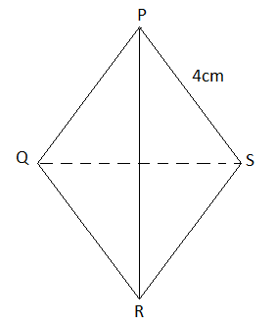

- Two similar solids whose densities are each 1g/cm³ are such that the first has a height of 5 cm and a volume of 120 cm³. The second has mass of 3240g. Find the height of the second solid. (3 marks)

- A bank in Canada offers the following exchange rates between Canadian dollars (CAD) and Euros (EUR) .The bank sells 1CAD for 0.82EUR and buys 1CAD for 0.78 EUR. A customer wishes to exchange 800 CAD for Euros. After spending 200 Euros he decided to sell the remaining Euros. How much Canadian dollars did he get after selling the remaining amount to the bank? (3 marks)

- Given the curve $y=x^{3}-3x-1$, find the equation of the tangent to the curve at the point (1,-3). (4 marks)

SECTION B (50 MARKS)
Answer any five questions in this section
- Wafula left Bungoma at 8.00 a.m. towards Nairobi through Kisumu at an average speed of 90 km/hr. Kilima also left Bungoma at 8.21 a.m. towards Nairobi along the same road at an average speed of 97 km/hr.

(a) Determine

(i) the time Kilima caught up with Wafula. (4 marks)

(ii) the distance from Bungoma when Kilima caught up with Wafula.
(2 marks)

(b) Musumba left Kisumu towards Bungoma on the same day at 8.40 a.m. at an average speed of 80km/hr. He met Wafula after 45 minutes of his drive. Determine the distance between Bungoma and Kisumu. (4 marks)

- A school ordered books worth Ksh. 28,000 priced at Ksh. X each. Because of the number involved the supplier reduced the price of each book by Ksh. 10 and the school finally decided to spend Ksh. 27,300 on the books.

(a) Write down expressions for
(i) The number of books originally ordered. (1 mark)

(ii) The number of books finally obtained. (1 mark)

(b) If the second number is 10 more than the first, write down the equation which X satisfy. Hence find the price at which the school bought the books. (6 marks)

(c) Find the ratio of the number of books to be bought originally to the number of books bought finally. (2 marks)

- The figure below is triangle OAB in which OA= a and OB= b. M and N are points on OA and OB respectively such that OM:MA =1:3 and ON:NB =2:1.

A
B
O
N
Y
M

(a) Express the following vectors in terms of a and b
(i) AM (1 mark)

(ii) BM (1 mark)

(iii) AB (1 mark)

(b) Lines AN and BM intersect at X such that AX=hAN and BX=kBM. Express OX in two different ways and find the value of h and k. (6 marks)

(c) OX produced meets AB at Y such that AY:YB =3:2. Find AY in terms of a and b.
(1 mark)

- The figure below shows circumscribed circle centre C. Chords XY and YZ measures 5cm and 7cm respectively. Angle YXZ=48⁰.

X

5cm
7cm

Y
Z

Calculate;

(a) the length of chord YZ (3 marks)

(b) the radius of the circle. (2 marks)

(c) Area of the triangle XYZ (2 marks)

(d) Area of the shaded region. (3 marks)

21. Draw the graph of for -4. Use a scale of 1 cm to represent 1 unit on the x-axis and 1cm to represent 2.5 units on the y-axis. (3 marks)

Use the graph to solve;
(a) 2 (1 mark)
(b) 2 (3 marks)
(c (3 marks)

22. The figure below shows two circles ABEF and BCDE intersecting at B and E. ABC and FED are straight lines. The line AEG is a tangent to the circle BCDE at E. O is the centre of circle ABEF. AE and BF intersect at K while BD and CE intersect at L. Angle $AEF = {42}^{0}$ and angle $BDE = {38}^{0}$

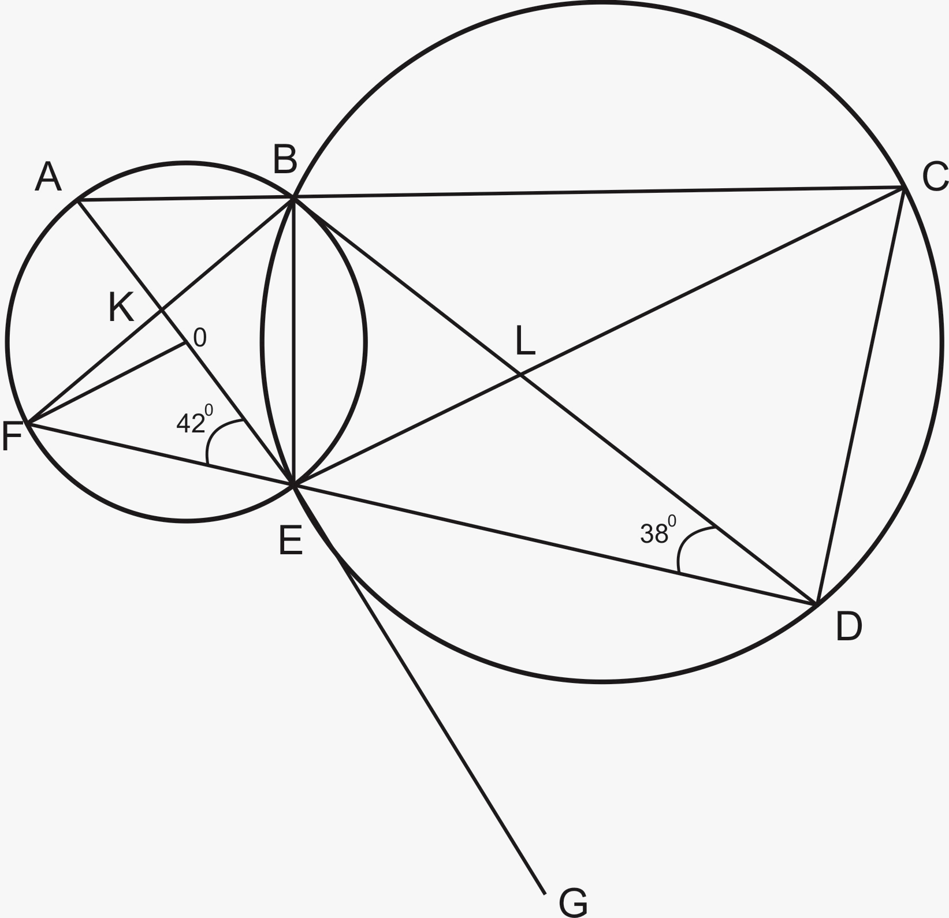

Find the size of the following angles, stating the reasons in each case.

(a) BCE (2 marks)

(b) BEF (2 marks)

(c) FBE (2 marks)

(d) ELD (2 marks)

(e) KFO (2 marks)

23. The figure below shows a frustum of a right pyramid whose top face is a rectangle of side 3 cm by 5 cm and the bottom face is also a rectangle of side 6cm by 10cm. The perpendicular distance between the top and bottom faces (height) is 25cm.
G D d

5cm
3cm
C
F
E
H

10cm

A 6cm B d
Find;

(a) the volume of the frustum. (6 marks)

(b) The surface area of the frustum. (4 marks)

24. PQR is a triangle with coordinates; P(3, 3), R (2, 1) and Q(5, 1). P’Q’R’ is the image of PQR under an enlargement such that the coordinates are P'(-3, 0), Q'(-7, 4) and R'(1, 4). Using a scale of 1:1 on both axes;
(a) (i) Plot PQR and P’Q’R’ hence locate the centre of enlargement by
construction. (4 marks)
(ii) State the scale factor of the enlargement. (2 mark)
(b) P’’Q’’R’’ is the image of PQR under a translation T. Plot P''Q''R''. (2 marks)

(c) P’’’Q’’’R’’’ is the image of PQR under a reflection whose mirror line is Plot P’’’Q’’’R’’’. (2 marks)

