Name: …………………………………………………………Class: ………….….Adm.No. ……………
232/1 Candidate’s Signature: …………………...
PHYSICS
THEORY
Paper 1
Time: 2 hours

St Catherine of Alexandria Ngaru Girls Secondary School
Kenya Certificate of Secondary Education
PHYSICS
PAPER 1
Instructions to Candidates
- Write your name, admission number, class and signature in the spaces provided at the top of the page. This paper consists of two sections; A and B.
- Answer ALL the questions in the spaces provided.
- Mathematical tables and electronic calculator may be used.
- This paper consists of 11 printed pages.
- Candidates should answer the questions in English
- You may use the following constants where necessary:-

g= 10N/kg, or m/s²

Density of water=1000kg/m³

FOR EXAMINER’S USE ONLY

SECTION | QUESTIONS | MAXIMUM SCORE | CANDIDATE’S SCORE
A | 1 – 11 | 25
B | 12 | 12
 | 13 | 15
 | 14 | 09
 | 15 | 09
 | 16 | 10
TOTAL SCORE |  | 80

SECTION A(25 MARKS)
- State the difference between heat and temperature (1 mark)
………………………………………………………………………………………………………………………………………………………………………………………………………………………………………………………………………………………………………………………………………………………………………………………………………………………………………………………………………………………………………………………………………………………………………………………………
- The acceleration due to gravity on Jupiter is about 2.6 times that on earth. A spacecraft has a weight of 24500N on earth.
- What is the mass of the spacecraft? (1 mark)

- What would be the weight on Jupiter? (take acceleration due to gravity on earth as 10N/Kg) (2 marks)

- Use kinetic theory to explain pressure law (3 marks)
………………………………………………………………………………………………………………………………………………………………………………………………………………………………………………………………………………………………………………………………………………………………………………………………………………………………………………………………………………………………
- The figure below shows a uniform block of mass 10kg and length 35cm lying on a table. It hangs over the edge of the table by 15cm.

A B

Block

Table 15cm

Determine the minimum force that can be applied on the block at point B to make it turn about the edge of the table. (3marks)

- Compare diffusion of chlorine gas into air and into vacuum then explain your comparison (2marks)
………………………………………………………………………………………………………………………………………………………………………………………………………………………………………………………………………………………………………………………………………………………………………………………………………………………………………………………………………………………………………………………………………………………………………………………………
- Two identical aluminum rods are placed as shown in the figure below. One rests on a metal block and the other on the wooden block. The protruding ends are heated on a Bunsen burner as shown below:

Aluminium rod wax Aluminium rod

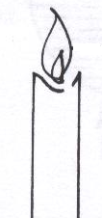

Metal block candle Wooden block

State with reason in which bar the wax is likely to melt (2marks)
…………………………………………………………………………………………………………………………………………………………………………………………………………………………………………………………………………………………………………………………………………………………………………………………………………

- Figure below shows one method of measuring the specific latent heat of fusion of ice. Two funnels A and B contain crushed ice at 0°C.
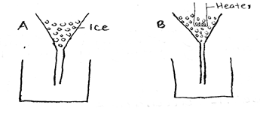
The mass of melted ice from each funnel is measured after 11 minutes. The results are shown below. Mass of melted ice in A = 24g, Mass of melted ice in B = 63g.If the power of the heater is 0.024Kw, determine the specific latent heat of fusion of ice. (3marks)

- An ungraduated mercury thermometer attached to a millimeter scale reads 24mm in ice at 0ºC and 250mm in steam of water at 100ºC.Calculate its reading on a day when the temperature is 30ºC. (3marks)

- Sketch a pulley system with a velocity ratio of 4 using 3 pulleys (2marks)

- Explain why a Bunsen burner has a wide heavy base (2marks)
………………………………………………………………………………………………………………………………………………………………………………………………………………………………………………………………………………………………………………………………………………………………………………………………………………………………………………………………………………………………………………………………………………………………………………………………

- Why is the capillary bore of liquid in glass thermometer narrow (1mark)
………………………………………………………………………………………………………………………………………………………………………………………………………………………………………………………………………………………………………………………………………………………………………………………………

SECTION B (55 marks)

- a) State the principle of conservation of momentum (1mark)
………………………………………………………………………………………………………………………………………………………………………………………………………………………………………………………………………………………………………………………………………………………………………………………………………………………………………………………………………………………………………………………………………………………………………………………………
b)A bullet of mass 20g travelling horizontally at a speed of 250m/s hits a stationary block of wood of mass 1000g on a rough table surface. The bullet emerges on the other side of the block at a velocity of 90m/s
- State the types of collision involved above (1mark)
………………………………………………………………………………………………………………………………………………………………
- Determine the initial velocity of the block after being hit by the bullet (3marks)

- If the block travels at a distance of 5m, determine;

- the deceleration on the block (3marks)

- frictional force on the block (2marks)

- coefficient of friction on the surface (2marks)

- a) State the law of floatation. (1mark)
………………………………………………………………………………………………………………………………………………………………………………………………………………………………………………………………………………………………………………………………………………………………………………………………
b) A piece of sealing wax weighs 3N in air and 0.22N when immersed in water. Calculate
- its relative density (2marks)

- its apparent weight in a liquid of density 800kg/m³ (3marks)

c)The figure below shows a uniform beam one metre long and weighing 2N kept in horizontal position by a body of weight 5N immersed in a liquid
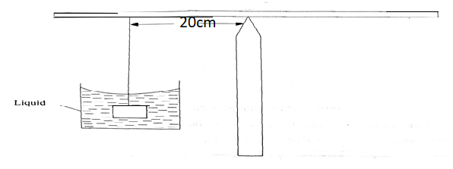
Determine the upthrust on the load (3marks)

d)A block of wood of volume V floats with 0.75 of its volume submerged in water. When put in another liquid it floats with 0.42 of its volume under the liquid. Calculate:
- the density of the wood (3marks)

- the density of the liquid (3marks)

- a) Explain why bodies in circular motion undergo acceleration even when their speed is constant. (2marks)
………………………………………………………………………………………………………………………………………………………………………………………………………………………………………………………………………………………………………………………………………………………………………………………………………………………………………………………………………………………………………………………………………………………………………………………………
b) A stone of mass 40g is tied to the end of a string 50cm long and whirled in a vertical circle making 2 revolutions per second. Calculate the maximum tension in the string.
(3marks)

c)Figure below shows a stone being whirled in a vertical circle in the clockwise direction.
B
.

A C

D
On the axes provided, sketch a graph of tension against time as the stone moves through points A, B, C and D. (2marks)

Tension(N)

Time (s)
c) State two applications of uniform circular motion. (2marks) ………………………………………………………………………………………………………………………………………………………………………………………………………………………………………………………………………………………………………………………
- a) The figure below shows a simple mercury barometer
= 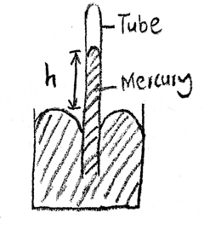
- when the tube was tilted mercury did not fill the tube completely. Give a reason for the observation (1 mark) ……………………………………………………………………………………………………………………………………………………………………………………………………………………………………………………………………… ………………………………………………………………………………………………………………………………………………………………………………………………………………

- give a reason why mercury is preferred as a liquid in a glass barometer
(1mark)
……………………………………………………………………………………………………………………………………………………………………………………………………………………………………………………………………………………………………………………………………………………………………………………………………………………………………………………………………………………
- A town at an altitude of 548m has a barometric height of 70cmHg.Given that the standard atmospheric pressure is 76cmHg and that the density of mercury is 13600kg/m³, determine the density of air (3marks)

b) A student half-filled a container with water, boiled the water for several minutes with the cork removed. Then later replaced the cork and poured some cold water on the container. State and explain the observation made (2marks) ………………………………………………………………………………………………………………………………………………………………………………………………………………………………………………………………………………………………………………………………………………………………………………………………………………………………………………………………………………………………………………………………………………………………………………………………………………………………………………………………………………………………………………………………………………………
c)Determine the pressure on a piston of cross-sectional 20cm² when a force of 50MN is applied to its surface (2marks)

- In an experiment to determine the approximate diameter of an oil molecule,the following measurements were obtained:
-diameter of oil drop=0.05cm
-diameter of oil patch=0.2m
Determine:
- volume of oil drop (3marks)

- area of oil patch (2marks)

- thickness of oil molecule (3marks)

- state two assumptions made in the above experiment (2marks)
……………………………………………………………………………………………………………………………………………………………………………………………………………………………………………………………………………………………………………………………………………………

