FORM 4 PHYSICS
PAPER ONE TERM 1 MARKING SCHEME

- Main scale reading=6.7
V scale reading=0.6

6.7+0.6=6.76
Correct reading =6.76-0.02
=6.74cm

- A. Smoke particles are lighter than air particles and big enough to be seen.
B. The smoke particles are observed to be in continuous random motion.
C. The rate of continuous motion reduces due to decrease in k.e.

- Water at 4ºc is denser; it is also poor conductor of heat.

- - Increase base area
- Lower C.O.G

- H=1/2gt²

- a)

b. The liquid level is high in pipe B than in pipe A because is low deu to the high speed of the air.

- The bulb gets heated first and expands creating more volume.
-The mercury then gets heated and expands.

- Gas pressure=pa +hpg
=1.0×10⁵+ (900×10×0.06)
=10, 000+540
=100,540 pa

- T=1/50=0.02 sec
U=0.06 =30cm/s
0.02

V=2.6=130cm/s
0.02
A=v-u=130-30
t (7×0.02)
= 100
0.14

=714.29cm/s²

- For a thick glass, the inner wall expands more than the outer wall because glass is a poor conductor, while in a thinner one, the expansion is uniform.

- W=1/2ke²
=1/2 ×25× (0.1)²
=1/2 ×25× 0.01
=0.125J

SECTION B
- A) Specific latent heat of fusion a substance required to melt completely one kilogram of a substance to liquid without change in temperature.
B i) Q=ML
=0.02×334,000J
=6680J
ii) Q=Mcd0
=0.02×4200 (t-0)
=84T J
iii) Heat lost by warm water
=mcDo
=0.2×4200 (60-T)
Heat lost by colollmeter
=mcDo
=0.08 ×900 (600T)
iv. Heat gained=Heat lost
6680+84T=0.2 ×4200 (60-T) +0.08×900 (60-T)
6680 +84T =50,400 + 4320 -72T
996T =48040
T= 48.2⁰C
- R=ut =5×0.5
=2.5ms⁻¹
b. S=ut+1/2gt²
u=0
S= 1/2×10× (0.5)²
=5×0.25
=1-25m

c. i) m₁u₁+m₂u₂= (m₁+m₂) v
(0.022×300) = (0.022 +1.978) v
6.6=2/2v
V=3.3ms⁻¹

D i)
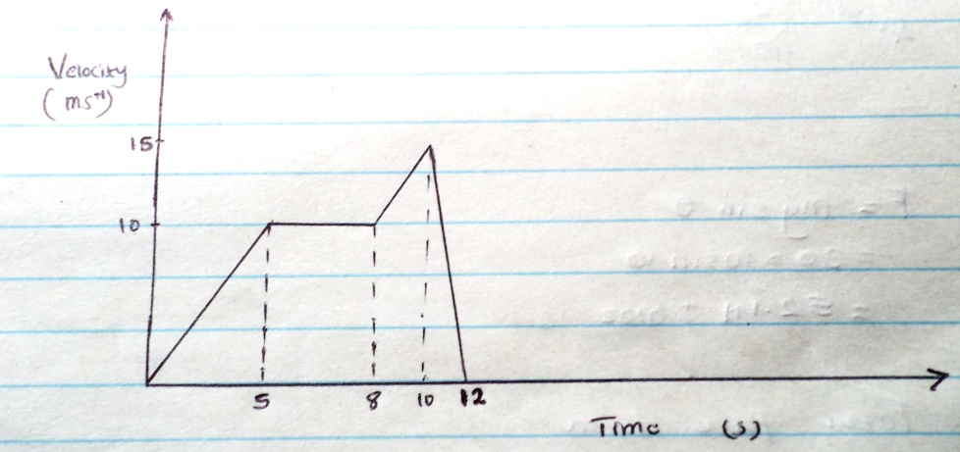

ii)1/2×5×10=25
3×10=30
(15+10)×1/2×2=50
1/2×2×15=15
25+30+50+15=120m

- A) Radius of the curve.
Critical speed.

B) I. W=v/r
=5/2
=2.5rads⁻¹
II) T=F_{c}=mv²
r
= 2×5²
2
= 0.625=0.3125N
2
= 0.3125N

- (a) (i)

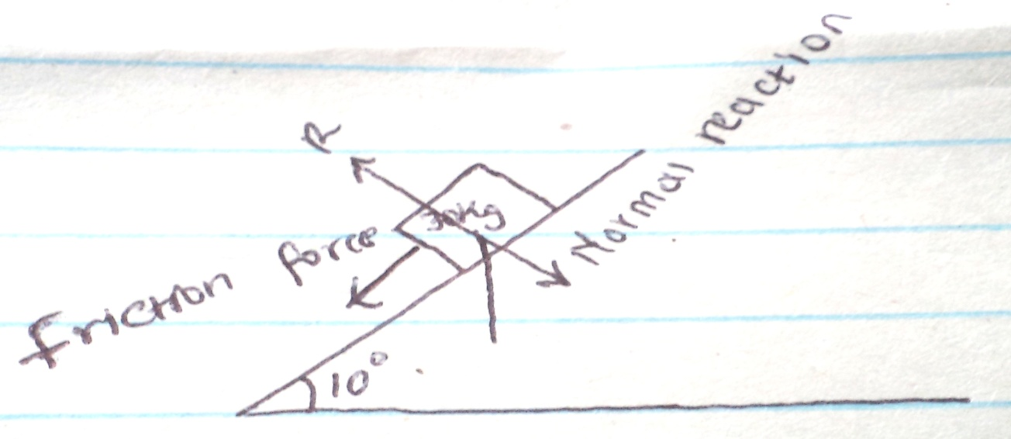

ii) F=mgsin0
=30×10sin 10

=52.1N ±0.02
iii) F=Total force down
=mg sin 0 +friction force
=52.1N + 20.0N
=72.1N

(b) (i) Friction force

(ii) Net force down =mg sin –friction force
=52.1 -20
=32.1

But F=ma
A=f/m=32.1=1.07ms⁻²
30

(iii) Acceleration downwards increases with increase in angle

- (a)(i) The rate of change of momentum of the body is directly proportional to the applied force and takes place in the direction of force.

(ii)

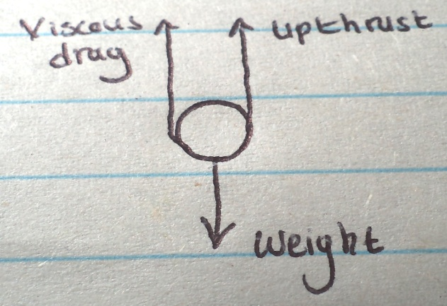

(iii)

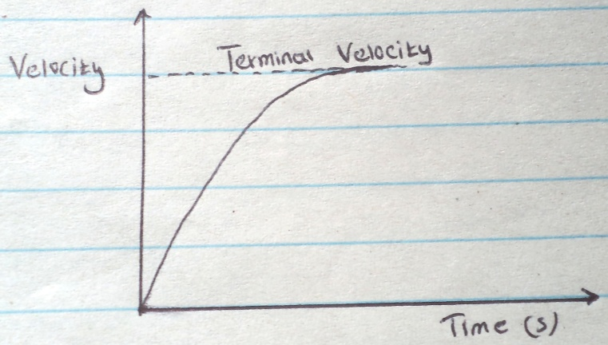

(b) (i) For a fixed mass of a gas pressure is inversely proportional to the volume at constant temperature.

(ii) Temperature at which the gas molecules have zero internal energy.
(iii) P₁V₁=P₂V₂
T₂ T₂

760×80 =1700×38
283 T₂

T₂=1700×38×283
760×80

=300.68
Temp rise =300.68-283 =17.69k

17.69k

