MARKING SCHEME
FORM 4 TERM 1
232/3
PHYSICS PAPER 3

Table 1
Length X cm | 32 | 28 | 24 | 20 | 16 | 12
Time t for 10 oscillations (s) | 9.32 | 8.72 | 8.00 | 7.40 | 6.62 | 5.75
Period T= (s) | 0.932 | 0.872 | 0.8 | 0.74 | 0.662 | 0.575
T² (S²) | 0.87 | 0.76 | 0.64 | 0.55 | 0.44 | 0.33

2

2

1
(any 4 to 6 correct values, 2 marks, 2 to 4 values, 1 mark, less than 2 values, no mark)
- Plot a graph of T² (y-axis) against X (metres) on the graph paper provided. (5 marks)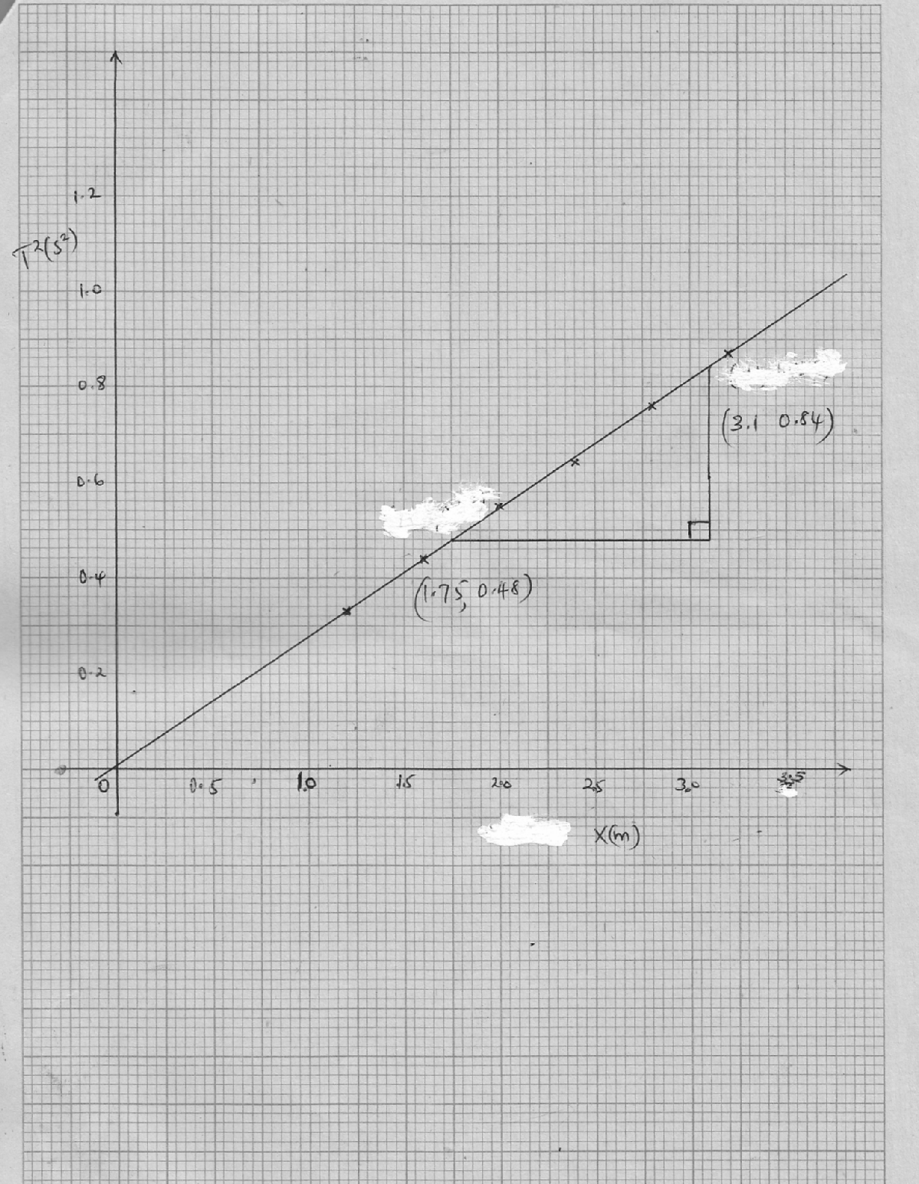
Scale =1 mark
Axes with units=1 mark
Plots = 2 marks
Line = 1 mark
- i)

slope= 

slope = 
slope = 2.67s²/m (3 marks)
ii) Obtain the value of K in the equation S= (2marks)
2.67s²/m=

=

=

/ 
PART B
- (3 marks)
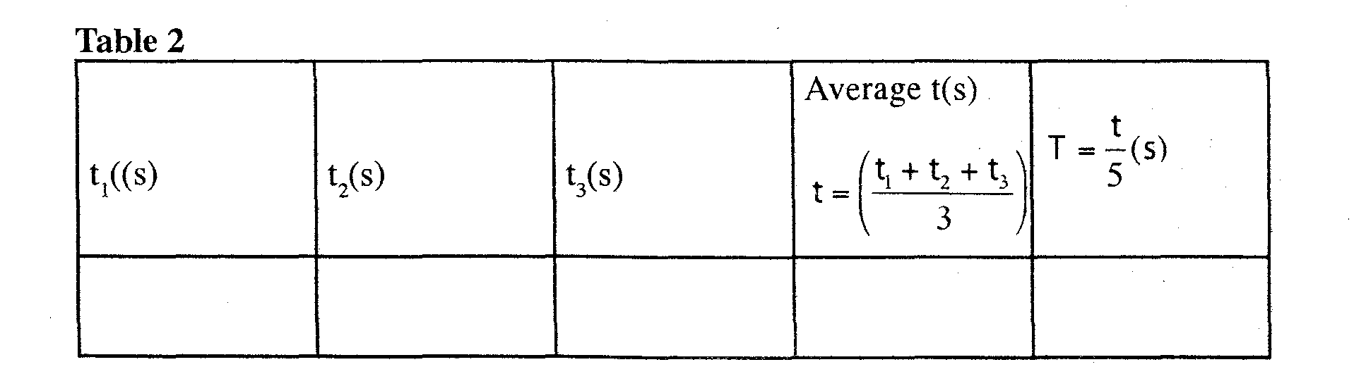
 1
 ½
3.81  ½

3.75  ½
3.68  ½
- (2 marks)
P= 
P=8.547m/s² 
QUESTION TWO
h= 6.3cm  (1 Marks)
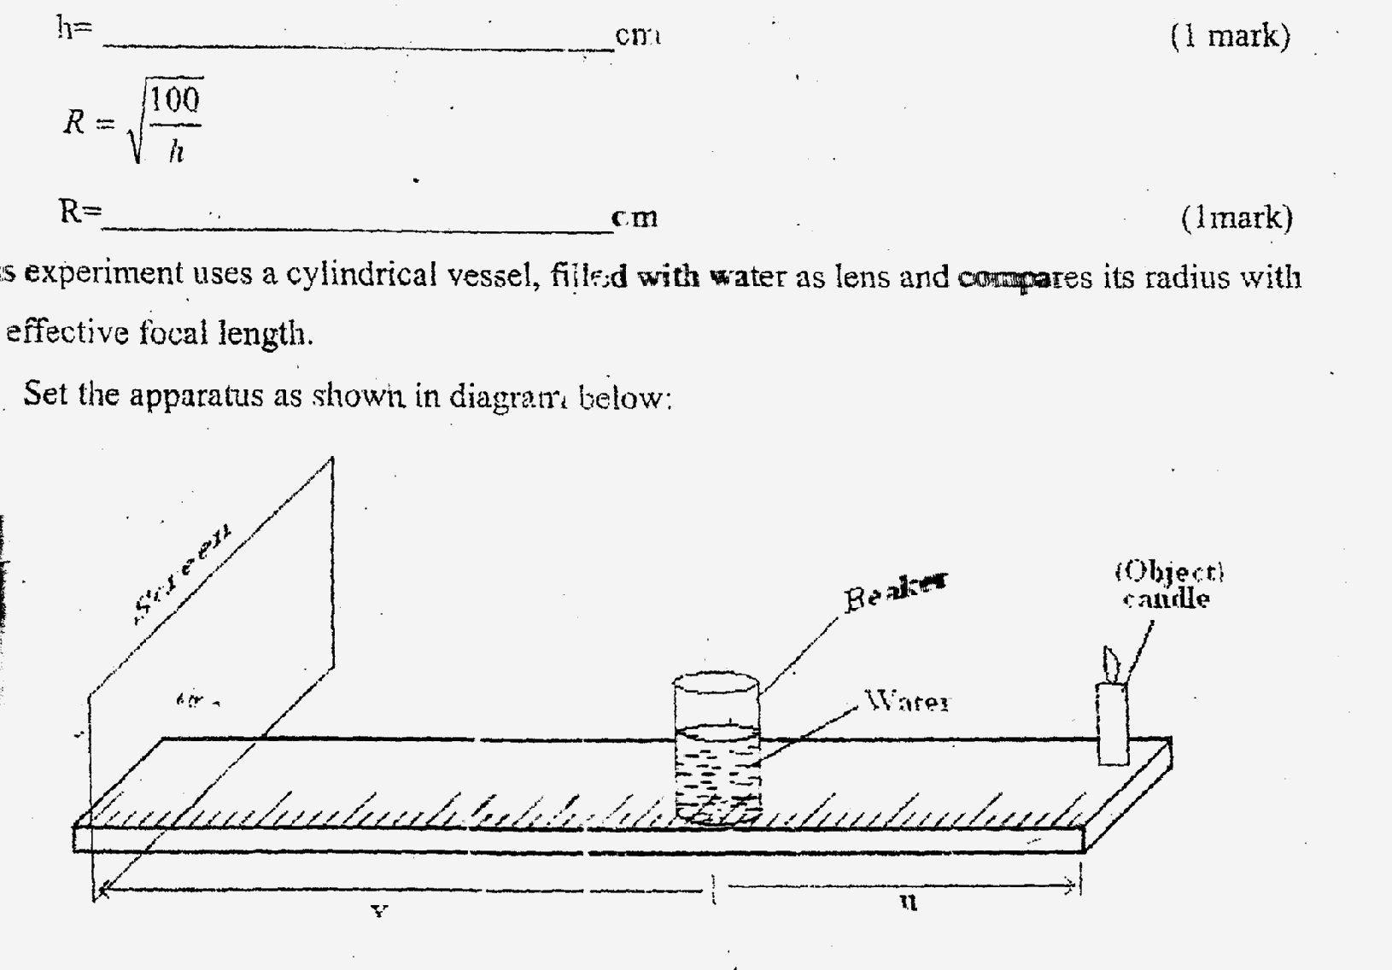

R= cm  (1 Marks)

(i) (8 marks)
 | 10R | 9R | 8R | 7R | 6R | 5R | 4R | 3R
U (cm) | 39.8 | 35.9 | 31.9 | 27.9 | 23.9 | 19.9 | 15.9 | 12.0
V (cm) | 8.5 | 8.8 | 9.1 | 9.1 | 10.4 | 10.6 | 11.4 | 15.0
NB: Any other appropriate value of u and v depending on the value of R obtained can be awarded.
-each correct value = ½ mark
(5 marks)
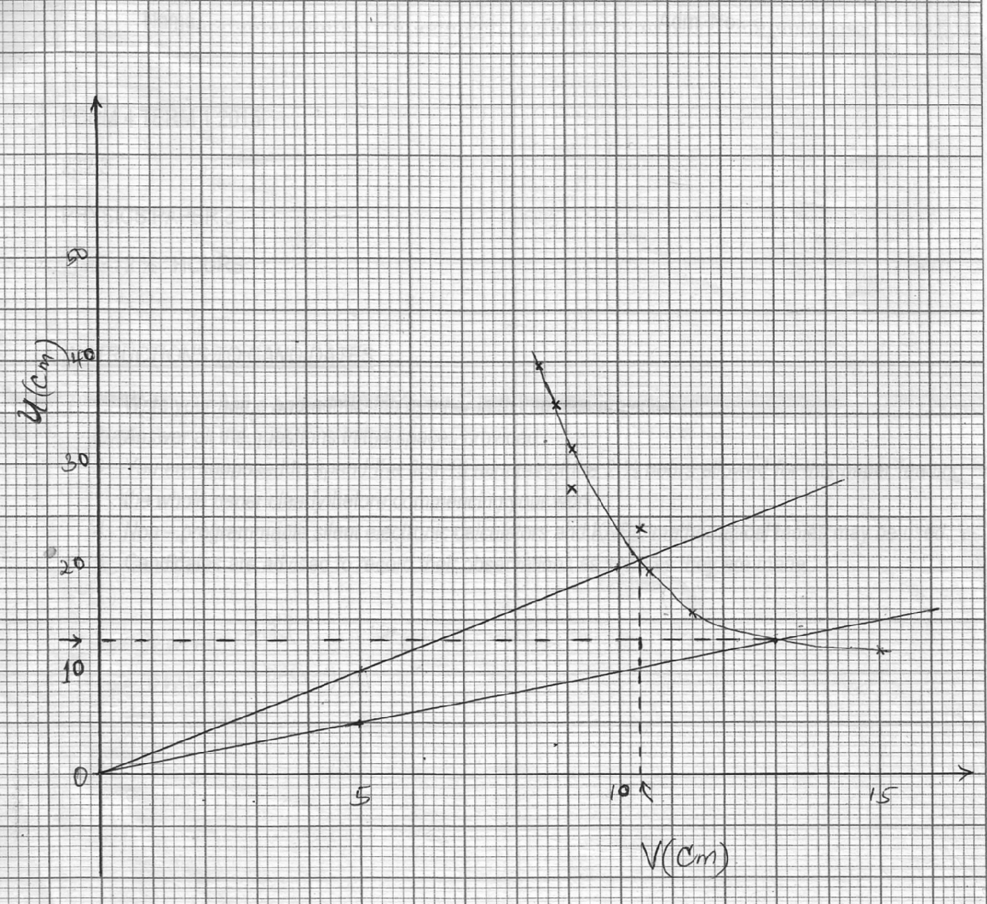

Scale =1 mark
Axes with units=1 mark
Plots = 2 marks
Smooth Curve = 1 mark
- From the graph determine
‘V’ the value of V for which v=u (1 Mark)
‘V’=13cm
- ‘U’ the value of U for which u=2v (1 Mark)
‘U’ = 10.4cm
- Determine the effective focal length of the ‘lens’ from the formulae f= (2 Marks)

=

- Hence determine the value of (1 Mark)


