Name……………………………………………..….… Adm No………………. Class………

Candidate’s Signature…………………….…………….….…...Date…………………………



(SCHOOL OF CHOICE)

**ST. BRIGID’S - KIMININI**

**POST MOCK – 2024 SERIES**

***Kenya Certificate of Secondary Education***

**443/2**

**AGRICULTURE**

**Paper 2**

**SEPTEMBER - 2024**

**Time: 2hours**

**Kenya Certificate of Secondary Education (K.C.S.E)**

**INSTRUCTIONS TO CANDIDATES**

1. Write your name, class, admission numbers and school in the spaces provided
2. Sign and write the date of examination in space provided
3. This paper consists of three sections **A, B** and **C**
4. Answer all questions in section A and B in the spaces provided
5. In section C, answer any two questions in the spaces provided
6. This paper consists of **10** printed pages
7. Candidates should check the question paper to ascertain that all pages are printed as indicated and that no questions are missing

**FOR EXAMINERS USE ONLY**

|  |  |  |  |
| --- | --- | --- | --- |
| **SECTION** | **QUESTION** | **MAX SCORE** | **CANDIDATE SCORE** |
| **A** | **1 – 16** | **30 MARKS** |  |
| **B** | **17-20** | **20 MARKS** |  |
| **C** | **21-23** | **40 MARKS** |  |
|  | **TOTAL** | **90 MARKS** |  |

**SECTION A (30 MARKS)**

**Answer all the questions in the spaces provided**

1. Name **four** zoonotic diseases in livestock (2mks)

………………………………………………………………………………………………

………………………………………………………………………………………………

………………………………………………………………………………………………

………………………………………………………………………………………………

………………………………………………………………………………………………

2. State **four** reasons for maintaining farm tools (2mks)

……………………………………………………………………………………………………………………………………………………………………………………………………………………………………………………………………………………………..

………………………………………………………………………………………………

………………………………………………………………………………………………

3. State **four** advantages of artificial rearing in calves (2mks)

………………………………………………………………………………………………

………………………………………………………………………………………………

………………………………………………………………………………………………

………………………………………………………………………………………………

………………………………………………………………………………………………

4. State **four** reasons for steaming up in dairy cattle (2mks)

………………………………………………………………………………………………

………………………………………………………………………………………………

………………………………………………………………………………………………

………………………………………………………………………………………………

………………………………………………………………………………………………

5. Fill in the table below giving the terms used in reference to animals (2mks)

|  |  |  |
| --- | --- | --- |
| Young one of; | Sheep  ………………………….… | Rabbit  …………………….. |
| Mature female of; | Cattle  …………………. | Goat  ………………………....... |

6. State **four** effects of livestock parasite (2mks)

………………………………………………………………………………………………

………………………………………………………………………………………………………………………………………………………………………………………………………………………………………………………………………………………………

………………………………………………………………………………………………

7. Give **four** signs of ill health observed in the animals skin (2mks)

………………………………………………………………………………………………

……………………………………………………………………………………………...

……………………………………………………………………………………………...

……………………………………………………………………………………………...

………………………………………………………………………………………………

8. State **four** characteristics of a broody hen (2mks)

………………………………………………………………………………………………

………………………………………………………………………………………………

………………………………………………………………………………………………

………………………………………………………………………………………………

………………………………………………………………………………………………

9. Identify the nutrient that is deficient in the following disorder (2mks)

i) Curled toe paralysis in chicks

………………………………………………………………………………………………

………………………………………………………………………………………………

ii) Milk fever

………………………………………………………………………………………………

………………………………………………………………………………………………

iii) Piglet anaemia

………………………………………………………………………………………………

………………………………………………………………………………………………

iv) Sway back in lambs

………………………………………………………………………………………………

………………………………………………………………………………………………

10. State **four** signs of farrowing (2mks)

………………………………………………………………………………………………

………………………………………………………………………………………………

………………………………………………………………………………………………

………………………………………………………………………………………………

11. Give **four** components of power transmission system in a tractor (2mks)

………………………………………………………………………………………………

………………………………………………………………………………………………

………………………………………………………………………………………………

………………………………………………………………………………………………

12. State **four** factors that favour fish farming (2mks)

………………………………………………………………………………………………

………………………………………………………………………………………………

………………………………………………………………………………………………

………………………………………………………………………………………………

13. State **four** factors that stimulates milk let down (2mks)

………………………………………………………………………………………………

………………………………………………………………………………………………

………………………………………………………………………………………………

………………………………………………………………………………………………

14. State **four** symptoms of Gumboro disease in poultry (2mks)

………………………………………………………………………………………………

………………………………………………………………………………………………

………………………………………………………………………………………………

………………………………………………………………………………………………

15. If a cow is detected to have signs of heat at 6am on 12th May 2024, when should it be served? (1mk)

………………………………………………………………………………………………

16. Give **two** categories of vitamins (1mk)

………………………………………………………………………………………………

………………………………………………………………………………………………

**SECTION B (20 MARKS)**

**Answer all questions in this section in the spaces provided**

17. Study the farm tools below and answer the questions that follow

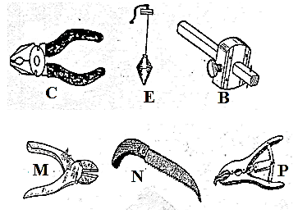

a) Identify the farm tools C,E and B (3mks)

C …………………………………………

E……………………………………………

B…………………………………………….

b) State the functional difference between M and N (1mk)

………………………………………………………………………………………………

………………………………………………………………………………………………

c)State **two** maintenance practices carried out on tool labelled P (1mk)

………………………………………………………………………………………………

………………………………………………………………………………………………

18. The diagram J and K below shows livestock parasites

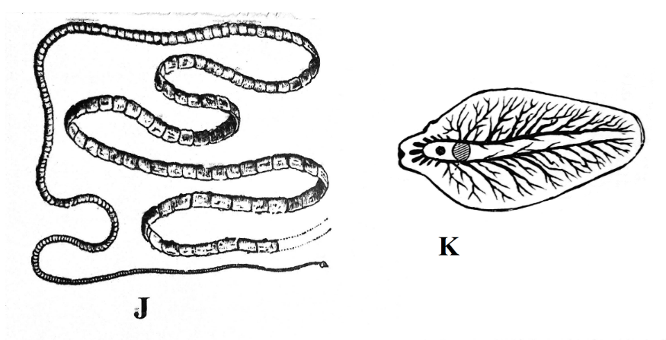

a) Identify parasite labeled J and K (2mks)

J…………………………………………………………………………………………

K…………………………………………………………………………………………

b) Name the organ in which each parasite is commonly found (1mk)

Parasite J

………………………………………………………………………………………………

Parasite K

………………………………………………………………………………………………

c) State **two** control measures of the parasite labeled K in livestock production

(2mks)

………………………………………………………………………………………………

………………………………………………………………………………………………

19. The illustration below shows an animal handling structure. Study it and answer the following questions

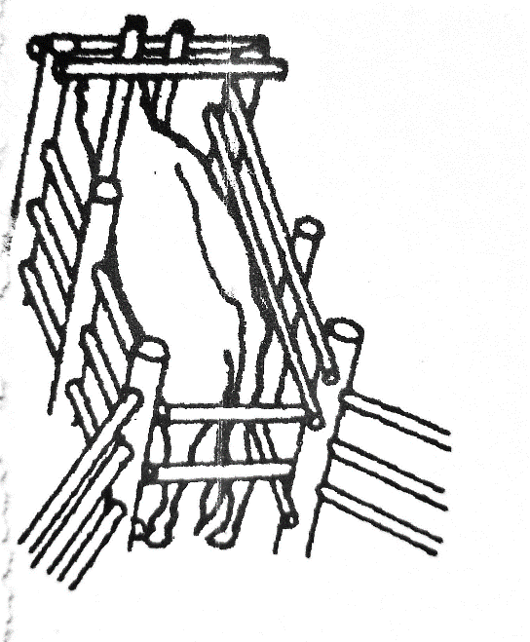

1. Identify the structure illustrated (1mk)

………………………………………………………………………………………………

1. State **two** operations given to animals when confined in the above structure

(2mks)

………………………………………………………………………………………………

………………………………………………………………………………………………

1. Name **two** other related structures that are used in parasite and disease control

(2mks)

………………………………………………………………………………………………

………………………………………………………………………………………………

20. Below are farm implements. Study them and answer the questions that follow

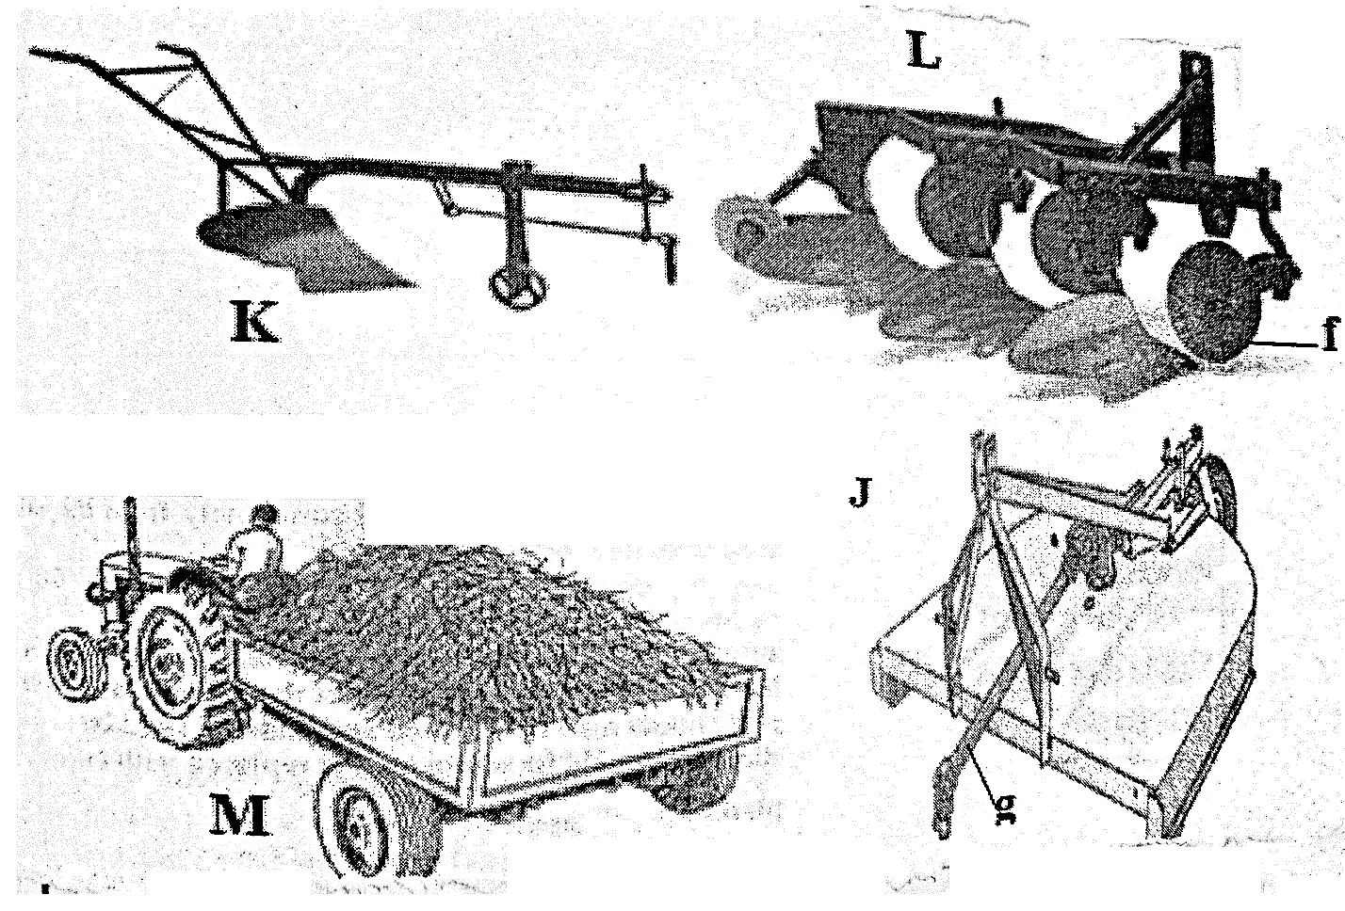

a) Identify the implements K and M (2mks)

K……………………………………………

M……………………………………………

b) State the function of implement J and L (2mks)

J……………………………………………………………………………………..

L…………………………………………………………………………………….

c) State **two** maintenance practices carried out on part labeled F (1mk)

………………………………………………………………………………………………

………………………………………………………………………………………………

**SECTION C (40 MARKS)**

**Answer any two questions in this section**

21. a) Describe coccidiosis under the following sub headings

i) Causal organism (1mk)

ii) Animals attacked (2mks)

iii) Symptoms (3mks)

iv) Control (4mks)

b) Describe **five** essentials of clean milk production (5mks)

c) State **five** advantages of using artificial insemination (5mks)

22. a) Describe the strokes in a four stroke cycle petrol engine (10mks)

b) State the differences between ruminants and non-ruminants (5mks)

c) State **five** characteristics of good dairy cattle breed (5mks)

23. a) Describe management of layers from point of lay to culling (10mks)

b) Explain **six** factors to consider when sitting farm structures (6mks)

c) State **four** factors that determine quality of honey (4mks)

………………………………………………………………………………………………………………………………………………………………………………………………………………………………………………………………………………………………………………………………………………………………………………………………………………………………

………………………………………………………………………………………………………………………………………………………………………………………………………………………………………………………………………………………………………………………

………………………………………………………………………………………………………………………………………………………………………………………………………………………………………………………………………………………………………………………

………………………………………………………………………………………………………………………………………………………………………………………………………………………………………………………………………………………………………………………

………………………………………………………………………………………………………………………………………………………………………………………………………………………………………………………………………………………………………………………

………………………………………………………………………………………………………………………………………………………………………………………………………………………………………………………………………………………………………………………

………………………………………………………………………………………………………………………………………………………………………………………………………………………………………………………………………………………………………………………

………………………………………………………………………………………………………………………………………………………………………………………………………………………………………………………………………………………………………………………

………………………………………………………………………………………………………………………………………………………………………………………………………………………………………………………………………………………………………………………

………………………………………………………………………………………………………………………………………………………………………………………………………………………………………………………………………………………………………………………

………………………………………………………………………………………………………………………………………………………………………………………………………………………………………………………………………………………………………………………

………………………………………………………………………………………………………………………………………………………………………………………………………………………………………………………………………………………………………………………

………………………………………………………………………………………………………………………………………………………………………………………………………………………………………………………………………………………………………………………

………………………………………………………………………………………………………………………………………………………………………………………………………………………………………………………………………………………………………………………

………………………………………………………………………………………………………………………………………………………………………………………………………………………………………………………………………………………………………………………

………………………………………………………………………………………………………………………………………………………………………………………………………………………………………………………………………………………………………………………

………………………………………………………………………………………………………………………………………………………………………………………………………………………………………………………………………………………………………………………

………………………………………………………………………………………………………………………………………………………………………………………………………………………………………………………………………………………………………………………

………………………………………………………………………………………………………………………………………………………………………………………………………………………………………………………………………………………………………………………

………………………………………………………………………………………………………………………………………………………………………………………………………………………………………………………………………………………………………………………

………………………………………………………………………………………………………………………………………………………………………………………………………………………………………………………………………………………………………………………

………………………………………………………………………………………………………………………………………………………………………………………………………………………………………………………………………………………………………………………

………………………………………………………………………………………………………………………………………………………………………………………………………………………………………………………………………………………………………………………

………………………………………………………………………………………………………………………………………………………………………………………………………………………………………………………………………………………………………………………

………………………………………………………………………………………………………………………………………………………………………………………………………………………………………………………………………………………………………………………

………………………………………………………………………………………………………………………………………………………………………………………………………………………………………………………………………………………………………………………

………………………………………………………………………………………………………………………………………………………………………………………………………………………………………………………………………………………………………………………

………………………………………………………………………………………………………………………………………………………………………………………………………………………………………………………………………………………………………………………

………………………………………………………………………………………………………………………………………………………………………………………………………………………………………………………………………………………………………………………

………………………………………………………………………………………………………………………………………………………………………………………………………………………………………………………………………………………………………………………

………………………………………………………………………………………………………………………………………………………………………………………………………………………………………………………………………………………………………………………

………………………………………………………………………………………………………………………………………………………………………………………………………………………………………………………………………………………………………………………

………………………………………………………………………………………………………………………………………………………………………………………………………………………………………………………………………………………………………………………

………………………………………………………………………………………………………………………………………………………………………………………………………………………………………………………………………………………………………………………

………………………………………………………………………………………………………………………………………………………………………………………………………………………………………………………………………………………………………………………

………………………………………………………………………………………………………………………………………………………………………………………………………………………………………………………………………………………………………………………

………………………………………………………………………………………………………………………………………………………………………………………………………………………………………………………………………………………………………………………

………………………………………………………………………………………………………………………………………………………………………………………………………………………………………………………………………………………………………………………

………………………………………………………………………………………………………………………………………………………………………………………………………………………………………………………………………………………………………………………

………………………………………………………………………………………………………………………………………………………………………………………………………………………………………………………………………………………………………………………

………………………………………………………………………………………………………………………………………………………………………………………………………………………………………………………………………………………………………………………

………………………………………………………………………………………………………………………………………………………………………………………………………………………………………………………………………………………………………………………

………………………………………………………………………………………………………………………………………………………………………………………………………………………………………………………………………………………………………………………

………………………………………………………………………………………………………………………………………………………………………………………………………………………………………………………………………………………………………………………

………………………………………………………………………………………………………………………………………………………………………………………………………………………………………………………………………………………………………………………

………………………………………………………………………………………………………………………………………………………………………………………………………………………………………………………………………………………………………………………

………………………………………………………………………………………………………………………………………………………………………………………………………………………………………………………………………………………………………………………

………………………………………………………………………………………………………………………………………………………………………………………………………………………………………………………………………………………………………………………

………………………………………………………………………………………………………………………………………………………………………………………………………………………………………………………………………………………………………………………

………………………………………………………………………………………………………………………………………………………………………………………………………………

**THIS IS THE LAST PRINTED PAGE!**