**NAME______________________________ ADM NO_______________**

**SCHOOL____________________________ SIGN__________________**

**CLASS______________________________ DATE_________________**

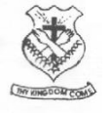

(SCHOOL OF CHOICE)

**ST. BRIGID’S - KIMININI**

**POST – MOCK - 2024**

***Kenya Certificate of Secondary Education***

**CHEMISTRY**

**PAPER 1**

**THEORY  
SEPTEMBER - 2024**

**2 HOURS**

**POST-2024**

***Kenya Certificate of Secondary Education (K.C.S.E)***

**CHEMISTRY PAPER 1 (233/1)**

**INSTRUCTIONS TO CANDIDATES**

1. ***Write your name, admission number, index number and the school in the spaces provided above.***
2. ***Sign and write the date of examination in the above spaces***
3. ***Answer all the questions in the spaces provided***
4. ***Mathematical tables and silent electronic calculators may be used***
5. ***All working must be clearly shown where necessary***
6. ***This paper consist of 12 printed pages***

**FOR EXAMINER USE ONLY**

|  |  |  |
| --- | --- | --- |
| **QUESTIONS** | **MAXIMUM SCORE** | **CANDIDATES SCORE** |
| **1 – 27** | **80** |  |
| **TOTAL SCORE** | **80** |  |

1. Air is a mixture of different components. Identify;
2. A compound that turn lime water to a white precipitate [1 mk]

_______________________________________________________________________________________

1. A compound that changes cobalt(ii)chloride from blue to pink [1 mk]

_______________________________________________________________________________________

1. A diatomic gas that has triple bond [1 mk]

_______________________________________________________________________________________

1. A mixture contains potassium chloride and lead(ii)sulphate. Describe how you would obtain crystals of potassium chloride from this mixture [3 mks]

____________________________________________________________________________________________________________________________________________________________________________________________________________________________________________________________________________________________________________________________________________________________

1. Oxygen is prepared in the laboratory through catalytic decomposition of hydrogen peroxide.
2. Name the catalyst in this experiment [1 mk]

_______________________________________________________________________________________

1. What mass of hydrogen peroxide would be needed to produce 120cm3 of oxygen gas at r.t.p in this experiment? (Molar gas volume at RTP = 24000cm3, H = 1, O = 16) [3 mks]

_____________________________________________________________________________________________________________________________________________________________________________________________________________________________________________________________________

1. Carbon(iv)oxide gas was passed over heated copper(ii)oxides shown in the diagram below.

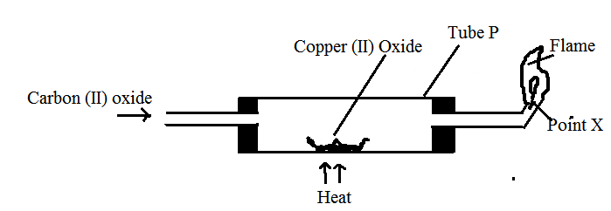

1. State the observation made in the tube P [1 mk]

_____________________________________________________________________________________________________________________________________________________________________________________________________________________________________________________________________

1. Write an equation for the reaction which took place in tube P [1 mk]

______________________________________________________________________________________________________________________________________________________________________________

1. Name the gas burning at point X [1 mk]

_______________________________________________________________________________________

1. The diagram below illustrates the steps involved in the industrial manufacture of of nitric(v)acid.

Use it to answer the questions that follow.

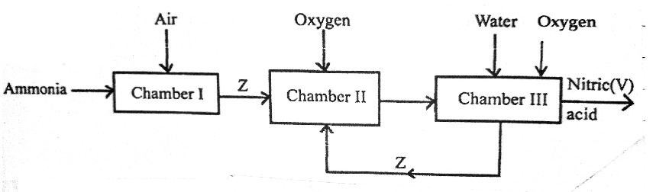

1. Identify the chamber in which a catalyst is used. [1 mk]

_______________________________________________________________________________________

1. Name substance Z [1 mk]

_______________________________________________________________________________________

1. Write an equation for the reaction that takes place in chamber III [1 mk]

_______________________________________________________________________________________

1. Draw a well labelled setup for the laboratory preparation and collection of dry sample of hydrogen chloride gas [3 mks]
2. Account for the following observations made when a piece of sodium is placed in a trough half filled with water.
3. Hissing sound [1 mk]

______________________________________________________________________________________________________________________________________________________________________________

1. Darts on the water surface [1 mk]

______________________________________________________________________________________________________________________________________________________________________________

_______________________________________________________________________________________

1. Solution formed turns red litmus paper blue [1 mk]

_____________________________________________________________________________________________________________________________________________________________________________________________________________________________________________________________________

1. The diagram below shows the structure of iodine

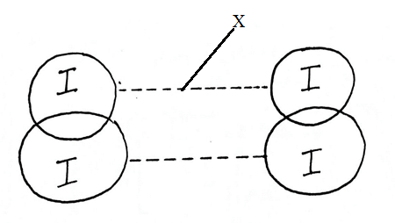

1. Name;
2. Part X [1 mk]

_______________________________________________________________________________________

1. Type of bond in the solid [1 mk]

_______________________________________________________________________________________

1. Explain why iodine has very low melting point [1 mk]

_____________________________________________________________________________________________________________________________________________________________________________________________________________________________________________________________________

1. 20g of salt X dissolves in 80g of water to form a saturated solution at 45oC. calculate the solubility of salt X at 45oC [2 mks]
2. When excess chlorine gas is bubbled through dilute sodium hydroxide solution, the resulting solution acts as bleaching agent.
3. Write an equation for the reaction between chlorine gas and sodium hydroxide [1 mk]

_______________________________________________________________________________________

1. Explain how the resulting solution acts as a bleaching agent [2 mks]

_____________________________________________________________________________________________________________________________________________________________________________________________________________________________________________________________________

1. Element Z has initial mass of 80g. After 5 years the remaining mass was 5g.
2. What is meant by the term half-life [1 mk]

_____________________________________________________________________________________________________________________________________________________________________________________________________________________________________________________________________

1. Calculate the half-life of element Z [2mks]

____________________________________________________________________________________________________________________________________________________________________________________________________________________________________________________________________________________________________________________________________________________________

1. Complete the table below [3 mks]

|  |  |  |  |
| --- | --- | --- | --- |
| Metal | Aluminum | Lead | Sodium |
| Chief ore | Bauxite | __________________ | Rock salt |
| Chemical formulae | ­­_______________ | __________________ | ___________ |
| Method of extraction | _______________ | reduction | ___________ |

1. Use the reaction scheme below to answer the questions that follow.

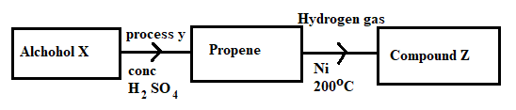

1. Draw the structure of alcohol X [1 mk]
2. Name process Y [1 mk]

_______________________________________________________________________________________

1. Write the molecular formulae of the 5th member of the homologous series in which propene belongs

[1 mk]

1. Calculate the enthalpy for the reaction:

C2H4(g) + H2(g) C2H6 [3 mks]

Give the following bond energies

|  |  |
| --- | --- |
| C – C | 347 kJ/mol |
| C = C | 612 kJ/mol |
| C – H | 413 kJ/mol |
| H – H | 436 kJ/mol |

1. Study the reactions below and answer the questions that follow.

Reaction Equation

J Ba2+(aq) + BaSO3(S)

K Br2(g) + 2I-(aq) 2Br-(aq) + I2(g)

l HSO-4(aq) + OH- (aq) + H2O(l)

Which of these reactions indicate: [3 mks]

1. A precipitation reaction

_______________________________________________________________________________________

1. A displacement reaction

_______________________________________________________________________________________

1. Neutralization reaction

_______________________________________________________________________________________

1. An atom of element A has mass number 39 and 19 protons. (A is not the actual symbol of the element)
2. Using crosses (**x)**  to represent electrons, draw the atomic structure of element A [1 mk]
3. State the group and period to which element A belongs [1 mk]

Group

_______________________________________________________________________________________

Period

_______________________________________________________________________________________

1. Name the type of structure adopted by element A [1 mk]

_______________________________________________________________________________________

1. a) State Graham’s law of rate of diffusion of gasses [1 mk]

_____________________________________________________________________________________________________________________________________________________________________________________________________________________________________________________________________

b) It take 44 seconds for nitrogen(iv)oxide to diffuse through a porous pot. Calculate how long it will take an equal volume of chlorine gas to diffuse through the same porous pot under the same conditions.(N = 4, O = 16, Cl = 35.5) [2 mks]

___________________________________________________________________________________________________________________________________________________________________________________________________________________________________________________________________________________________________________________________________________________________________________________________________________________________________________________

1. The setup below represents electrolysis of dilute sulphuric (vi) acid.

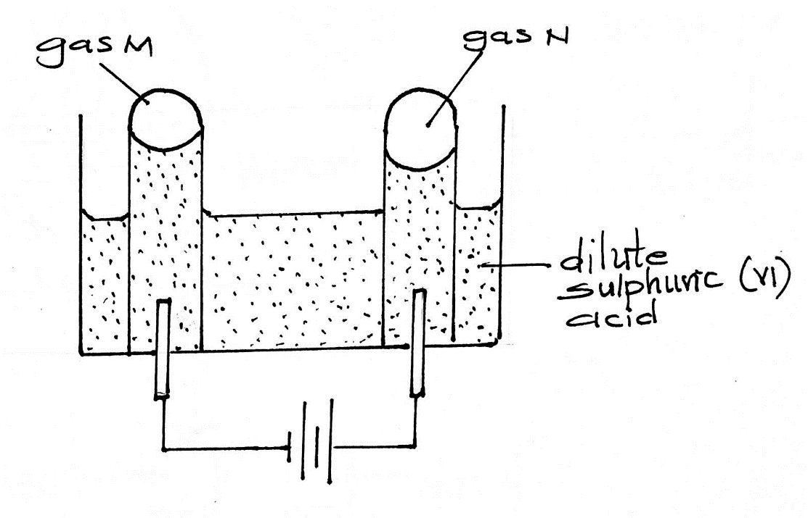

1. Name gas: [2mks]

M - ___________________________________________________________________________

N - ___________________________________________________________________________

1. At what electrode does oxidation take place? [1 mk]

_______________________________________________________________________________________

1. Dichromate (vi) ions are orange in colour while chromate (vi) ions are yellow. Consider the following equation at equilibrium

 (aq) + 2OH-(aq) 2+ H2O(l)

State and explain the observation which would be made if a few drops of dilute sulphuric(vi)acid were added to the equilibrium mixture [2 mks]

___________________________________________________________________________________________________________________________________________________________________________________________________________________________________________________________________________________________________________________________________________________________________________________________________________________________________________________

1. An element has an electron configuration of 2.8.6
2. Name the element [1 mk]

_______________________________________________________________________________________

1. This element forms a puckered ring. Draw the ring [1 mk]
2. Write the formulae of the puckered ring [1 mk]

_______________________________________________________________________________________

1. The melting point of sodium oxide is 1193oC while that of sulphure(iv)oxide is -72oC. In terms of the structure and bonding, explain why there is a large difference in the melting points of the two oxides [2 mks]

___________________________________________________________________________________________________________________________________________________________________________________________________________________________________________________________________________________________________________________________________________________________________________________________________________________________________________________

1. The diagram below illustrates some steps involved in manufacturing sodium carbonate. Use it to answer the questions that follow

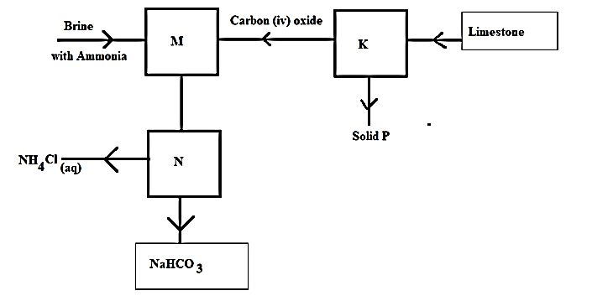

1. Name the industrial process illustrated by the above flowchart [1 mk]

_______________________________________________________________________________________

1. Write an equation for the reaction that takes place in chamber M [1 mk]

______________________________________________________________________________________________________________________________________________________________________________

1. Name the process which takes place in chamber N [1 mk]

_______________________________________________________________________________________

1. How is sodium carbonate obtained in this process [1 mk]

______________________________________________________________________________________________________________________________________________________________________________

1. Explain why potassium is kept under paraffin while phosphorous is kept under water. [2 mks]

_____________________________________________________________________________________________________________________________________________________________________________________________________________________________________________________________________

1. Dilute sulphuric (vi) acid was added to each of the three beakers containing the substances shown below

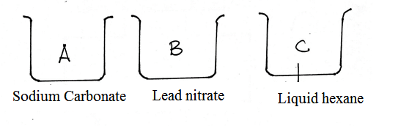

State the observation made in each beaker [3 mks]

A - ­­­­­­­­­­­­­­­­­______________________________________________________________________________

B - ______________________________________________________________________________

C - ______________________________________________________________________________

1. Hydrogen chloride gas was separately dissolved in water and methylbenzene and the solutions labelled B and A respectively. A piece of magnesium ribbon was placed in each of the solutions. There was a lot of bubbles in solution A but no bubbling occurred in solution B. Explain the observations [3 mks]

__________________________________________________________________________________________________________________________________________________________________________________________________________________________________________________________________________________________________________________________________________________________________________________________________________________________________________________________________________________________________________________________________________

1. Give the IUPAC names of the following compounds [3 mks]

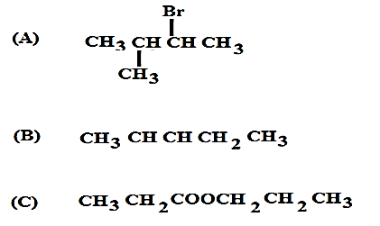

A______________________________________________________________________________________B______________________________________________________________________________________C______________________________________________________________________________________

1. A solution contains 40.32g per litre of compound XOH. 25cm3 of this solution was exactly neutralized by 30cm3 of 0.3M sulphuric(vi)acid. Determine the relative atomic mass of X(O = 16,

H = 1) [4 mks]

**THIS IS THE LAST PRINTED PAGE!**