Name……………………………………………..….… Adm No………………. Class………

Candidate’s Signature…………………….…………….….…...Date…………………………

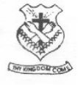

(SCHOOL OF CHOICE)

**ST. BRIGID’S – KIMININI**

**POST MOCK – 2024 SERIES**

***Kenya Certificate of Secondary Education (K.C.S.E)***

**CHEMISTRY PAPER 2 (233/2)**

**CHEMISTRY**

**PAPER 2**

**THEORY  
SEPTEMBER - 2023**

**2 HOURS**

**INSTRUCTIONS TO CANDIDATES**

1. ***Write your name, admission number, index number and the school in the spaces provided above.***
2. ***Sign and write the date of examination in the above spaces***
3. ***Answer all the questions in the spaces provided***
4. ***Mathematical tables and scientific electronic calculators may be used***
5. ***All workings must be clearly shown where necessary***
6. ***Check the question paper to ascertain no question is missing***

**FOR EXAMINER USE ONLY**

|  |  |  |
| --- | --- | --- |
| **QUESTIONS** | **MAXIMUM SCORE** | **CANDIDATES SCORE** |
| **1** | **12** |  |
| **2** | **10** |  |
| **3** | **10** |  |
| **4** | **11** |  |
| **5** | **12** |  |
| **6** | **13** |  |
| **7** | **12** |  |
| **TOTAL** | **80** |  |

1. The table below shows the elements in period 3 of the periodic table. Study it and answer the qestions that follow

|  |  |  |  |  |  |  |  |  |
| --- | --- | --- | --- | --- | --- | --- | --- | --- |
| Element | Na | Mg | Al | Si | P | S | Cl | Ar |

I. a) Write the formulae of two oxides for each of the following [2 marks]

1. Sodium: Oxide I Oxide II

_______________________________________________________________________________________

1. Sulphur: Oxide I Oxide II

_______________________________________________________________________________________

b) The products of the reaction between phosphorus and chlorine depend on the conditions used. Write the equation for the reaction when phosphorus reacts with limited chlorine gas [1 marks]

______________________________________________________________________________________________________________________________________________________________________________

c) Identify the most electronegative element. Give a reason [1 marks]

_______________________________________________________________________________________

d) State and explain the difference in the boiling point of sulphur and phosphorus [2 marks]

______________________________________________________________________________________________________________________________________________________________________________

II. Study the information below and answer the questions that follow. The letters do not represent the actual symbols of elements

|  |  |  |  |
| --- | --- | --- | --- |
| element | Atomic number | M.P of element | M.P of chloride |
| G | 11 | 98 | 801 |
| H | 12 | 650 | 715 |
| J | 14 | 1410 | -70 |
| K | 16 | 113 | -80 |
| L | 20 | 851 | 780 |

1. Write the formula of the compound formed when element H reacts with element K [1 mark]

______________________________________________________________________________________________________________________________________________________________________________

1. Use dot (.) and cross (x) to show bonding between G and K [2 marks]
2. What is the oxidation state of J in its chloride [1 marks]

_______________________________________________________________________________________

1. How does the melting point of fluoride of G compare with that of its chloride [2 marks]

____________________________________________________________________________________________________________________________________________________________________________________________________________________________________________________________________________________________________________________________________________________________

1. Study the setup below and answer the questions that follow

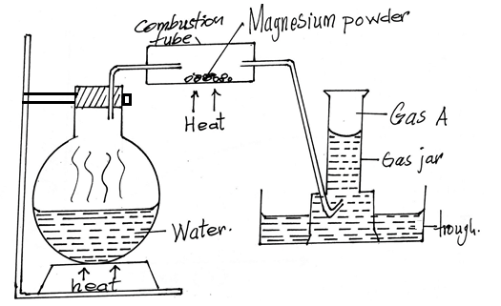

1. Give two reasons why it is necessary to heat the water in the flask just before heating the magnesium powder [2 marks]

_____________________________________________________________________________________________________________________________________________________________________________________________________________________________________________________________________

1. Write a chemical equation for the reaction taking place in the combustion tube [1 mark]

_______________________________________________________________________________________

1. Give the test for gas A [1 mark]

_______________________________________________________________________________________

1. Give two uses of gas A [2marks]

_______________________________________________________________________________________

1. Given that 240cm3 of gas A was produced in the experiment, determine the mass of magnesium powder used.(molar gas volume = 24000cm3 at R.T.P, Mg = 24) [2 marks]

____________________________________________________________________________________________________________________________________________________________________________________________________________________________________________________________________________________________________________________________________________________________

1. What would be observed if magnesium powder was replaced with;
2. Copper metal? [1 marks]

_____________________________________________________________________________________________________________________________________________________________________________________________________________________________________________________________________

1. Potassium metal? [1 marks]

_____________________________________________________________________________________________________________________________________________________________________________________________________________________________________________________________________

1. The diagram below is a flow chart for the extraction of copper from the chief ore. Study it and answer the questions that follow. 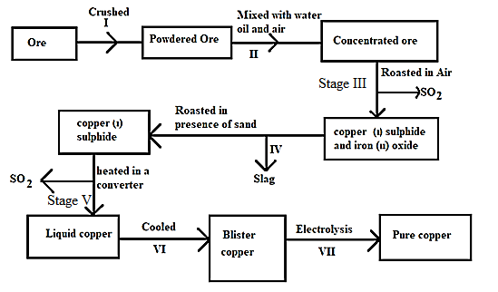
2. Name two ores of copper metal [2 marks]

______________________________________________________________________________________________________________________________________________________________________________

1. Name process II [1 mark]

_______________________________________________________________________________________

1. Give an equation for the reaction that occurs in stage III [1 mark]

______________________________________________________________________________________________________________________________________________________________________________

1. Explain what happens in stage IV [1 mark]

______________________________________________________________________________________________________________________________________________________________________________

1. Write half-cell equations occurring at the anode and cathode in stage VII

Anode [1 marks]

_______________________________________________________________________________________

Cathode [1 marks]

_______________________________________________________________________________________

1. State one impurity in blister copper [1 mark]

_______________________________________________________________________________________

1. Draw a simple diagram showing the setup that is used in electrolytic purification of copper [2 marks]
2. Consider the electrochemical cell represented by the cell notation below, when X is an unknown metal:

Fe2+(aq) / Fe3+(aq) // X+(aq) / X(s)

1. The cell potential of the cell was found to be 0.03V
2. What does the single line (|) in the above cell notation represent? [1 mark]

______________________________________________________________________________________________________________________________________________________________________________

1. Write down the half reaction that takes place at the anode in the above cell [1 marks]

______________________________________________________________________________________________________________________________________________________________________________

1. Given that:

Half reaction Eθ(volts)

Fe3+(aq) + e- Fe2+(aq), +0.77

Ag+(aq) + e- Ag(s) +0.80

Na+(aq) + e- Na(s) -2.87

K+(aq) + e- K(s) -2.92

Identify X with the aid of calculation [2 marks]

____________________________________________________________________________________________________________________________________________________________________________________________________________________________________________________________________________________________________________________________________________________________

1. The diagram below shows the apparatus that can be used to electrolyze dilute sulphuric acid. Study it and answer the questions that follow.

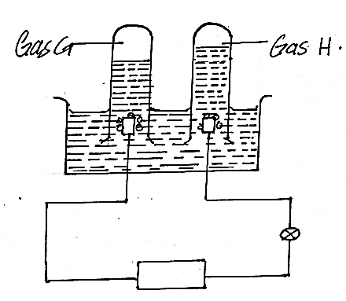

1. Identify the gases H and G
2. H [1 mark]

_______________________________________________________________________________________

1. G [1 mark]

_______________________________________________________________________________________

1. What happens to the concentration of the sulphuric acid during the process with time? Explain [2marks]

______________________________________________________________________________________________________________________________________________________________________________

1. During electrolysis a current of 0.72A was passed through the electrolyte for 15 minutes. Calculate the volume of gas G produced. (1 Faraday = 96500C, molar gas volume = 24dm3 at r.t.p) [3 marks]

___________________________________________________________________________________________________________________________________________________________________________________________________________________________________________________________________________________________________________________________________________________________________________________________________________________________________________________

1. a) The sketch below represents a graph obtained when zinc granules were reacted with excess 0.2M sulphuric (VI) acid in the presence of a catalyst in a conical flask placed on an electronic balance.

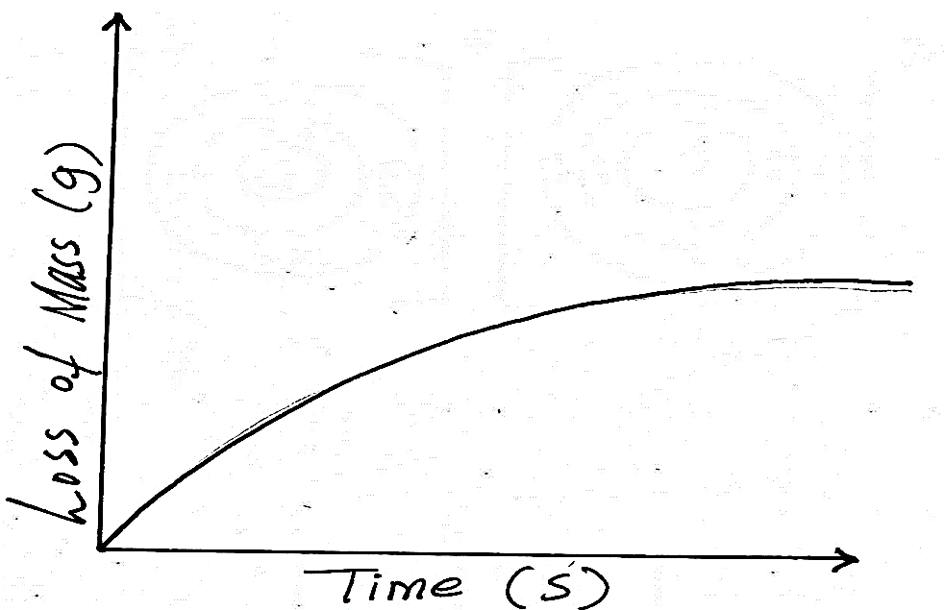

1. Write an equation for the reaction that took place [1 mark]

_______________________________________________________________________________________

1. Explain why there is loss in mass [1 mark]

______________________________________________________________________________________________________________________________________________________________________________

1. Name the catalyst used [1 mark]

_______________________________________________________________________________________

1. Sketch on the same axes, the curves obtained when
2. Zinc powder was used under the same conditions[1 mark]
3. No catalyst was used[1 mark]

b) In the contact process, sulphur(iv)oxide is converted to sulphuric(vi)oxide in the catalytic chamber which a dynamic chemical equilibrium is reached.

2SO2(g) + O2(g) 2SO3(g) ∆H = -197kJ/mol

1. What is meant by dynamic equilibrium [1 mark]

_____________________________________________________________________________________________________________________________________________________________________________________________________________________________________________________________________

1. State and explain how each of the following would affect the position of equilibrium
2. Decrease in temperature [2 marks]

_____________________________________________________________________________________________________________________________________________________________________________________________________________________________________________________________________

1. Decrease in pressure [2marks]

_____________________________________________________________________________________________________________________________________________________________________________________________________________________________________________________________________

1. Equilibrium exists between chromate and dichromate ions as shown below.

 + 2H+(aq) + H2O(l)

Yellow Orange

State and explain the observation made when aqueous sodium hydroxide is added to the above mixture. [2 marks]

___________________________________________________________________________________________________________________________________________________________________________________________________________________________________________________________________________________________________________________________________________________________________________________________________________________________________________________

1. Study the formulae below and answer the questions that follow

I. CH3CH2COOH

II. CH3CH2CH2CH2OH

1. i) Give the systematic name of each compound [2 marks]

I.

_______________________________________________________________________________________

II.

_______________________________________________________________________________________

ii) Write the molecular formula of the compounds [1 mark]

I.

_______________________________________________________________________________________

II.

_______________________________________________________________________________________

iii) How does the boiling point of I compare to that of II. Explain [2 marks]

____________________________________________________________________________________________________________________________________________________________________________________________________________________________________________________________________________________________________________________________________________________________

iv) A gas J is bubbled into concentrated sulphuric(vi)acid. Water is added to the mixture then boiled to yield compound II. Name gas J. [1 mark]

_______________________________________________________________________________________

v) Draw the structural formula of the compound immediately after compound I in the homologous series [1 mark]

b) Study the structural formula of the two monomers below and answer the questions that follow.

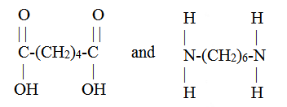

i) Name the type of polymerization these monomers would undergo to form a polymer [1 mark]

______________________________________________________________________________________________________________________________________________________________________________

ii) Draw the structural formula to represent the polymer formed. [1 mark]

iii) What is the name of the polymer [1 mark]

_______________________________________________________________________________________

iv) State the use of this polymer [1 mark]

______________________________________________________________________________________________________________________________________________________________________________

c) Two cleaning agents are represented below

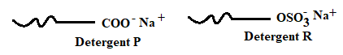

Select one of the detergent which would be suitable for washing in water containing magnesium chloride. Explain [2marks]

____________________________________________________________________________________________________________________________________________________________________________________________________________________________________________________________________________________________________________________________________________________________

1. a) Define the term half-life [1 mark]

_____________________________________________________________________________________________________________________________________________________________________________________________________________________________________________________________________

b) The table below contains information from the measurements made of the radioactivity in counts per minute from a radioactive iodine – 128

|  |  |  |  |  |  |  |  |
| --- | --- | --- | --- | --- | --- | --- | --- |
| Counts per minute | 240 | 204 | 180 | 156 | 138 | 122 | 108 |
| Time (min) | 0 | 5 | 10 | 15 | 20 | 25 | 30 |

i) Plot a graph of counts per minute against time [3 marks]



ii) Use the graph to determine the half-life of iodine – 128 [1 mark]

____________________________________________________________________________________________________________________________________________________________________________________________________________________________________________________________________________________________________________________________________________________________

iii) What is the count rate after 22 minutes [1 mark]

____________________________________________________________________________________________________________________________________________________________________________________________________________________________________________________________________________________________________________________________________________________________

iv) After how many minutes were the counts rate 160 counts per minute [1 mark]

_____________________________________________________________________________________________________________________________________________________________________________________________________________________________________________________________________

c) Potassium has two isotopes  and radio active

i) State how the two isotopes differ [1 mark]

_____________________________________________________________________________________________________________________________________________________________________________________________________________________________________________________________________

ii) The half life of is 1.3 ˟ 109 years. Determine how long it would take for 4g of the isotope to decay to 1g [1 mark]

_____________________________________________________________________________________________________________________________________________________________________________________________________________________________________________________________________

iii)  undergoes beta decay to form an isotope of calcium. Write the nuclear equation for this decay [1 mark]

_____________________________________________________________________________________________________________________________________________________________________________________________________________________________________________________________________

d) The figure below shows how a radioactive material emitted radiations from its source. Study it and answer the questions that follows as shown.

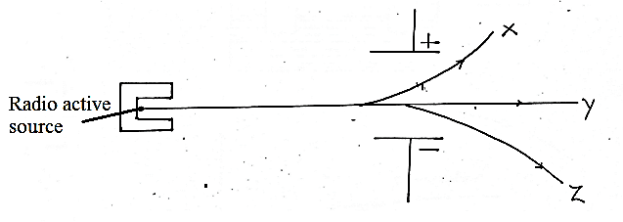

Identify the radiation that:

i) Has no mass [1 mark]

_______________________________________________________________________________________

ii) Contains helium particles [1 mark]

_______________________________________________________________________________________

**THIS IS THE LAST PRINTED PAGE!**