Name……………………………………………..….… Adm No………………. Class………

Candidate’s Signature…………………….…………….….…...Date…………………………



(SCHOOL OF CHOICE)

**ST. BRIGID’S - KIMININI**

**POST MOCK – 2024 SERIES**

***Kenya Certificate of Secondary Education***

**121/2**

**MATHEMATICS ALT.A**

**PAPER 2**

**SEPTEMBER - 2024**

**TIME: 2½ HOURS.**

**INSTRUCTIONS TO THE CANDIDATES**

* This paper contains two sections; **Section** I and **Section II**.
* Answer all the questions in **section I** and only **five** questions from **Section II.**
* All workings and answers must be written on the question paper in the spaces provided below each question.
* Non programmable silent electronic calculators and KNEC Mathematical tables may be used **EXCEP**T where stated otherwise.
* Show all the steps in your calculations, giving your answers at each stage in the spaces below each question.

**FOR EXAMINER’S USE ONLY**

**Section 1**

|  |  |  |  |  |  |  |  |  |  |  |  |  |  |  |  |  |  |
| --- | --- | --- | --- | --- | --- | --- | --- | --- | --- | --- | --- | --- | --- | --- | --- | --- | --- |
| Question | 1 | 2 | 3 | 4 | 5 | 6 | 7 | 8 | 9 | 10 | 11 | 12 | 13 | 14 | 15 | 16 | Total |
| Marks |  |  |  |  |  |  |  |  |  |  |  |  |  |  |  |  |  |

**Section 1I**

|  |  |  |  |  |  |  |  |  |  |
| --- | --- | --- | --- | --- | --- | --- | --- | --- | --- |
| Question | 17 | 18 | 19 | 20 | 21 | 22 | 23 | 24 | **Total** |
| Marks |  |  |  |  |  |  |  |  |  |

**SECTION I (50MKS)**

**Answer all questions in this section**

1. Make P the subject of the formula XYP = QPX (3 marks)
2. Without using a calculator or mathematics table. Evaluate form

$\frac{2\tan{60}}{Sin 45^{0}-Cos 30^{0}}$ = a $\sqrt{b}$ + c Leaving your answer in simplified form. (3 marks )

1. Solve for x in the equation below:

3 Log 3 X + 4 = log 3 24 (3 marks)

1. Wanjiku pays for a car on hire purchase in 15 monthly instalments. The cash price of the car is Ksh.300, 000 and the interest rate is 15%p.a. A deposit of Ksh.75, 000 is made. Calculate her monthly repayments. (3 marks
2. Pipe A can fill a tank in 2 hours, Pipe B and C can empty the tank in 5 hours and 6 hours respectively. How long would it take:

a) To fill the tank if A and B are left open and C is closed. (2 marks)

1. To fill the tank with all pipes open. (2 marks)
2. The difference between the second and fourth terms of an arithmetic sequence is 3. If the product of the first and the fourth term is 34, **calculate** the value of the first term. (3marks)
3. The triangular prism shown below has the sides AB =DC =EF = 12 cm. The ends are equilateral triangles of sides 1ocm. The point N is the midpoint of FC

(3Marks)

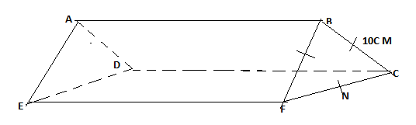

1. Find length BN ( 1 mark)

b) Find the angle EB make with CDEF (3 mark)

1. The length and breadth of a rectangular floor garden were measured and found to be 4.1m and 2.2m respectively. Find the percentage error in its area. (3 marks)
2. .In the figure below , BDEF are points on the circumference of a circle centre O. Points ABC and BOE are straight lines. Given that angle BDF= 500 and BF=DF.

( 3marks)

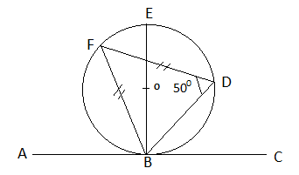

Find the value of the following angles

1. EBA
2. EOF
3. EBD
4. The position vectors of points A, B and C are 4**i-**3**j+**5**k,** 5**i-**6**j+**10**K** and 3i respectively. Show that points A, B and C are collinear. (3 marks)
5. In the figure below , O is the centre of the circle and AT is a tangent to the circle at A.

AT =  cm and DT = 4cm. **Determine** OD (3mks)

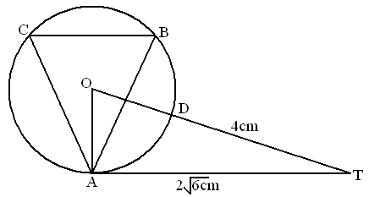

1. A bag contains 10 balls of which 3 are red, 5 are white and 2 green. Another bag contains 12 balls of which 4 are red, 3 are white and 5 are green. A bag is chosen at random and a ball picked at random. Find the probability the ball so chosen is red. (3 marks)
2. The coordinates of the end points of diameter are A(2,4) B(−2,6). Find the equation of a circle in the form ax2 + by2 +cx + dy + e = 0 (3 marks)
3. The sketch below represents the graph for y= x2 – x – 6. Use the curve and five trapezia to estimate the area bounded by the x – axis, y – axis x = 0 and x = 5.

(3mks)

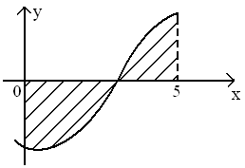

1. (a) **Expand** and **simplify** the expression up to the third term. (2mks)

(b) Hence use the expansion in (a) above to **approximate** the value of (39.6)5 correct to 3 significant figures. (2mks)

1. A wholesaler stocks two types of beans Nyayo and Rose coco. The wholesale price of Nyayo is kshs 80 and Rose coco is kshs 140. The wholesaler also stock a blend C beans which is a mixture of Nyayo and Rose coco beans mixed in the ratio 3:2
2. Determine the cost price of 1 kg of blend C beans ( 1 mark)
3. A retailer bought 10 kg of blend C beans. To this blend the retailer added some Rose coco beans to prepare a new mixture blend D. The ratio of Nyayo beans to Rose coco in blend D was 1:2 . Determine the amount of Rose coco that was added ( 3 marks)

**SECTION B**

**Answer only five questions in this section**

1. Give the matrix 

(i) **Calculate** A2 and A 3  (4mks)

1. **Find** the values of the constants p and q for which A2 = pA + qI where I is the identity matrix. (3mks)
2. The triangle ABC maps onto A1B1C1 under the transformation represented by matrix A. **Find** the area of triangle ABC if the area of triangle A1B1C1 is 21cm2 (3mks)
3. The marks of 50 students in a mathematics test were taken from a form 4 class and recorded in the table below.

|  |  |  |  |  |  |  |  |  |
| --- | --- | --- | --- | --- | --- | --- | --- | --- |
| Mark (%) | 21-30 | 31-40 | 41-50 | 51-60 | 61-70 | 71-80 | 81-90 | 91-100 |
| Frequency | 2 | 5 | 7 | 9 | 11 | 8 | 5 | 3 |

1. On the grid provided, **draw** a cumulative frequency curve of the data. (4mks)

Take: 1cm to represent 5 students on the vertical scale and 1cm to represent 10 marks on the horizontal scale

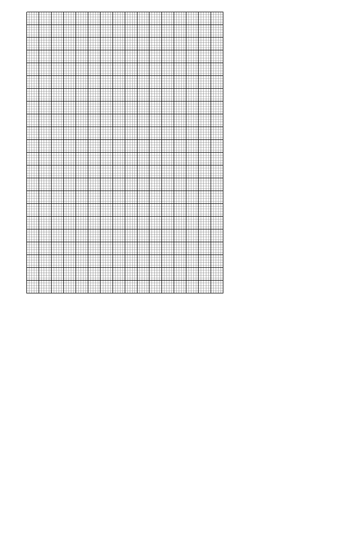

1. From your curve in (a) above
   1. **Estimate** the median mark. (1mk)
   2. **Determine** the quartile deviation. (2mks)
   3. **Determine** the 90th percentile range. (1mk)
   4. It is given that students who score over 45 marks pass the test.

Use graph in (a) above to **estimate** the percentage of students that pass. ( 2 marks)

1. A tourist took 1 hour 20 minutes to travel by an aircraft from town T (30S, 350E) to town U (90N, 350E). Take R=6370km and π =22/7.

a) Find the average speed of the aircraft (3mks)

b) After staying at town U for 30mins, the tourist took a second aircraft to town

V (90N,50E). The average speed of the second aircraft was 90% that of the

first aircraft. Determine the time to the nearest minute the

air craft took to travel from U to V. (3mks)

1. When the journey started at town T the local time was 0700hours. Find the local time at V, when the tourist arrived. ( 4 marks)
2. The table below shows income tax rates for the year 2022

|  |  |
| --- | --- |
| **Taxable income per month** | **Tax rate in %** |
| 1 - 4720 | 10 |
| 4721- 9340 | 15 |
| 9341 - 13960 | 20 |
| 13961 - 18580 | 25 |
| Above 18580 | 30 |

a) A tax relief of Kshss.1162 per month was allowed. . In a certain month of that year, the employees’ taxable income in the fifth band was Kshs 18,204 Calculate;

(i) The employee’s total taxable income in that month. (2 marks)

(ii) The tax payable by the employee in that month. (5 marks)

(b) The employee’s other deductions include: 5% of taxable income as cooperative shares. 2% of taxable income as WCPS, Insurance policy Kshs.2 800 Calculate the employee’s net monthly salary. (3 marks)

1. (a) Construct triangle PQR with PQ = 7.2cm, QR = 6.5cm and angle PQR = 480

(3mks)

b) The locus L1, of points equidistant from P and Q, and locus , L2 of points equidistant from P and R, meet at M. Locate M and measure QM (4mks)

c)A point x moves within triangle PQR such that QX ≥ QM. Shade and label the locus of X. (3mks)

22) Complete the table below for y=sin 2x and y=sin ( 2x + 30) giving values to 2d.p

|  |  |  |  |  |  |  |  |  |  |  |  |  |  |
| --- | --- | --- | --- | --- | --- | --- | --- | --- | --- | --- | --- | --- | --- |
| X | 0 | 15 | 30 | 45 | 60 | 75 | 90 | 105 | 120 | 135 | 150 | 165 | 180 |
| Sin 2x | 0 |  |  |  | 0.87 |  |  |  | -0.87 |  |  |  | 0 |
| Sin ( 2x + 30) | 0.5 |  |  |  | 0.5 |  |  |  | -1 |  |  |  | 0.5 |

(2 marks)

b) Draw the graphs of y=sin 2x and y = sin (2x + 30) on the axis. (4 marks)



c) Use the graph to solve  (1 mark)

d) Determine the transformation which maps  (1 mark)

e) State the period and amplitude of  (2 marks)

23. (a) The equation of a curve is given by y = X3 + X2 – bx. **Show** that the value of X at the minimum turning point is  (3mks)

(b) The displacement X metres of a particle moving along a straight line after t seconds is given by X = 4t + 2t2 – t3

(i) **Find** its initial acceleration (2mks)

(ii) **Calculate** the time when the particle was momentarily at rest. (2mks)

(c) (i) **Find** the values of X where the curve y = X2 (x - 2) crosses the x-axis. (1mk)

(ii) Hence **find** the area enclosed by the curve y = X2 (x - 2), the lines x = 0, x = 2  and the x-axis. (2mks)

* + - 1. A uniform distributor is required to supply two sizes of skirts to a school: medium and large sizes. She was given the following conditions by the school.

1. The total number of skirts must not exceed 600.
2. The number of medium size skirts must be more than the number of large size skirts.
3. The number of medium size skirts must not be more than 350 and the number of large size skirts must not be less than 150. If the distributor supplied χ medium size and y large size skirts.
4. Write down, in terms of χ and y, all the linear inequalities representing the conditions above. (4mks)

(b) On the grid provided, represent the inequalities in (a) above by shading the unwanted regions. (4mks)



The distributor made the following profits per skirt.: Medium size = Sh.300., Large size= Sh.250. Determine the maximum profit. (2mks)